14.07.2020 YEAR 4 HOME LEARNING – Maths

Today we are exploring quadrilaterals.
Watch this video to help you https://vimeo.com/434742962
A quadrilateral is a 4 sided shape.
There are 5 types of quadrilaterals you will need to know.
- Square
A square is a regular quadrilateral (all sides and angles are the same).
All the angles on a square are always right angles (90°).
4 cm
4 cm
4 cm
4 cm

- Rectangle
A rectangle is an irregular quadrilateral as it has 2 sets of sides that are the same. However, all the angles are the same as they are all right angles (90°).
4cm
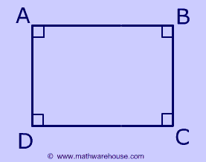
3 cm
3 cm
4cm

- Parallelogram
A parallelogram is a shape with 2 sets of parallel lines (2 straight lines that never meet).
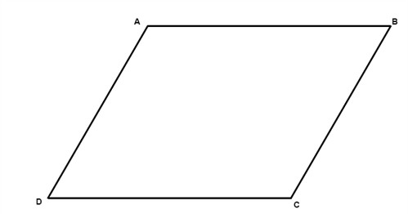
Here, the 2 blue lines are parallel to each other and the 2 red lines are parallel to each other.
- Rhombus
A rhombus is a 4 sided shape in which all 4 sides are the same length.

- Trapezium
A trapezium is a shape that has one pair of parallel lines.
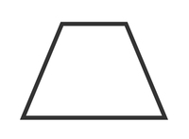
These red lines are the parallel lines.

14.07.2020 YEAR 4 HOME LEARNING – Comprehension

