13.07.2020 YEAR 4 HOME LEARNING – Maths

Today we are exploring triangles.
Watch this video to help you https://vimeo.com/434625195
There are 4 types of triangles you will need to know for this lesson.

- Equilateral triangle
An equilateral triangle is a triangle whereby all three sides and angles are equal.
Each angle is always 60°.

- Isosceles triangle
An isosceles triangle has 2 sides and angles the same and 1 different.
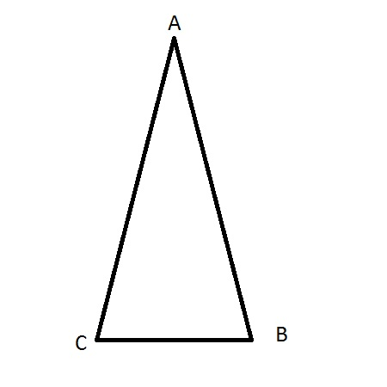

- Scalene triangle
In a scalene triangle, all the sides and angles are different.

- Right-angle triangle
This triangle has one angle that is a right angle (90°).

13.07.2020 YEAR 4 HOME LEARNING – Comprehension

