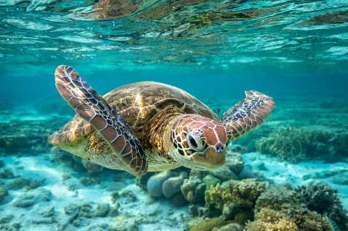
Find the different animals, tick them off and find the fact.

Type of creature | Tick or cross | Fact
Green Moray Eel
Yellow Tang
Black Grouper
Sand Tiger Shark
Atlantic Bottle Nose Dolphin
Red Lion Fish
Moon Jellyfish
American Alligator
Sea Turtle
Emperor Angelfish

