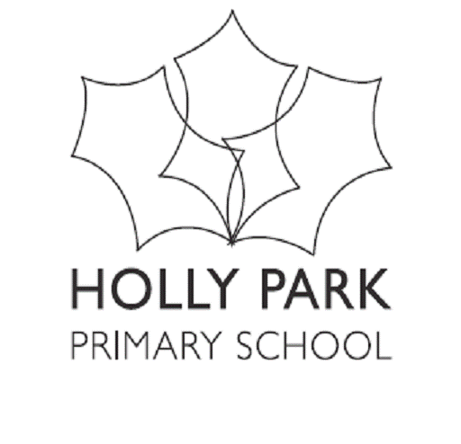 Reception After School Club

Please complete the form below by ticking the boxes you require and return it to school by 13th July 2020.
Please return to head@hollypark.barnetmail.net

 | Monday | Tuesday | Wednesday | Thursday | Friday
Afterschool club 3:30 - 6pm

£18.75 per day.

You can provide your child with a packed tea or the school can provide a tea at £2.34 per day on top of the cost of the session.

Please be aware that your child won't be able to start their after school club sessions until a member of the reception team feels that your child has settled well into the normal school day.

Please also be advised that spaces are limited and we cannot go over pupil/adult ratios.

We offer places on a first come first served basis.

If you choose to take up a place at our EYFS after school club and do not attend you will still be charged as another child could have had the space.

All Invoices are paid for a half term in advance with the exception of the first half term which will start once your child attends their first session.

