Holly Park School
Playtime & Lunchtime Policy

We recognise that playtime is a vital part in every child’s day at school.

Playtimes need to:
• Enhance the quality of play in the playground
• Develop any playtime areas to their full potential
• Ensure that all staff involved in playtime supervision are aware of their
role and routines.

Links to the UN Rights of the Child
Article 31
Every child has the right to relax, play and take part in a wide range of cultural and artistic activities.

Aims For Playtimes
Our playground and school grounds are places where children have the
opportunity to:
- Have a break from structured routines
- Develop new skills, find new challenges and take new risks
- Explore and discover things about the world in which they live
- Take exercise and improve their fitness and health
- Talk to other members of staff
- Be themselves.
- choose to be alone, be private or be with friends.

It can be a time to recognise their own individuality and be responsible for their own actions
• Have a snack, drink and go to the toilet
• Make new friends
• Learn to play together and mix with other year groups

We aim for children to "enjoy playtimes" and to keep "physically fit" and we take the issue of time spent at play seriously.

To a child `play' is an important part of their `work'. We encourage children to say if they are unhappy at playtimes.

Playtime Provision:
KS1 Playground
Tarmac playground areas
Small fitness trails
Play bus
Climbing equipment
A slide
Board game zone
Make believe zones – puppets & dressing up
Quiet zones - reading
Dance and singing zone

KS2 Playground
Tarmac playground areas
Fitness trail
Amazon climber
Table tennis
Ball shooter
A slide
Football Area
A quiet zone – story garden, reading, cats cradle, jacks etc
Make believe zones – puppets & dressing up
Dancing & singing zone
Board game zone
Skipping zone
Traditional games zone
Craze of the week zone – French skipping, stilts, hoops etc

Football
All Key Stage Two children have opportunities for football. A rota for year groups playing football is in place. Children are not allowed to bring in footballs from home. Football at lunchtime finishes 10 minutes before the end of the lunch hour in order to give children time to cool down and get a drink. A whistle will blow to mark the end of football time.

Amazon Climber & Fitness trail
The trim trail is to be supervised by the adult on duty on the top playground.
The trail will only be used when it is not slippery.

Friendship bench
This is a sign in the playground where children can go if they are looking for a
friend. Other children and the play leaders & mini mentors are encouraged to look out
for and make friends with children who are standing by the sign.

Playtime sessions and supervision
A rota of staff on duty is given to all staff and is displayed so it can be seen in the playgrounds. The following gives detail of the session and supervision.

SESSION TIME SUPERVISION
Morning Break KS2 10.35-10.55am
Morning break KS1 10.15 – 10.30am
Lunch Break Key Stage 1 12.20 – 1.20pm
Lunch Break Key Stage 2 12.00 – 1.00pm
Lunch break Reception 11.40-1.00pm
Afternoon Break Key Stage 2 2.20 – 2.30

Staff responsibilities during playtimes
The members of staff on duty need to be on the playground promptly at the
being of playtime. At the end of the playtime the bell will be rung and the
children will walk to their class line. The teachers on duty will
remain on the playground until all children have been collected by their class
teacher.

Staff on duty should not be standing talking to each other – they should be interacting with children and supervising.
MTS should be engaging pupils in play

At playtimes, the rota shows which member of staff is responsible for which area of the playground
At lunchtimes the senior MTS will designate areas of responsibility

At playtimes the staff member responsible for supervising the grass area will decide if it is too slippery to go on the equipment
At lunchtime the Senior MTS will do the same job

Wet playtimes
Wet playtimes are supervised by the members of staff on duty
Wet lunchtimes are supervised by MTS

Play Leaders
The play leaders help to ensure that the playground is a happy environment. Play leaders are chosen from Year 6 and help support play in both playgrounds. Our play leaders are led by our Children’s Co-ordinator. They all have caps, fluoorescent jackets and badges to identify them and make them easily seen in the playgrounds. They meet regularly with the Children’s co-ordinator to learn new games and also to discuss problems they are having. The idea of the play leaders is to help the younger children with games and activities during the lunchtimes. The play leader role includes ensuring that equipment is put out and away, helping other children to play games sensibly and to befriending lonely children at the Friendship bench and helping them to make friends.
Mini Mentors
The Mini mentors are selected children from Y5 who will work with children in the playground who are having small conflicts to help them to resolve them. They are introduced in assembly so that everyone knows what their role is and they will be easily identified as they will be wearing bright yellow tabards that say “Mini Mentors” on them. The Deputy Head and Learning Mentor have put together a training programme (based on the experience of other schools) which they work through with the selected children so that they know exactly what to do, what to say and when to ask an adult to intervene.

First Aid Procedure
First aid treatment is available in the welfare room by our pupil support officer. Accidents are recorded in the accident book. Accidents are analysed termly and reported to governors. Parents/ guardians and teachers are informed of any serious injuries. Text messages are sent to inform parents of any head injuries and children wear a head injury sticker.
*See first aid policy.

Playground rules
Children are made aware of the playground rules at the beginning of each year
The rules are:
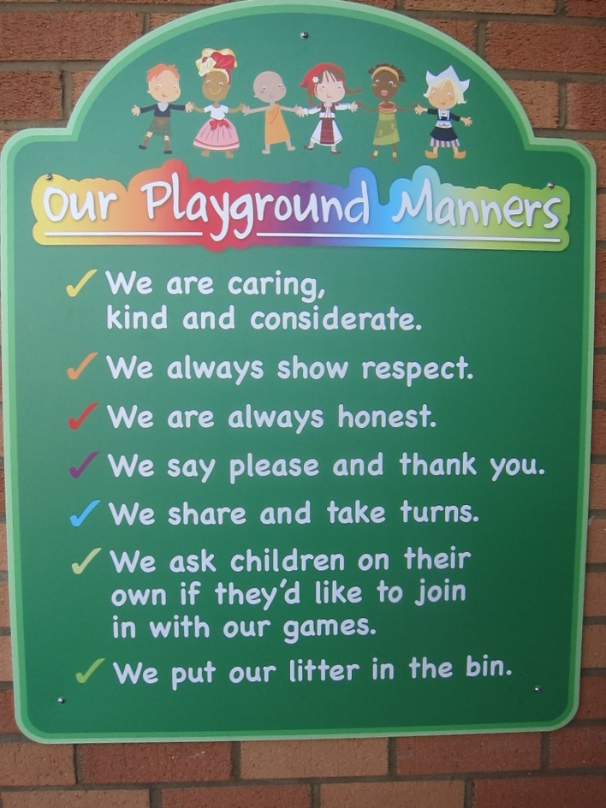

Children are not to bring in toys and trading cards from home.

Rewards and Sanctions
Our rewards and sanctions follow the same rules as in our behaviour policy for lesson time (see behaviour policy)
We expect the same standard of behaviour at playtimes as during lesson time
House points are awarded for good behaviour – e.g holding a door open, picking up some litter etc
At lunchtimes, the MTS give out golden raffle tickets for good behaviour. Children then take these back to class and write their name on. Each ticket earns them a housepoint.
Every raffle ticket is put in the golden box for the class. At the end of every half term a raffle ticket is drawn out of each golden box in an assembly and the winners are given a special treat. The more raffle tickets a child has in the box the greater their chance of being drawn out.
There is also a special golden book for very special behaviour or acts of kindness. Names can be written in this book and the names will be read out in assembly each week.
The MTS can also add names to a class book for any children whose behaviour is of concern at lunchtime. There is a book kept in each classroom.
Document Control
Revision History
Version | Revision Date | Revised By | Revision
1.0 | Spring 2016 | Ann Pelham | Written following training by Jennie Moseley and new actions & systems implemented
1.2 | Summer 2016 | S&PW Committee | Reviewed & ratified
1.3 | Summer 2017 | S&PW Committee | Reviewed & ratified
1.4 | Summer 2018 | S&PW Committee | Reviewed & ratified
1.5 | Summer 2019 | S&PW Committee | Reviewed & ratified
1.6 | Summer 2020 | S&PW Committee | Reviewed & ratified
Signed by
 | Name | Signature | Date
Headteacher | Ann Pelham
Chair of Governors | Tim Graveney
Distribution
Shared with
- Staff via school server
- Parents via Website
- Governors via committee meetings

Date for next review
Summer 2021

