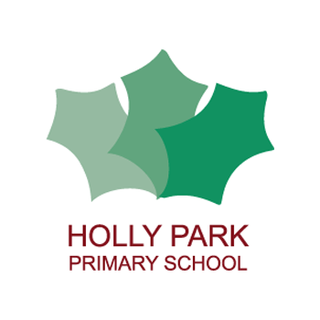Holly Park Nursery
Dear parents and carers,
This week the school is having a virtual sports day and it would be lovely if the nursery children could join in too. You can find information on the front page of the school website and the links to the different activities children are expected to take part in.
It is important to keep active, especially as there is a lot more time spent at home at the moment. Below are some activities that you can do in your garden, at the park or even inside your home. Give them a go! Just a little bit of exercise every day can make all the difference to children’s wellbeing.
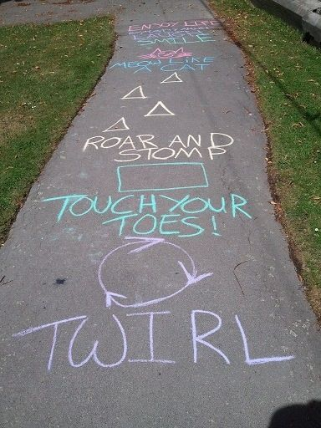

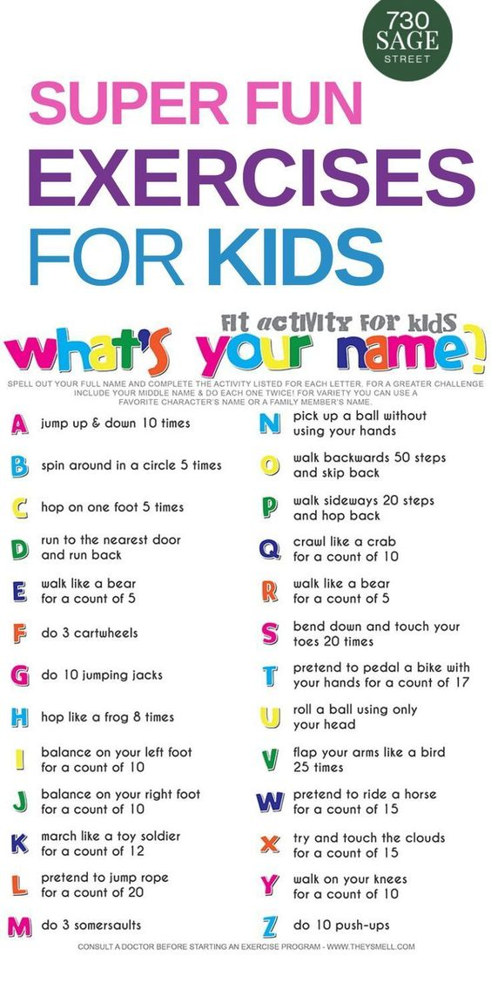

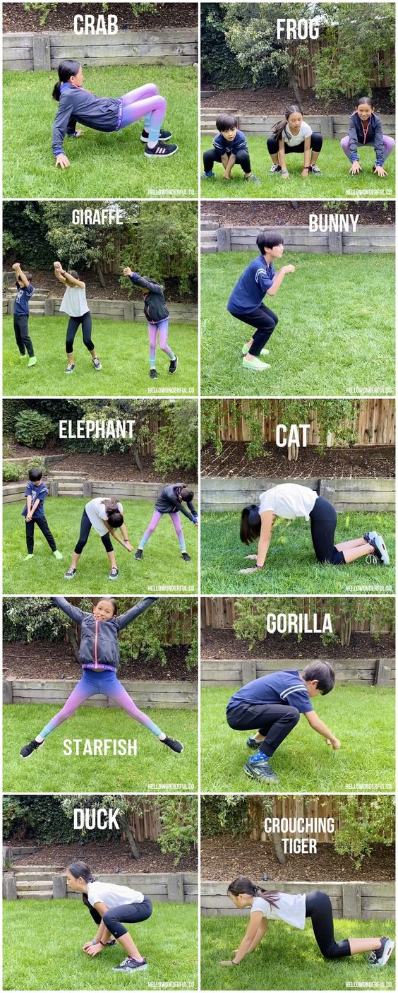
Shout out an animal and your child must move around like that animal.
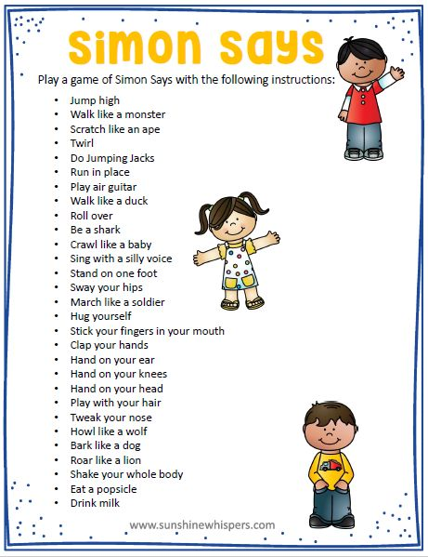
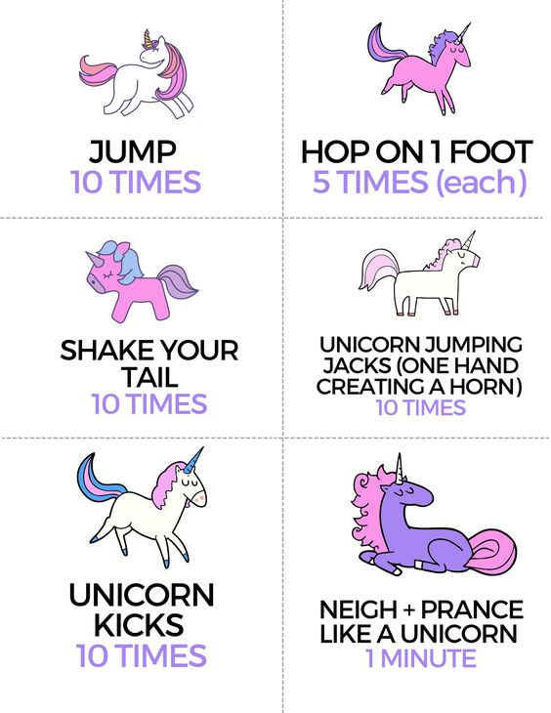

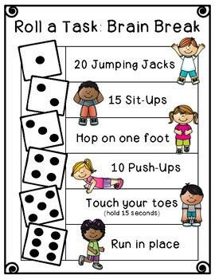
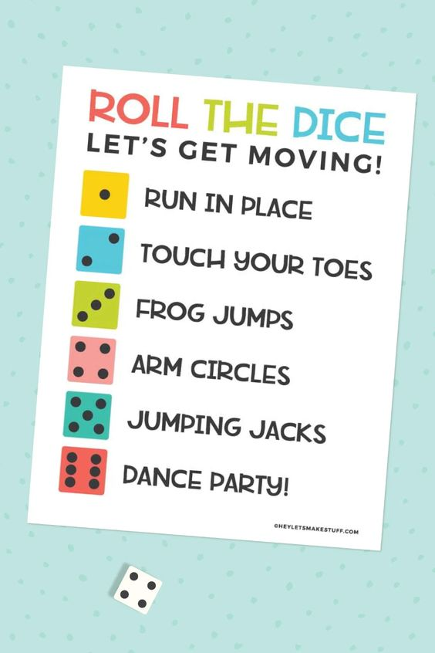
You could make up your own exercise for each number.

There are some lovely things on YouTube that the children love. Try typing in:
Just Dance Kids
Go Noodle
Cosmic kids yoga
You can also make obstacle courses with your child and time how quick they can get around it.
They could make a den using various materials around the house.
Going on a scavenger hunt in the woods or park – take sandwich bags and collect natural objects such as leaves, stones and sticks
Have a great week and enjoy the Holly Park Virtual Sports Day.
Miss Wood
Reading stories

Please continue to read stories to your child every day. There are lots of stories being read by different teachers on the Holly Park website. Here are some of the stories that I have read:

https://youtu.be/gdFvApYljZg
My Pet Star

https://youtu.be/oNHBQt4hsn8
Don’t worry little crab

https://youtu.be/VblfzuOZ0Qg
Oh no George!

https://youtu.be/gNHj1Sc1PuM
Goldilocks and the three bears

