Holly Park School
Marking and Feedback Policy

Rationale
Marking and feedback is a powerful tool in assessment of learning and all children have the right to have their work acknowledged through feedback which demonstrates respect for the work produced. Regular feedback keeps the teacher in tune with individual needs and abilities and helps raise standards. Feedback is an essential part of teaching and learning and is an integral component in pupil progress.
We have reviewed our marking policy because we have realised that our 'deep marking' policy was a burden on staff, did not necessarily move learning on and we have researched better ways of providing feedback:
- Meaningful feedback that improves pupils’ work does not have to be written (Department for Education’s marking review group and the Education Endowment Foundation)
- Most pupils need a low level of scaffolding or prompts, but very few need extensive modelling and ‘hand-holding' through extensive marking.

Aims
At Holly Park we aim to:
- Provide consistency and continuity in marking and feedback throughout the school so that children have a clear understanding of teacher expectations
- Encourage children to look at mistakes in a positive way
- Raise standards by celebrating successes and encouraging children to improve on their last piece of work
- Create a dialogue which will aid progression and improve children’s confidence and self esteem
- Help pupils to understand how well they are doing, where a piece of work can be improved and offer additional challenges that extend learning
- Provide teachers with information about future planning
- Develop children's ability to self and peer assess

Our policy is underpinned by the evidence of best practice from the Education Endowment Foundation and other expert organisations.
The Education Endowment Foundation research shows that effective feedback should:
- Redirect or refocus either the teacher’s or the learner’s actions to achieve a goal
- Be specific, accurate and clear
- Encourage and support further effort
- Not overload a child – it needs to be meaningful
- Provide specific guidance on how to improve and not just tell students when they are wrong

Our policy on feedback has at its core a number of principles:
- The sole focus of feedback and marking should be to further children’s learning
- Evidence of feedback and marking is incidental to the process; we do not provide additional evidence for external verification
- Written comments should only be used where they are accessible to students according to age and ability
- Feedback delivered closest to the point of action is most effective, and as such, feedback delivered in lessons is more effective than comments provided at a later date
- Feedback is provided as part of assessment processes in the classroom, and takes many forms other than written comments
- Feedback is a part of the school’s wider assessment processes, which aim to provide an appropriate level of challenge to pupils in lessons, allowing them to make good progress
- All pupils’ work should be reviewed by teachers at the earliest appropriate opportunity so that it might impact on future learning. When work is reviewed, it should be acknowledged in books
- Feedback will be positive, motivating and constructive
- It will be at the child’s level of comprehension
- It will be related to a specific learning objective for that piece of work or a target the child is working on
- It will identify what has been done well and what still needs improvement
- It will positively impact on the child’s progress
- It will be consistent throughout the school
- Wherever possible, it will be discussed and completed with the child present

Feedback may be given in one of three ways:
- Immediate – at the point of teaching
- Summary – at the end of a lesson/task
- Review – away from the point of teaching (including written comments)

Type | What it looks like | Evidence (for observers)
Immediate | - Includes teacher gathering feedback from teaching, including mini-whiteboards, book work, etc.  - Takes place in lessons with individuals or small groups  - Often given verbally to pupils for immediate action  - May involve use of a teaching assistant to provide extra support or further challenge  - May re-direct the focus of teaching or the task  - May include highlighting/annotations according to the marking code | - Lesson observations/learning walks  - Some evidence of annotations or use of marking code/highlighting  - Improvements evident in books, either through editing or further work
Summary | - Takes place at the end of a lesson or activity  - Often involves whole groups or classes  - Provides an opportunity for evaluation of learning in the lesson  - May take form of self – or peer – assessment against an agreed set of criteria  - In some cases, may guide a teacher’s further use of review feedback, focusing on areas of need | - Lesson observations/learning walks  - Timetabled pre – and post – teaching based on assessment  - May be reflected in selected focus review feedback (marking)
Review | - Takes place away from the point of teaching  - May involve written comments/annotations for pupils to read/respond to  - Will probably involve looking through the class set of books  - Provides teachers with opportunities for assessment of understanding  - Leads to adaptation of future lessons through planning, grouping or adaptation of tasks  - May lead to targets being set for pupils’ future attention, or immediate action | - Acknowledgment of work completed  - Written comments and appropriate response /action  - Adaptations to teaching sequences tasks when compared to planning  - Use of annotations to indicate future groupings

Writing Feedback

- For all activities either during or after a lesson, look through the class's work and note down any common mistakes or misunderstandings. The teacher will look through the work in pupils’ books, and is aware of what has often been misunderstood and uses this for future lessons,

- For extended pieces of writing (at least fortnightly) in individual books, highlight the pre prepared stamps that are stuck in books for end of year expectations (expectation sheets) to highlight off in green or pink

- Peer and self-marking should be used sparingly and in extended pieces of writing should only focus one or two aspects of the expectations. Peer and self-editing of work should still be part of the writing process.

- For more exercise based writing lessons e.g SPAG or short written tasks – the learning objective will be highlighted in pink or green. If the objective has been partially met the L.O will be dashed in pink.

- At the start of the next lesson, (if the work is ongoing) show an example of a piece of good work completed by a pupil

- Point out the good aspects of the work to the whole class - for example, descriptive language or perfect punctuation
- Run through the common misconceptions/mistakes /improvements needed with the whole class the next day.
- Next, show an (anonymised) piece of work that needs some improvement or a teacher prepared one

- Correct mistakes and make changes with the class

- Pupils have time to look over their own work and correct their mistakes.

For a very few pupils who need more help (SEND):

- If they need even more help, highlight a specific section of their work to help them find the error e.g punctuation errors if it is felt they would not be aware where to find them

Sometimes:

- those who need more help may work with the teacher or a a teaching assistant on the above

- For more able pupils, teachers might provide an additional pointer during the editing stage, such as ‘think about which other words could be used to describe X’, for example

This approach can be described as ‘strategic minimal marking’. The teacher starts with the assumption that no pupil actually needs much more help aside from the scaffolding and modelling already done in the lesson. It works on the basis that the whole point of feedback is actually to 'feed forwards', and ensure the pupil knows what to do next time.
Pupils do have the stamps for year group expectations highlighted for longer pieces of writing so the pupil knows to focus on that. Best practice is that the teacher does this as much as possible in guided writing sessions with the children.
If they need even more help, the teacher highlights the stamp as above but highlights a specific section to help the pupil find the error.
Pointing out individual errors is the last resort and is only done when a pupil is really struggling.
This process takes more in-class time than the previous system of written marking. A whole lesson can be spent reflecting on a previous lesson's work if it was a longer piece of writing. This supports mastery in marking.

Examples of expectation sheets to be highlighted:
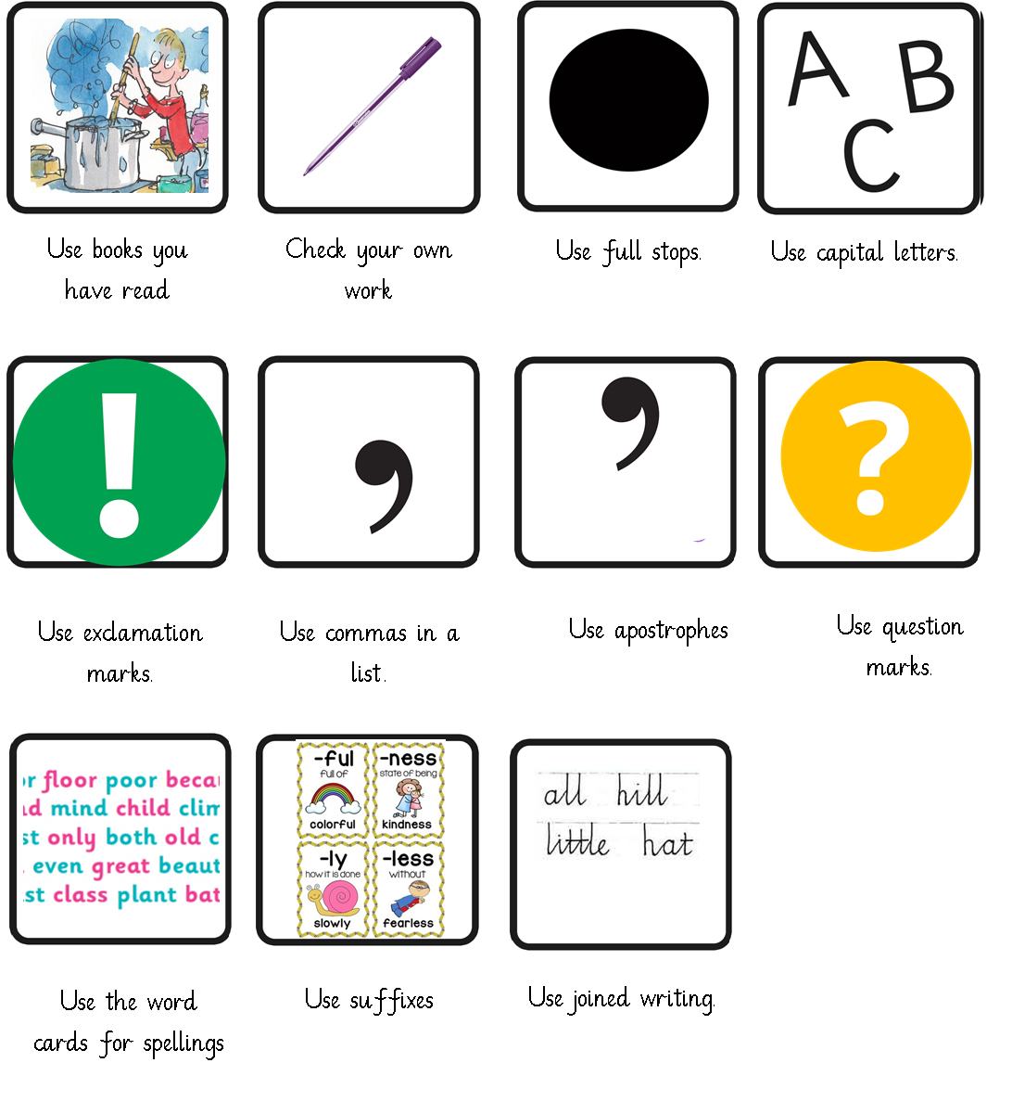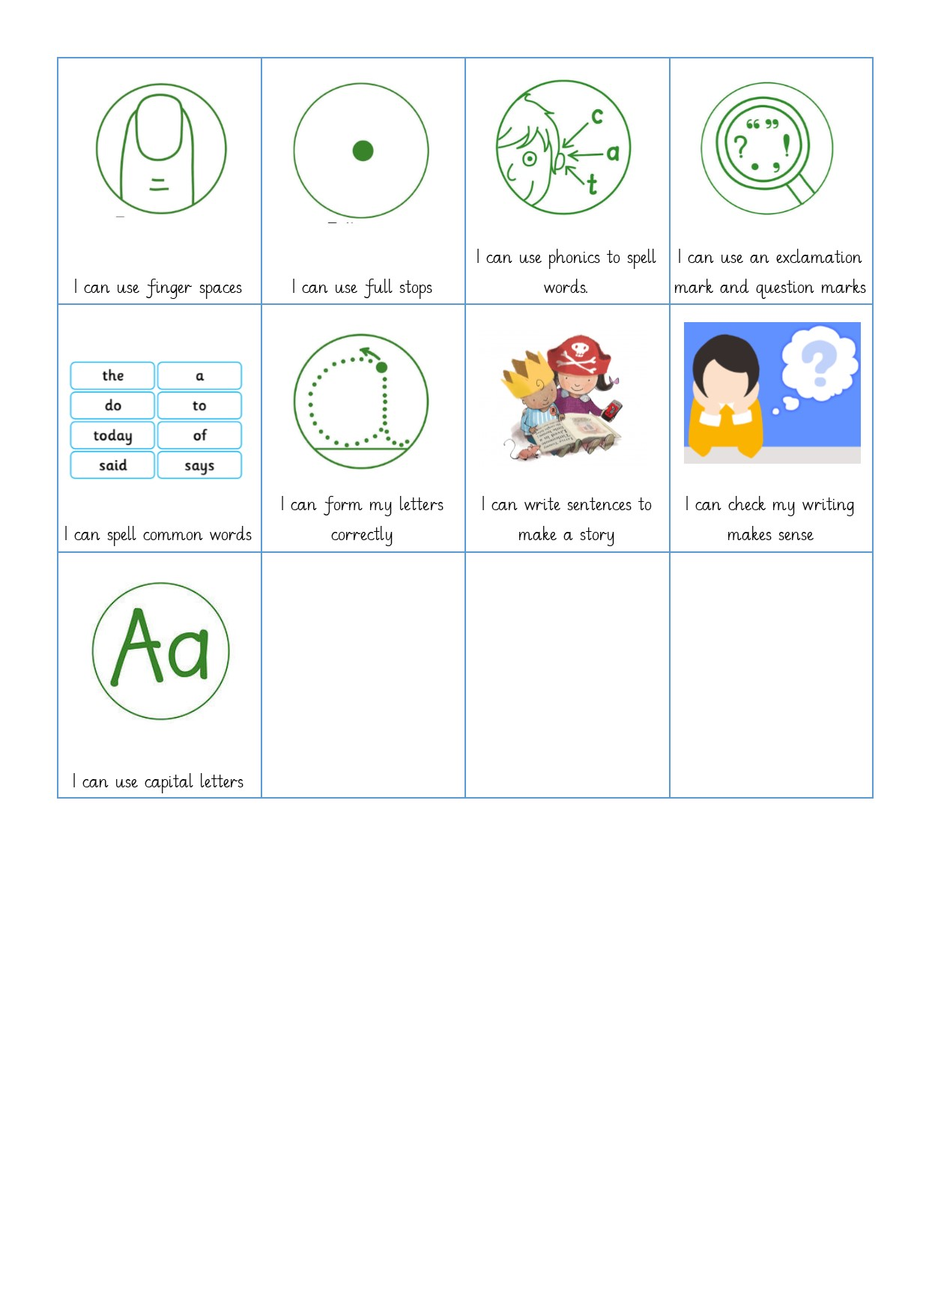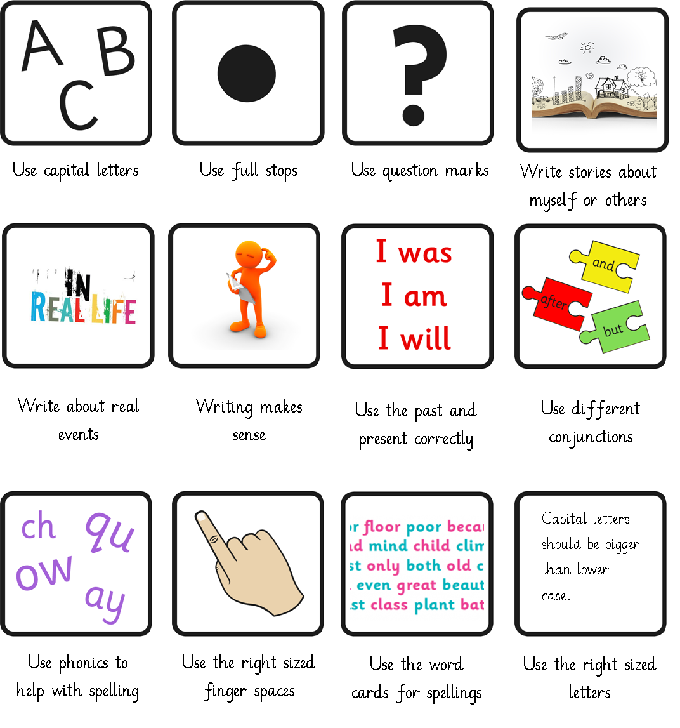
Y1 EXS Y2 EXS Y2GDS
Paragraphs  Headings and subheadings | Correct tense  I go to school.  I went to school.  I have been to school. | First person  Third person  I am happy.  He is happy.  She is happy.  We are happy.  They are happy.
Capital letters  Full stops  A | Other punctuation  ? ! , ‘ “ “ | ‘a’ or ‘an’  a balloon  an apple
Spelling | Conjunctions  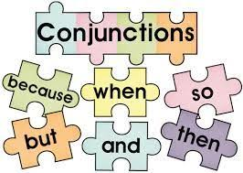 | Adverbs  Prepositions  Where?  When?  How?
Describe characters and setting | Joined handwriting

Y3 EXS

LO: To write my own Greek Myth.

Criteria (non-negotiable):
Has used appropriate grammar and vocabulary.
Has used neat handwriting, with letters joined.
Has evaluated and edited their writing, making changes to vocabulary, grammar and punctuation.
Criteria (specific):
Has described and developed setting, character and narrative.
Has used ellipses…
Has separated clauses using semi-colons or colons.
**Challenge Set**
Has used passive verbs.

LO: To write an instruction leaflet on becoming a Highwayman.

Criteria (non-negotiable):
Has used appropriate grammar and vocabulary.
Has used neat handwriting, with letters joined.
Has evaluated and edited their writing, making changes to vocabulary, grammar and punctuation.
Criteria (specific):
Has used headings, bullet points and underlining to guide the reader.
Has used a colon to indicate the beginning of a list.
Has used modal verbs.
Has structured work using headings, sub-headings, columns, bullets or tables.
Y5 EXS

Maths

In KS1
- The teacher will highlight the learning objective pink or green at the end of a session
- As part of the integrated day the teacher will give verbal feedback to the children as they go
- The teacher will make observations of learning and next steps
- The teacher will mark as they go with children and scaffold and support as necessary
- The teacher will model best methods in the books to support learning

In KS2
- The majority of maths work will be marked by the pupils themselves. Pupils are taught to self-check their work in lessons, as they go along. The teacher then doesn't have to take books home and pupils don't have to wait until the next lesson to find out they have misunderstood a concept.
- The teacher will highlight the learning objective pink or green at the end of a session

- The teacher will always be working with groups of children across the week – and may indeed work with a couple of different groups of children in one lesson. Groupings are therefore flexible and indeed a teacher may have peel away groups after initial teacher input. The groups of children that teachers work with will often be determined as a result of AFL – from the previous lesson to see who needs consolidation or who needs extension etc. We aim to ensure that no child is forgotten and that over the course of time all children will receive some support of some sort from an adult. Teachers need to be aware of all the children in the class and we recognise that whilst children may appear to be getting their maths work correct, they may still need confidence building and that every child can be given support and guidance or extension.
Whilst working with these various groupings in a lesson the teacher – will make observations of learning, support and extend as necessary and will model best methods and make corrections to support learning. They will make written comments in books as necessary. Every child working with the teacher that day will have the teachers initials in a circle in their book.
- In lessons, facilitate opportunities for pupils to check their work throughout the lesson (approx. every 20 mins). At times, the teacher will use a visualiser to model ways of checking that lesson’s problems; for example, show pupils to add numbers in a different order to check their addition
- Use a ‘3 before me’ system for struggling pupils: first they try to fix their mistake themselves, then they ask a peer for help, then a group of their peers, and then finally they ask you
- As with writing, look through the class’s work after the lesson and note down any common mistakes or misunderstandings for the next lesson
- Go through good and (anonymised) bad examples in front of the class at the start of the next session to make teaching points
- At the end of a unit of maths work – there will be a White Rose unit test. The learning objectives covered in the unit will be printed and stuck in maths books. The objectives will be highlighted based on the test and ongoing formative assessment.
Foundation Subjects

- For all activities either during or after a lesson, look through the class's work and note down any common mistakes or misunderstandings. The teacher will look through the work in pupils’ books, and is aware of what has often been misunderstood and uses this for future lessons,
- The learning objective will be highlighted in pink or green to show if the learning objective has been met. If it has been partially met, the L.O will be dashed in pink.
- Comments will be written when the teacher or child can evidence either the greater knowledge that a child is showing through the comments they have made rather than based on the end product. Comments may also be recorded to show he clear misconceptions children have.
- From Y2, an AFL activity will take place before all subjects are taught (e.g science, DT, art, history etc) to find out: What the child knows and what they want to find out. At the end of a unit of work the children will be asked to write down what they now know. This will act as an assessment and will show progress in that subject. This activity will be recorded in books.
- Spelling and Handwriting work will be acknowledgement marked with comments as necessary

Marking keys and editing

Pink and Green are used for all highlighting when marking – Tickled pink, Green for growth.

Teacher comments are written in green

All pupil responses (self marking, peer marking, responding to teacher comments) should be in purple pen.

Marking of Homework
Homework is marked by the class teacher.
CGP workbook homework (maths and grammar) will be marked together as a class at the start or end of a lesson.

Monitoring and evaluation

As part of our regular audits, members of the Senior Leadership Team and Curriculum Leaders will review samples of work and carry out pupil interviews from each class to monitor the implementation of this policy. The Learning Council will regularly review marking and marking may be reviewed by our Network Inspector. This policy will be reviewed by governors annually at the Learning & Teaching Committee.

The desired outcomes for this policy are improvement in children’s learning and greater clarity amongst children and parents concerning children’s achievements and progress.

Document Control

Revision History
Version | Revision Date | Revised By | Revision
1.0 | Autumn 2013 | Govs T&L | Updated
1.1 | Autumn 2014 | Govs T&L | Updated
1.2 | October 2015 | Govs T&L | Updated
1.3 | September 2016 | Govs Achievement | Updated
1.4 | Autumn 2017 | Govs Achievement | Reviewed with pupils, staff & governors & Rewritten
1.5 | Autumn 2018 | Govs Achievement | Reviewed
1.6 | Autumn 2019 | Ann Pelham | Rewritten with DHT and phase leaders

Signed by
 | Name | Signature | Date
Headteacher | Ann Pelham
Chair of Governors | Tim Graveney

Distribution
Shared with
- Staff via school server
- Parents via Website
- Governors via committee meetings

Date for next review
Summer 2020
22

