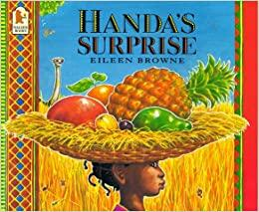
Handa’s Surprise
Your book activity is...
Think about making up your own version of Handa’s Surprise. What fruits would you include in your story? Draw a picture of a basket of your favourite fruits.
Your writing activity is...
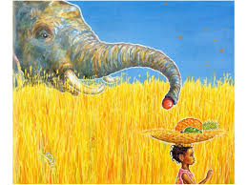
Choose one of the animals from the story and imagine they can talk. What would they say after taking fruit from the basket? Were they really hungry? Are they sorry? Draw a large speech bubble and write what they say in it.
Your maths activity is...
Have a close look at the different fruit you have at home. Think about their shape and size. Think of size and shape words that you can use to describe the fruits. Can you use words such as `curved`, `round`, `straight`, `long`, `short`,`large`, `small` `smaller`, `big`, `bigger`? Can you think of any other size and shape words that you could use? Hide the fruits under a cloth and then use your words to describe one of the fruits. Can your family guess what fruit you are talking about?
