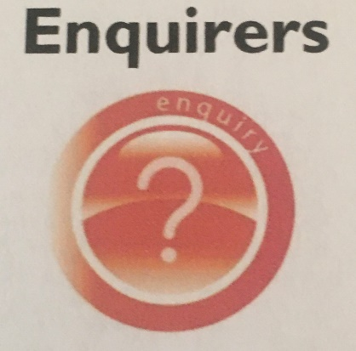 Holly Park Learning Skills - Enquiry
Enquiry is about:
- Looking at learning in new ways
- Deciding which parts of what you have learnt are important
- Finding answers to questions
- Finding problems to solve
- Finding exciting ways to learn something new
- Explaining reasons for your decisions
During Lockdown, many people – adults and children have had a lot more time on their hands and have taken the time to learn new things – perhaps a new language, play an instrument, garden, sew, knit, bake, cook, exercise etc
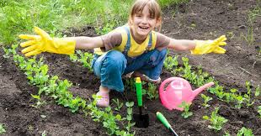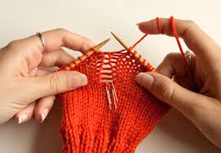
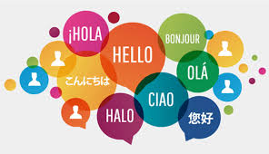
TASK
Draw me a picture or send me a photograph of something new that you have done during lockdown
I look forward to seeing what you have been up to and any new skills you have acquired
head@hollypark.barnetmail.net

