Aboriginal art.
Today we are travelling to Australia, another hot country.

We are learning about Aboriginal art. The first people to inhabit Australia are called Aborigines. Their culture dates back as far as between 60,000 to 80,000 years!! This is when Aborigine’s first settled in Australia.
Dirt called ‘Ochres’ were used to paint on rocks. There was no written language for Australian Aboriginal People so in order to tell their stories they used symbols in their artwork.
The use of symbols is a different way to writing down stories.

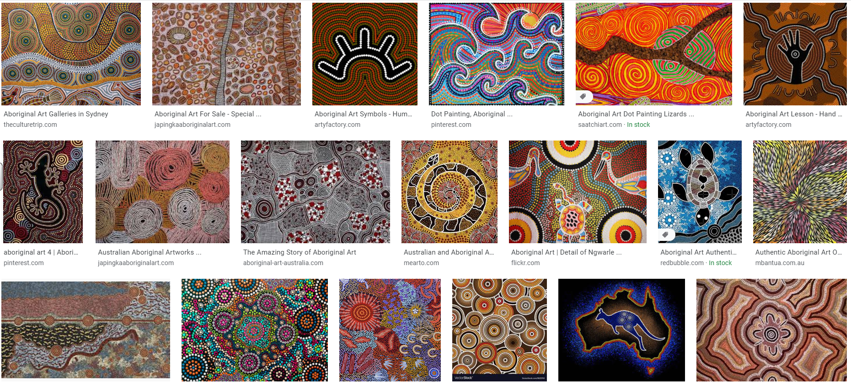

Please recreate your own Aboriginal painting. The Aborigines use hundreds of dots to create their amazingly colourful paintings. Hundreds and hundreds of dots! You will need paper, pencils to draw, paint, cotton buds or fingers. You could copy one from above or create your own. Just remember you aren’t making paint strokes like you would with a paint brush. You are using the end of your finger or cotton bub to dot lots of dots to make a painting.
Please post to the google classroom so we can see your work.

