Hi Year One Thursday 9th July 2020
Next week is the last week of school. Tomorrow in the newsletter, Mrs Pelham will be giving you details about how to join our video chats to say goodbye next week. You will need to logon to the Google Classroom to be able to do it. On Monday, you will be finding out who your new teachers are and you will be able to watch a video of your new teacher in your new classroom. We will be sad to say goodbye to you, but we know what brilliant Year Twos you are going to be, so we are excited at the same time!

READING – We are learning to answer questions and make suggestions on what is being said and done in a familiar book.
At the end of the story think back…What happened to Alice? Why did the ringmaster let Alice go on the tightrope? Look at page 11. Why did the crowd say “Oh no!” when Kat fell from the tightrope? What did they think might happen? When Kat fell on Alice, how do you think Alice felt? How do you think Kat felt at the end of the story? Why do you think that?

LITERACY - We are learning to write poems.
Have a good look at this picture.
How do you think the villagers are feeling?
What do you think they are saying to each other?
Today you are going to write a poem using these ideas. I have given you a sheet on the next page to help you.
It could go something like this…
Thank you for the rain
Now we can eat
Thank you for the rain
It feels like mama’s kisses
Thank you for the rain
Now we feeling like dancing…

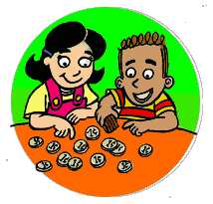
MATHS - We are learning to recognise and know the value of different coins and notes
Today you will be adding multiple coins. It sounds tricky but because a few weeks ago you learnt how to count in two, fives and tens this will be a breeze. I will give you a tip – if you see a 10p, 10p and 10p imagine you are counting 3 tens so 10 + 10 + 10 = 30 but don’t forget the p at the end to make it 30p. Complete the following sheets (again on paper or on your device) and then check your answers on the answer sheet tomorrow.

FOUNDATION SUBJECTS Art – We are learning about art techniques from different cultures.
Today we are travelling to Australia for some Aboriginal dot art.
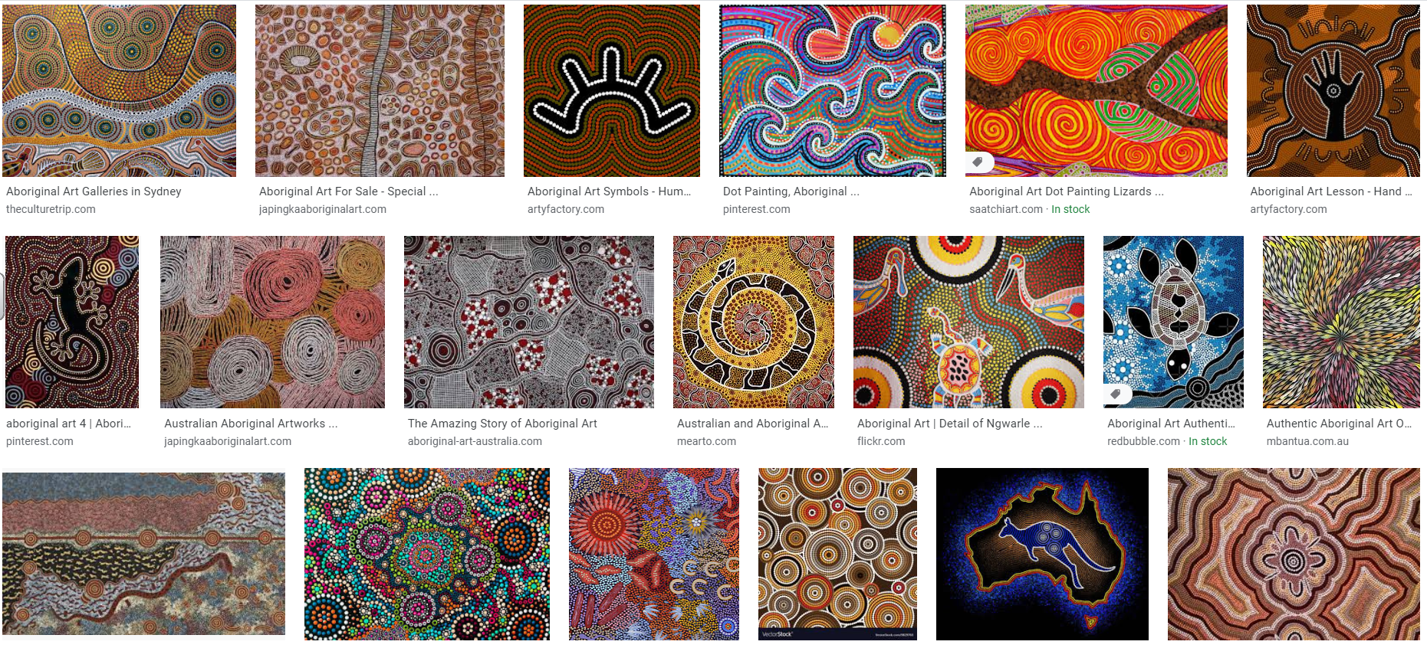
Have a look at the page that’s attached for your activity for today.

Rain Poem by …………………………..

Thank you for the rain
…………………………………………………………..
Thank you for the rain
…………………………………………………………..
Thank you for the rain
…………………………………………………………..
Thank you for the rain
…………………………………………………………..
Thank you for the rain
…………………………………………………………..

