Hi Year One Tuesday 7th July 2020
On Friday, we were going to have our school Sports Day, but as it can’t take place at school, you will have a sports event at home. Remember to wear your house colours. You might even win some house points!

READING – We are learning to read aloud many words quickly and accurately without obvious sounding and blending.
Today we are thinking about fluency with our reading. Making sure you are reading the words you know, not having to sound them out, and making really good attempts at sounding out tricky words. As the week progresses you should be able to read slightly quicker…but remember to stop at the full stops and take a breath!
This book has speech marks. What does this mean? Remember you have to use expression when reading the words in between the speech marks as they show how the character might speak.

LITERACY - We are learning to understand characters in stories.
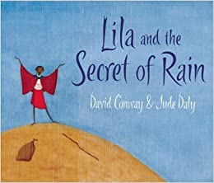
https://www.youtube.com/watch?v=YhfhxhSHZi8
Watch this teacher read the story of ‘Lila and the Secret of Rain’. Did you enjoy the story?
If you met Lila, what would you like to ask her? Think of three questions that you would ask. We learnt how to use question words a few weeks ago, so I hope you remember.
Once you have written your questions, try to think what Lila’s answers might be. Pretend to be Lila and answer the questions.

MATHS - We are learning to recognise and know the value of different notes
Today we will be looking at the big bucks – money notes. It would be very heavy to carry around 500 pennies when you can just carry a £5 note. In our currency we have a £5 note, a £10 note, a £20 and a £50 note. If you buy something for £25 you may use two notes such as a £20 note and a £5 note to make that value. It is helpful and a great thing you guys are super at adding. Complete the sheets on paper or on your computer and then look at the answer sheet to check your work.

FOUNDATION SUBJECTS – Geography – We are learning about countries that are different to the UK.
We are learning about hot and cold countries. Have a listen to the video on the website about hot and cold countries. Would you like to live in one of these countries?

