Hi Year One Monday 6th July 2020
We hope you have had a lovely weekend. Wasn’t it windy?! This week we will be thinking a lot about the weather and about hot and cold countries. Have you been to another country? Where was it? Do you remember what the weather was like? Different countries have different types of weather depending on where they are in the world. What is the weather like today?

READING - We are learning to check that what we read makes sense.
Look at the front cover. Where do you think the story is set? Before you start reading make sure you do steps one, two and three and the bug. Stop at page two. Have you ever been to a circus? Have you seen a circus on tv? What types of performers did you see? Stop at page 4. What do you think might happen next? Read on…were you correct?
There are lots of new or tricky words in this book. Talk with your adult about the words such as graceful, tightrope, clumsy, ringmaster, praised.
Look at page 8. What does concentrate mean? Does the picture help you to understand what the word means?

LITERACY - We are learning to predict what might happen in stories and relate events to our own experiences.
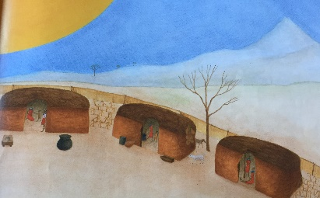
What type of weather do you like best?
What would it be like if the sun always shone and it never rained?
Look at the pictures on the attached slide. What do you see? Where do you think this story is set? Which characters do you think you might find in this story? Do you know another set in a place like this? What do you think will happen in this story?
Watch the video on this link http://www.bbc.co.uk/learningzone/clips/an-introduction-to-kenya/4496.html
How is it different in Kenya to where you live? Either write your ideas down or talk to someone in your house.

MATHS - We are learning to recognise and know the value of different coins
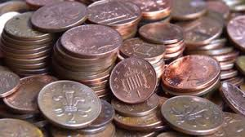
Today we will be looking very closely at coins. Ask your family if you can have a few coins. Do they have any numbers of them? Why might this be important? If a coin has ‘pound’ written on it, that means 100 pennies. So one pound is 100 pennies and two pounds means it is worth 200 pennies. Look at the Power Point and complete the pages. You can write it directly into your device or write the answers on a piece of paper (you do not have to print anything out). When you have finished click on the link below to go through the answers with me. (There are a couple of questions that will ask you to use < and > symbol. We haven’t learnt that yet, so you can leave them out.)
https://youtu.be/W9dyID-UGWo

FOUNDATION SUBJECTS - Science - We are learning to identify some common plants.
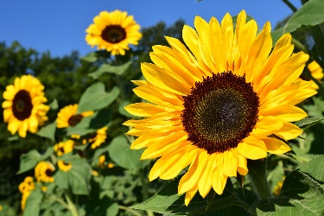
A lot of you have been growing various plants at home and we’ve seen some fabulous photos of your gardens/allotments/balconies/window sills. Unfortunately we haven’t been able to grow plants in class however here are a few amazing time lapse videos of sunflowers growing, cucumber growing and a pea plant growing.
https://www.youtube.com/watch?v=zst08tm9s6M
https://www.youtube.com/watch?v=b93Q0iaKcZM
https://www.youtube.com/watch?v=srhXI2MSR6w

