Hi Year One Friday 10th July 2020
It’s Friday. I remember at the start of lockdown when we wrote our first home-learning sheets for you. We didn’t think we would still be writing them at the end of the school year! There is only one more full week to go until the school holidays. We hope you have a really fun day, especially at our school sports day. Have a great weekend.

READING - We are learning to use our phonic knowledge to sound out and blend to read words accurately.
Today we are going to have a go at sounding out the words in section two in the front cover and having a go at writing them. You are going to write the word, for example, circus. You are then going to put dots under the single phonemes and lines under the digraphs (without looking at the words in the book!) After you have written the words with the lines and dots for phonemes and digraphs check if you are correct. It’s really important when we read to look out for these letter patterns as this helps us to sound out unknown words.

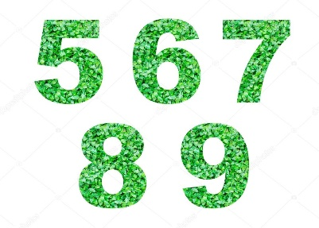
LITERACY - We are learning to form our numbers correctly
https://youtu.be/bn95XtPnUrk
Watch Mrs Thrasyvoulou teaching you how to form the numbers 5, 6, 7, 8 and 9. Remember to sit up straight and to hold your pencil correctly.

MATHS - We are learning to recognise and know the value of different coins
Today you will be making different amounts using coins. I wonder how many different ways you can make the same amount. Complete the sheet as best as you can. Maybe over the weekend you can try and play shops by making money labels for tins from your cupboards, money labels for your teddies or even make labels for your furniture. Let us know how it goes.

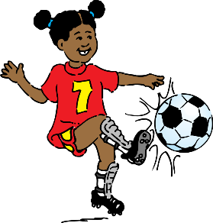
FOUNDATION SUBJECTS – PE
Today is Sports Day!!! Wear your house colours and try out the activities that Mrs Pelham has sent. Take some photos and send them to Mrs Pelham. She will give out housepoints for joining in. There are extra bonus points if your adults join in too!!!

