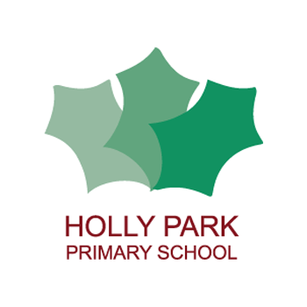Holly Park Nursery
Dear parents/carers,
A big thank you to to everyone who sent in photographs of their sandwich making and picnics. All of the photographs are on the nursery page of the website. We were very lucky with the weather and it was lovely to see all of the children’s smiling faces.
Many children had to think about what shape they were going to cut their sandwiches into. It is really important to use shape names in every day life and to talk about what objects look like. Are they long? Short? Small? Big? How many sides does it have? Can you find another object that is the same shape?
Below are some shape activities that you can do at home.
Enjoy!
Miss Wood
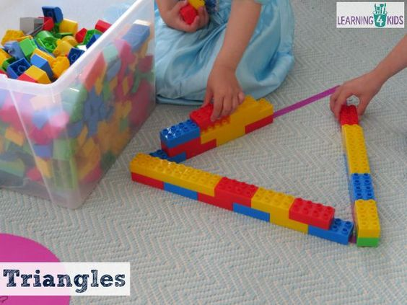
You could do this with all shapes.

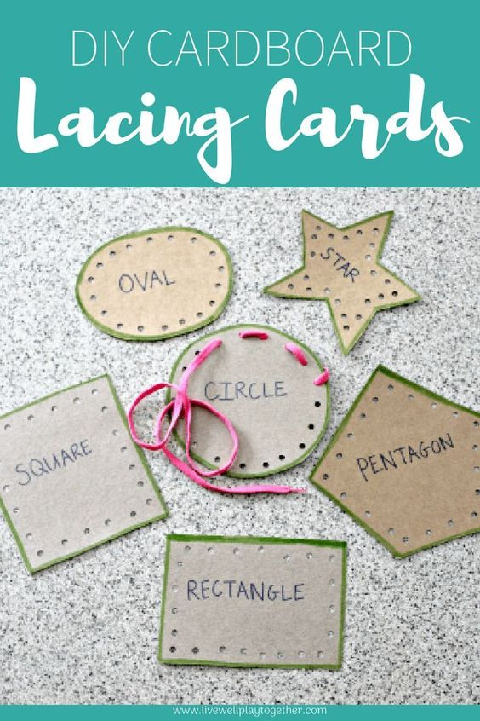
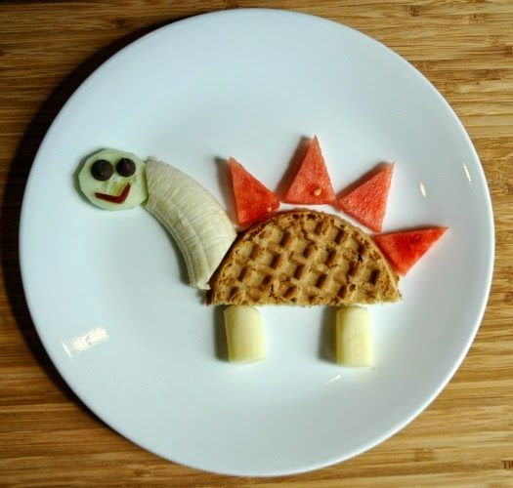
Cutting food into different shapes then creating patterns and pictures
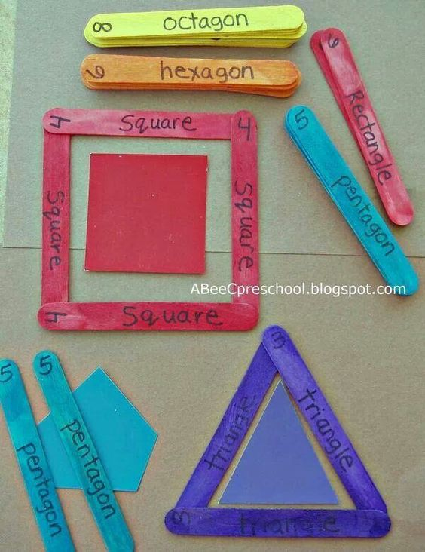
Making shapes with sticks or pipe cleaners

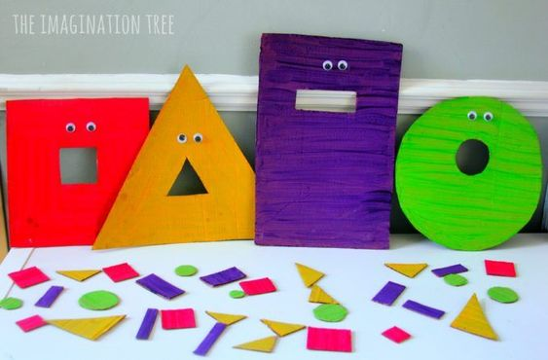
Feed the shape monster!
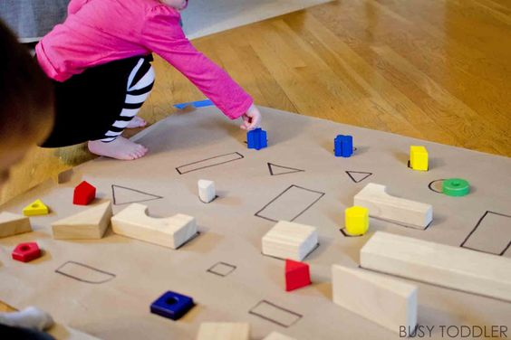

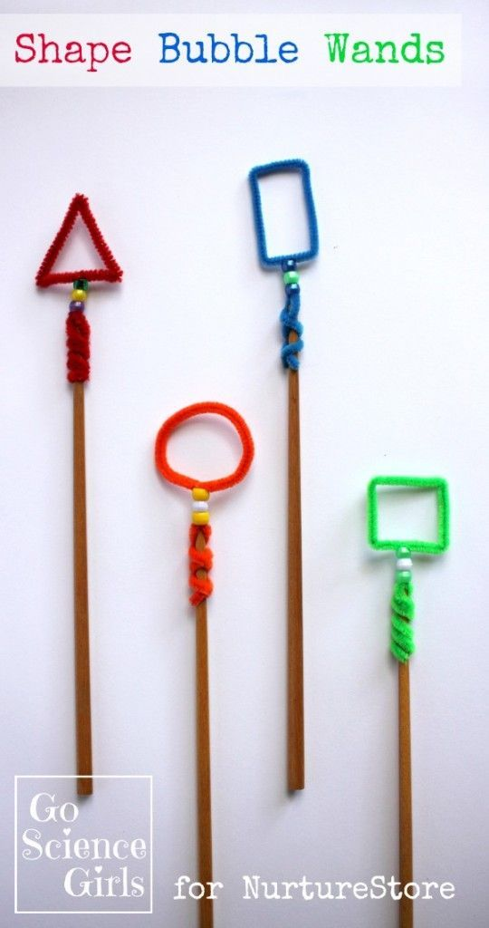
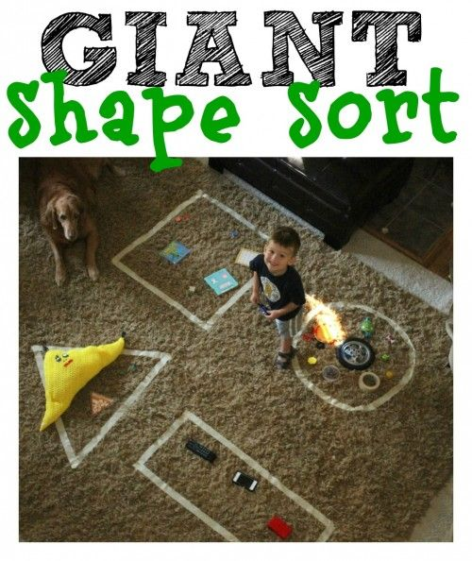
Reading stories

Please continue to read stories to your child every day. There are lots of stories being read by different teachers on the Holly Park website. Here are some of the stories that I have read:

https://youtu.be/kuSIawmqiJw
Sam’s Sandwich

https://youtu.be/UYLwXtdj204
Daddy’s sandwich

https://youtu.be/q6nwIwv_x40
Ruby’s Worry

