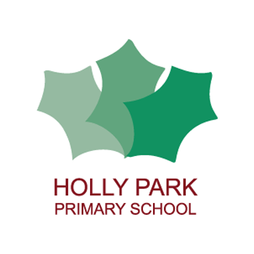Holly Park Nursery
Dear parents/carers,
I hope you have all read the letter about the nursery virtual picnic that is happening this week. Below is the video of me making a sandwich. Each child must watch the video and then make their own sandwich to eat on their picnic.
https://youtu.be/0tjC5rTPE9o
Please send your photos to Mrs Pelham and they will be put on the nursery page of the website. There are some there already! I cannot wait to see you all enjoying your picnic wherever it may be.
Below are some more activity ideas that you can do at home.
Have a lovely week. Enjoy the sun!

Reading stories

Please continue to read stories to your child every day. There are lots of stories being read by different teachers on the Holly Park website. Here are some of the stories that I have read:

https://youtu.be/jl_3eHc6Qyo
Oliver’s vegetables

https://youtu.be/yDPqPbKdCjI
The naughtiest fairy ever

https://youtu.be/2kSS3-zRUuM
The ravenous beast

https://youtu.be/kuSIawmqiJw
Sam’s sandwich

