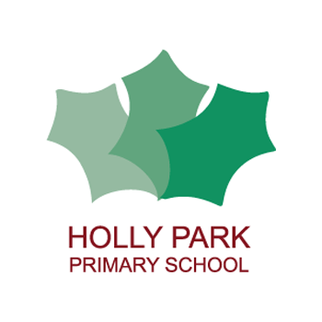Holly Park Nursery
Dear parents/carers,
Last week we looked at children developing their fine motor skills so that they could hold writing equipment correctly when drawing and writing. This week please find lots of mark making activity ideas that you can do at home.
We want children to be experimenting with the marks that they make and to use a variety of mark making equipment. We want the children to be talking about their marks and to begin thinking about the different shapes that they need to draw to ensure that their picture is clear. If children are confident with drawing different types of shapes in their pictures, this will make it easier for them to form letters when writing words.
If your child is showing an interest in writing their name then encourage them to write their name on each picture that they produce. However, if your child is struggling with writing letters, please concentrate on drawing pictures.
Miss Wood
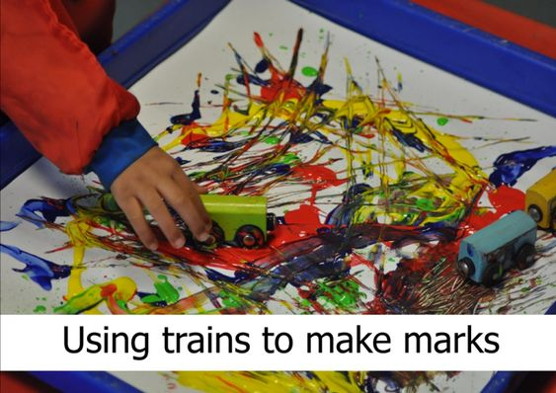
You can also use other vehicles such as cars or fire engines.

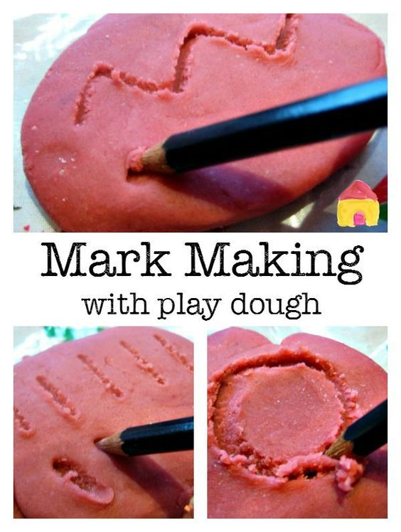
Reading stories

Please continue to read stories to your child every day. There are lots of stories being read by different teachers on the Holly Park website. Here are some of the stories that I have read:

https://youtu.be/ZcsNhI5RJ-8
Pants
https://youtu.be/wlMw_5uwdfk
Peace at last

Thank you so much for the photographs you have sent linked to the stories I read last week. I received a wonderful (and a little bit scary) drawing of a monster by Savannah and an amazing (and huge) model of a rocket from Sophia. I have also received some lovely photos of children’s learning at home. Keep them coming!

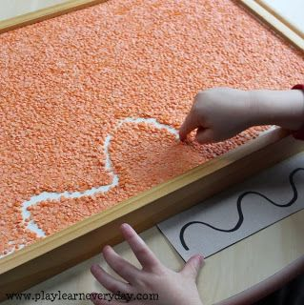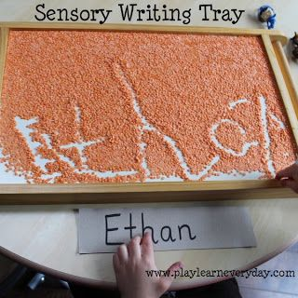
You can also use salt, glitter and corn flour.
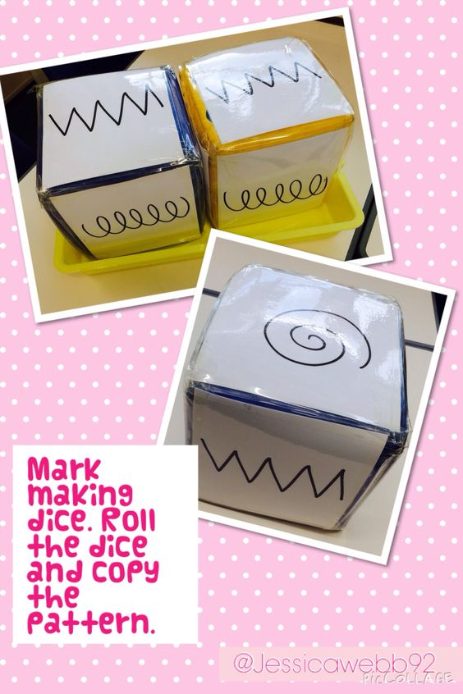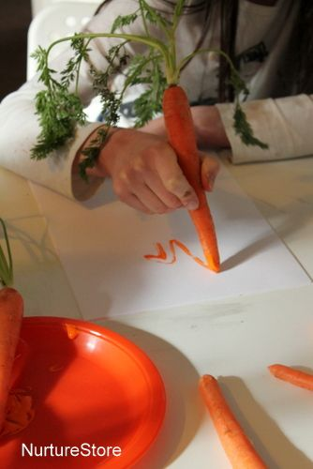
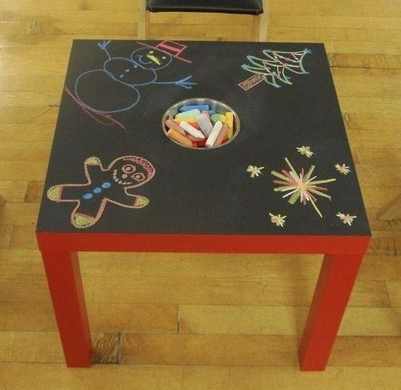
Black card/paper and chalk

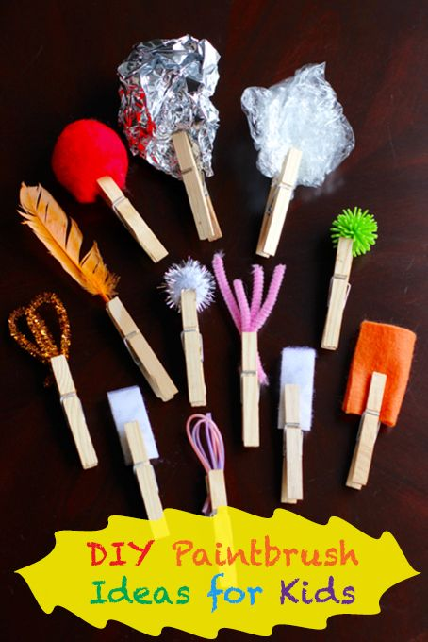

Just having exciting looking writing equipment and paper can make your child excited about mark making. The more colourful and unique looking the bettwer! Here are some ideas:
- Gel pens
- Crayons
- Felt tips
- Pastels
- Pencil toppers on end of pencils
- Biros
- Coloured paper/card
- Envelopes
- Post-its
- Greeting cards
- Diaries/notebooks
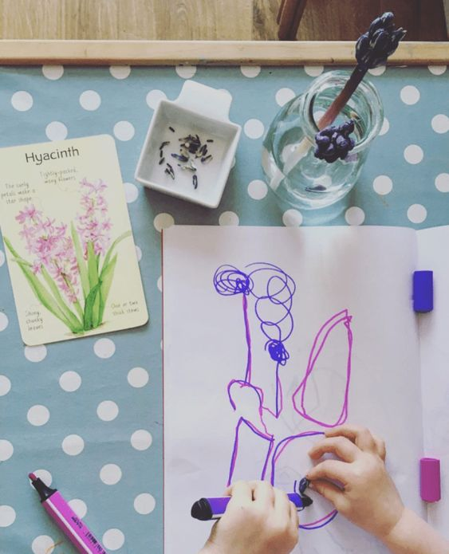
Observational drawing gives your child the opportunity to really examine the object before drawing it. They can talk about the shapes and colours that they will need to draw and use.
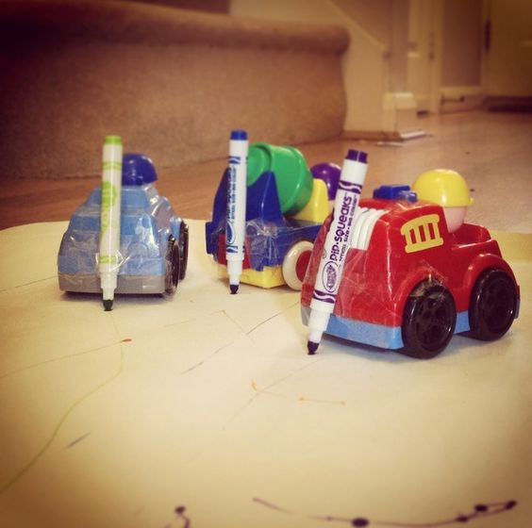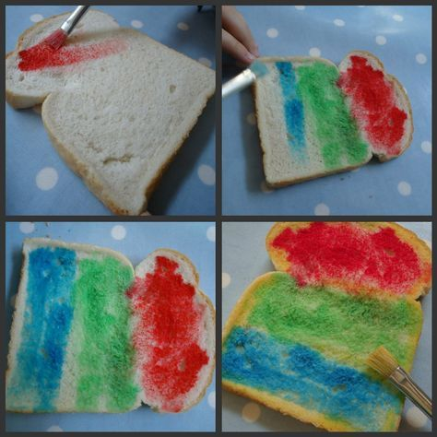
Have a wonderful week!

