Holly Park Nursery
Dear parents/carers,
We want your children to become confident mark makers and in the nursery we always have a variety of activities set up to help support the children’s fine motor skills so that they can hold pens and pencils correctly to draw and write.
Below are some activities that you can do at home that will help strengthen the muscles in your child’s fingers and wrist and help them to become confident mark makers. Even if your child can already hold a pen correctly, it does not mean that they can hold it for a long period of time so these activities will help with this.
It is hard for us adults to be good role models when it comes to holding writing equipment as nowadays we use phones and tablets to make notes and communicate with others. It is good for children to see us using pens and pencils so when you get a chance, sit down and write a shopping list with a pen and piece of paper, make a note of something you need reminding of and put it on your fridge or write a letter to another family member and get your child to give it to them to read. These small tasks will have a big impact on your child’s learning.
Please send any pictures of your child mark making or taking part in fine motor activities to Mrs Pelham so that she can send them on to me. I look forward to seeing them!
Miss Wood Making holes in paper with pins
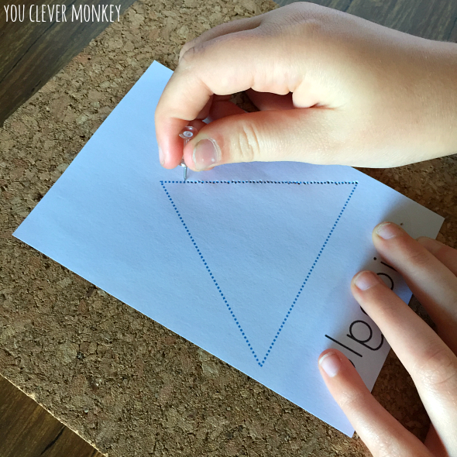
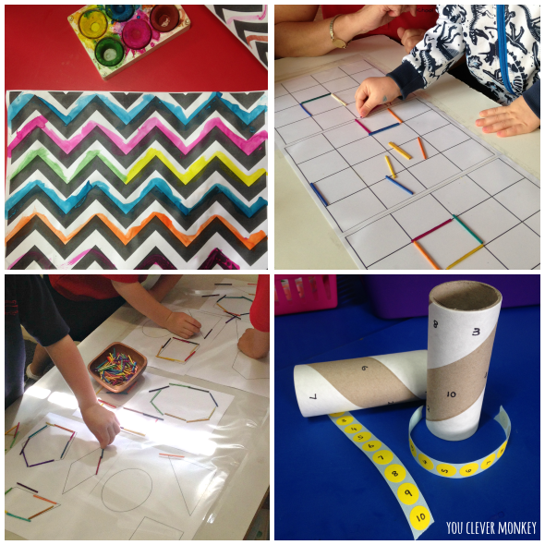

Reading stories

Please continue to read stories to your child every day. There are lots of stories being read by different teachers on the Holly Park website. Here are some of the stories that I have read:

https://youtu.be/eAlaXi4NPdc
Captain Duck

https://youtu.be/JfGbin9cDEg
Whatever Next

https://youtu.be/QMosAGvmiTQ
Monstersaurus

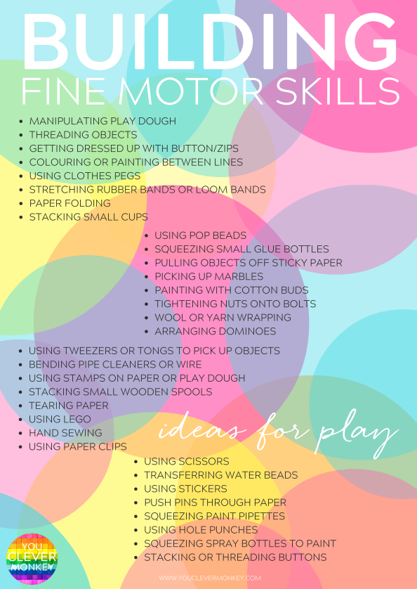

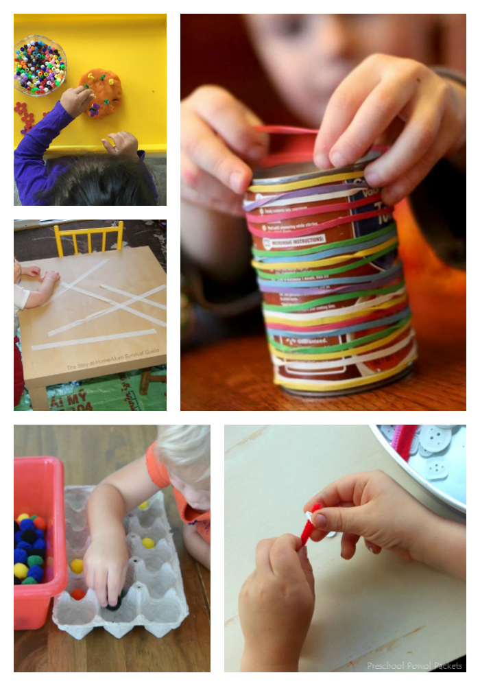
Threading is really good for children’s hand-eye coordination. In the nursery the children love threading cheerios/wheetos onto pipe cleaners.
Stacking sugar cubes is another fund activity. How tall can your child make their tower of sugar cubes before they fall down?

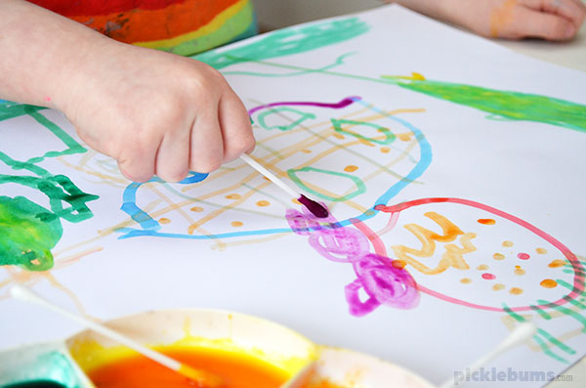
Painting with cotton buds
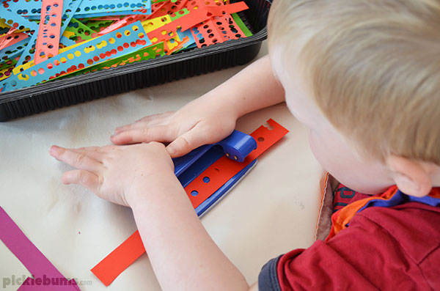
Using a hole punch

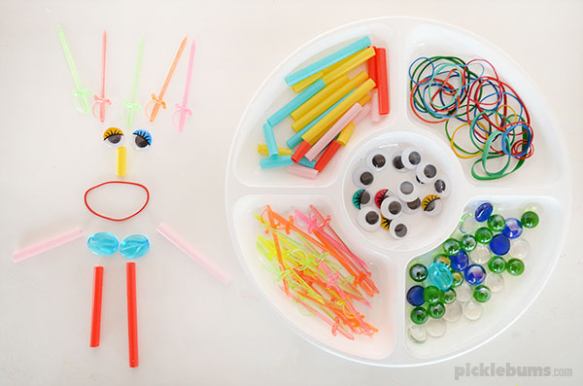
Loose parts play
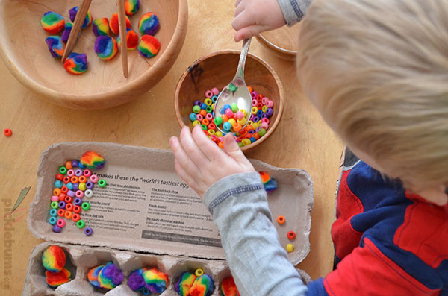Using spoons and tweezers
I hope these ideas are useful.
Have a fantastic week and please do email Mrs Pelham if you have any questions.
Enjoy!

