Holly Park Nursery
Dear parents/carers,
I hope that you are all safe and well and that you all had a lovely half term. The weather has been beautiful which means there are lots of opportunities for outside learning. Why don’t you try some of these…?
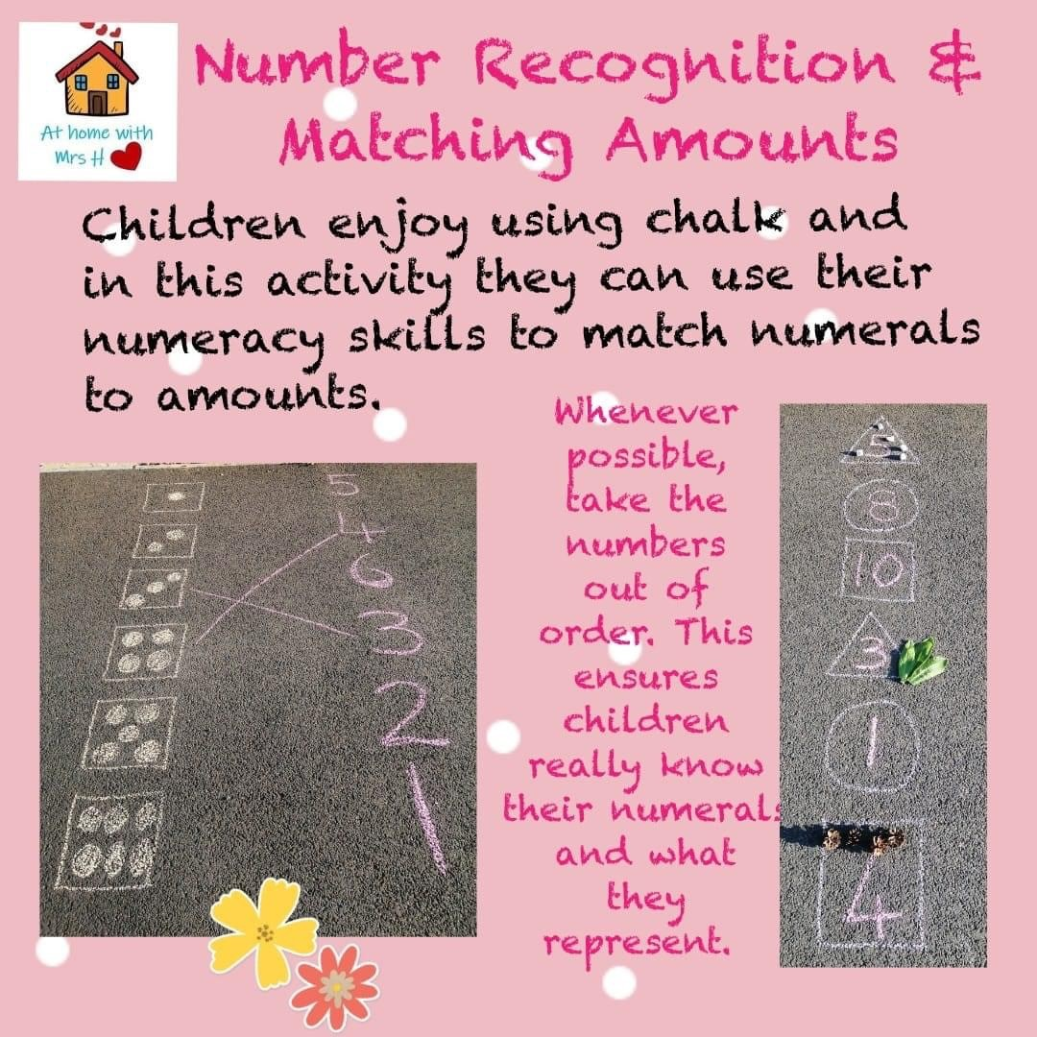
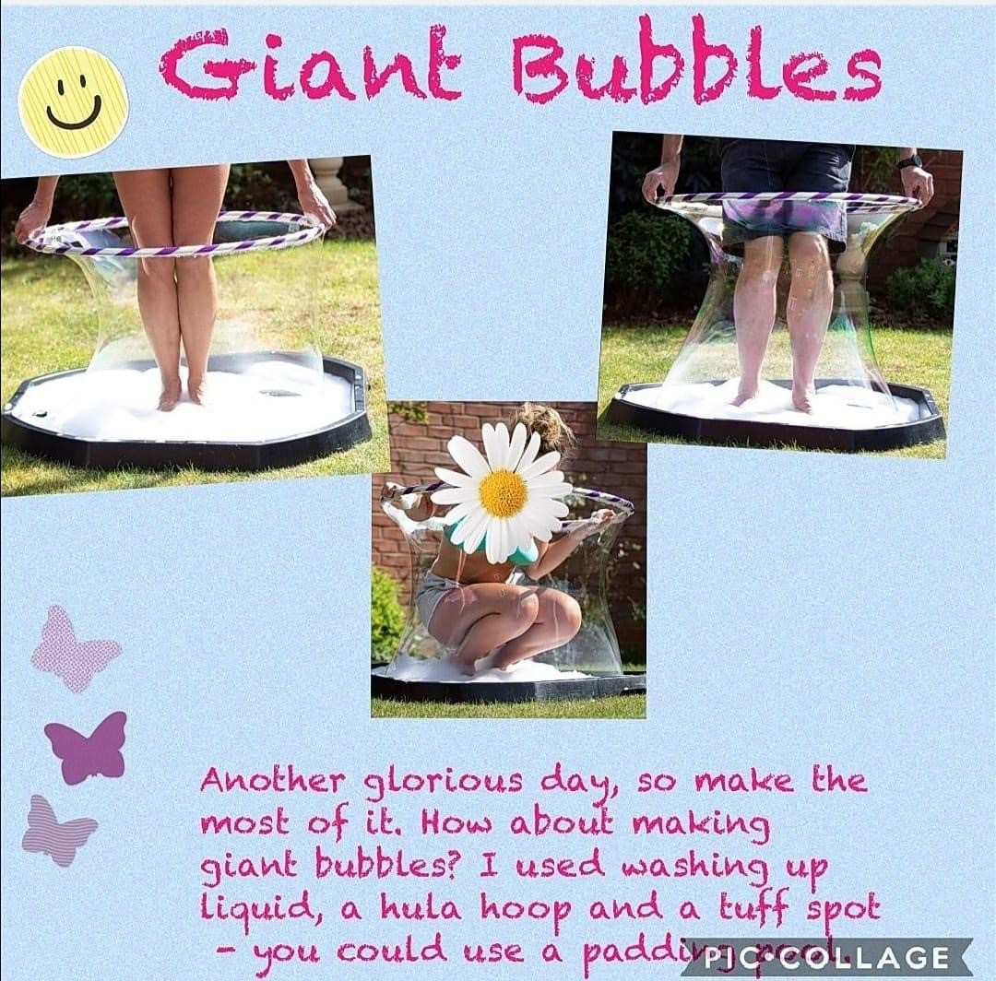
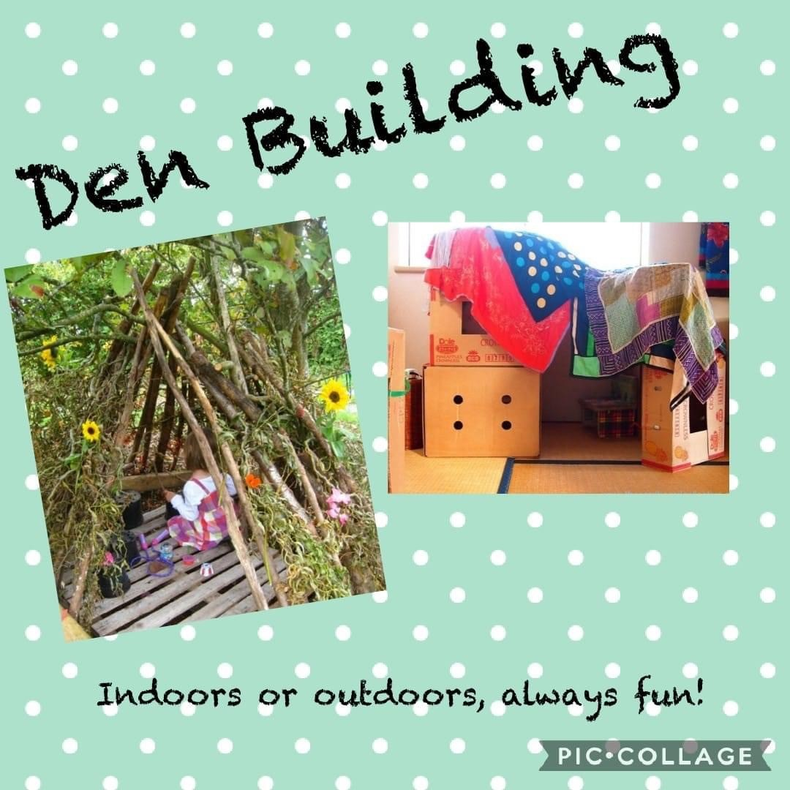
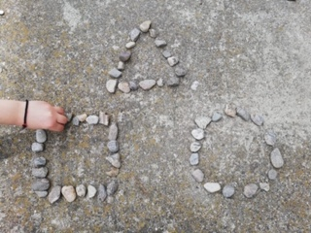

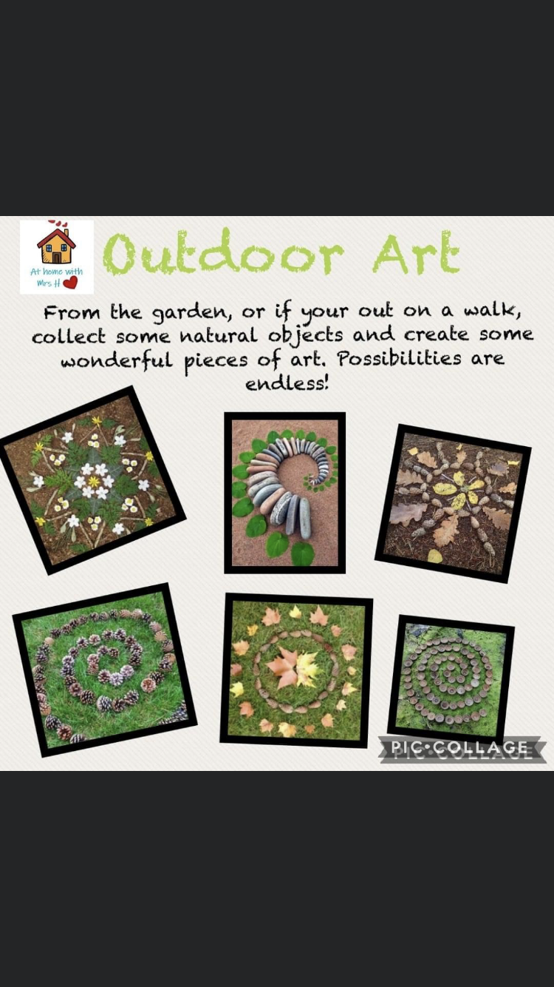
Reading stories

Please continue to read stories to your child every day. There are lots of stories being read by different teachers on the Holly Park website. Here are some of the stories that I have read:

https://youtu.be/YJbe4J4UloY
The ugly duckling

https://youtu.be/q0Zxs87nna4
The Gingerbread Man

Fizzy Lemonade
When life gives you lemons… make fizzy lemonade!!

Recipe:
Add baking powder to a large mixing bowl.
Add a few drops of water.
Squeeze a lemon and watch the FIZZZZZZ
Then add a few drops of yellow food colouring to water and add to your large mixing bowl to make your lemonade

(Unfortunately, even though this looks good enough to drink, I wouldn’t advise it!)

I hope you enjoy giving some of these activities a try. Please send any photographs of the learning that you do to Mrs Pelham and she will forward them on to me.
Have a good week!
Miss Wood

