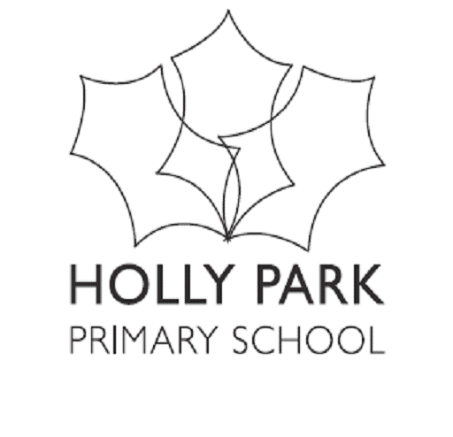
Bellevue Road, Friern Barnet, London N11 3HG
t: 020 8368 1434 e: office@hollypark.barnetmail.net
www.hollyparkschool.co.uk
Dear Parents / Carers,
I just wanted to write to you to welcome you officially to Holly Park School. We are delighted that you have chosen to send your child to our school.

So far, you will have received from Barnet an offer of a place for your child. I can see from our system that many of you have accepted the offer but some have not yet. Please can I remind you that you need to make your decision about your school place before the deadline or the places can be removed by Barnet and offered to other children who are on our waiting list.

As you will be aware, schools across the UK are closed at the moment due to the Corona Virus. At this point we have absolutely no idea when schools will return fully and even when they do, how far it will be business as normal.

Parent Meeting
In normal circumstances we would hold a parent evening for you to come and collect a pack, meet staff and hear about some important information. The date we had planned this for was Monday 22nd June. If we are able to do so of course this meeting will still happen –if not, we will email the packs out to you and arrange another meeting for September.

Classroom Visit
In addition, we also invite your children to come in and visit our Reception Class at a time when the other children are not here. This is an opportunity to see the environment and meet the staff. We had scheduled the dates for these to be Friday 17th July at 9.30am. Again, we are not sure if these will be able to go ahead but will keep you informed

Home Visits
We also arrange home visits so that members of staff can come and meet you and your child in their own environment. This allows you to tell us specific things about your child that you feel we should be aware of and it is a nice and easy environment for the children to be relaxed with the staff. Usually we do these at the beginning of September. Schools are unsure if these will be able to go ahead.

Start Dates
We are assuming that schools will open as normal in September. Our Reception children do not all start back together. We stagger them in and run a settling in process over a couple of weeks. Although you will be given a start date for your child – please be advised that this is PROVISIONAL and is likely to change as we may need to push start dates back in order to make the necessary home visits in September before children can attend and also follow government guidelines.

We hope you and your families are all well and we are very sorry for any disruption that this may cause you as it is unlikely we will be able to follow our normal process due to the virus. This is a difficult time to have a child about to start school but we will do our best to provide as much information to you as possible.
I look forward to meeting you and your children as soon as possible
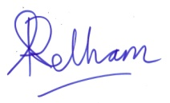
Mrs. Ann Pelham
Head Teacher

