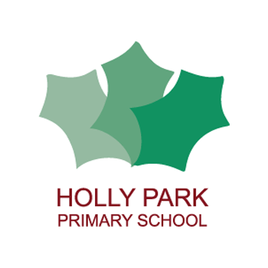Holly Park Nursery
Dear parents/carers,
What a strange half term it has been! I hope you are all safe and well. Myself, Miss Rush, Mrs Elia and Mirsije are missing the children very much. Mrs Pelham has been forwarding me the photographs and messages you have been sending which I have loved. I am glad to see that lots of the children have been enjoying the stories that I have been reading and I hope that they have enjoyed watching the Duck Pond videos. I have one more very special one today!
Next week is half term but I will be back in contact the week after. If you need to contact me, please email Mrs Pelham and I will get back to you as soon as I can.
Miss Wood
Baby animals
THE EGGS HAVE HATCHED!!
Below is a video of what I found when I went to the pond on Friday. The vi-deo is silent. Encourage your child to talk through what they can see using full sentences. Ask them questions such as:
- What colour are the baby geese?
- How many are there?
- What other babies can you see?
- What is the daddy goose doing?
- What do you think the babies might eat?

https://youtu.be/UDRkk7tO9X8

Phase One Phonics
In nursery we do phase one phonics. Children need to be confident in all aspects of phase one before learning to read and write. You can find more information on the Letters and Sounds website which is on the nursery newsletter. Here are three activities that you can do at home.
- Roly poly Rehearse the rhyme with the actions (rotating hand over hand as in the song ‘Wind the bobbin up’).
Ro … ly … po … ly … ever … so … slowly Ro … ly … poly faster. (Increase the speed of the action as you increase the speed of the rhyme.)
Now add in new verses, such as: Stamp … your … feet … ever … so … slowly Stamp … your feet faster. Ask the children to suggest sounds and movements to be incorporated into the song. Say hello ever so quietly Say HELLO LOUDER!
- Playing with words Gather together a set of familiar objects with names that have varying syllable patterns (e.g. pencil, umbrella, camera, xylophone). Show the objects to the children, name them and talk about what they are used for. Wait for the children to share some of their experiences of the objects; for instance, some of them will have used a camera. Then encourage them to think about how the name of the object sounds and feels as they say it. Think about the syllables and clap them out as you say each word. Then clap the syllables for a word without saying it and ask: What object could that be?
- Bertha goes to the zoo Set up a small toy zoo and join the children as they play with it. Use a toy bus and a bag of animal toys with names starting with the same sound (e.g. a lion, a lizard, a leopard, a llama and a lobster) to act out this story. Chant the following rhyme and allow each child in turn to draw an animal out of the bag and add an animal name to the list of animals spotted at the zoo.
Bertha the bus is going to the zoo, Who does she see as she passes through? … a pig, a panda, a parrot and a polar bear.

Activity ideas in photographs

Nature potions!

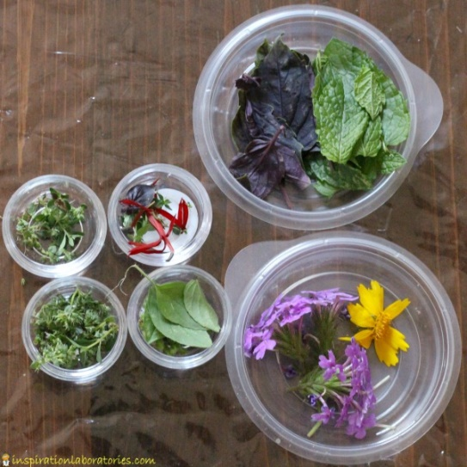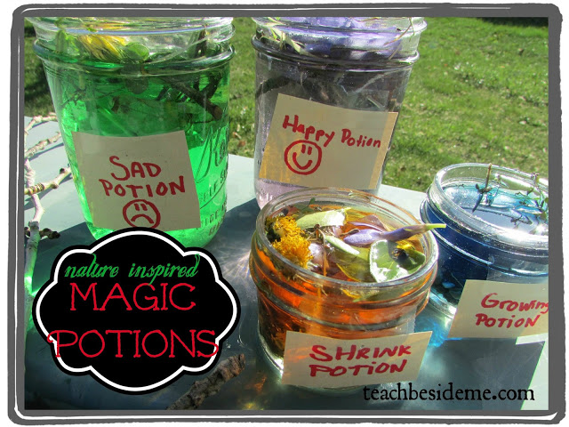

PENPALS for Handwriting
Every week the children do exercises that help to develop the strength in their arms, wrists, hands and fingers. This helps with pen grip which leads them to become good writers. Here are this weeks exercises:

https://youtu.be/RgPdQuQo4PU

https://youtu.be/g3uAoF9TtMo

More activity ideas!

Garden play | Create a ‘potion or perfume’ using an old bowl and spoon, leaves, sticks, mud, daisies etc… Practise using scissors to snip ‘ingredients’.
Counting with a ball | Throw, catch, roll and bounce a ball backwards and forwards. Each person to count in sequence.
Creating a ‘dried food’ picture | Use dried pasta, rice, herbs, lentils, seeds to create a picture of pattern. Lovely sensory activity! You can use glue if you wish.
Guitar fun! | Make different guitars using elastic bands around different shaped boxes. Discuss sounds and shapes you can see within 3D objects
Daily walk: Stone sorting | Find stones and pebbles on your daily walk. Once home, how can you sort them? By colour, shape, size. How many do you have (Remind children to never put stones in their mouth!)
Car colours | Create a simple tally chart with colours on one side of the paper. Record down which colour cards go by. This could be completed at home or during a daily walk.
Small World Play | Set up a play experience using toys you have at home or loose parts play such as twigs, logs, pebbles etc… Ideas include; train track, farm, hospital etc… Create a story together. Adult to record the story which is then shared at story time or bedtime.

Reading stories

Please continue to read stories to your child every day. There are lots of stories being read by different teachers on the Holly Park website. Here are some of the stories that I have read:

https://youtu.be/sLnNB4f6wtw
The trouble with dad

https://youtu.be/z9kUdyoPT4I
Aliens love underpants

https://youtu.be/Q5JfIbVsCck
Brown bear brown bear what do you see?

Useful links

Please Mr Crocodile phonics game
http://youtu.be/w1NvuYDqBBI

Developing listening skills
http://www.bbc.co.uk/teach/school-radio/eyfs-listening-skills/zbc4y9q

Letters and Sounds – Aspect 2
https://m.facebook.com/story.php?story_fbid=2862220490480307&id=790520820983628

Enjoy your half term!

