Holly Park Nursery
Dear parents/carers,
Below are some more activity ideas. These include story videos, Penpals handwriting and Letters and Sounds Phase one activities. These are things we would be doing every day at nursery so please find time to do them at home if you can. I have had some lovely emails and photographs sent to me through Mrs Pelham’s email address so thank you so much for those. They really make me smile! Hope you are all ok and happy and I’m sure I will speak to you soon.
Enjoy!
Miss Wood
Baby animals
I still visit the duck ponds near to my house every day and I am still waiting for the eggs underneath the Canada goose to hatch! I have also found some more babies… Parents, please talk to your child about what they can see and what is happening. The Egyption Geese are getting so big!

https://youtu.be/cuxBDtGrNwI
Canada Goose update
https://youtu.be/iNmwnz4p9Is
Egyption Geese sleeping
https://youtu.be/76_qx8EmOlw
Egyption Geese awake
https://youtu.be/_64dWdBcMjc
What other baby animals did I find???

Phase One Phonics
In nursery we do phase one phonics. Children need to be confident in all aspects of phase one before learning to read and write. You can find more information on the Letters and Sounds website which is on the nursery newsletter. Here are three activities that you can do at home.
- Oral blending It is important that the children have plenty of experience of listening to adults modelling oral blending before they are introduced to grapheme–phoneme correspondences. For example, when giving children instructions or asking questions the adult can segment the last word into separate phonemes and then immediately blend the sounds together to say the word (e.g. It’s time to get your c-oa-t, coat! or Touch your t-oe-s, toes! Who can touch their f-ee-t, feet?) Use only single-syllable words for oral blending.
- A listening moment This is another activity that can take place indoors or outdoors. Remind the children how to be good listeners and invite them to show how good they are at listening by remembering all the sounds they hear when they listen for a moment. It may be useful to use a sand timer to illustrate, for example, the passing of half a minute. Ask them what made each sound and encourage them to try to make the sound themselves.
- Story sounds As you read or tell stories, encourage the children to play their instruments in different ways (e.g. Make this instrument sound like giant’s footsteps, … a fairy fluttering, … a cat pouncing, … an elephant stamping). Invite them to make their own suggestions for different characters (e.g. How might Jack’s feet sound as he tiptoes by the sleeping giant? And what about when he runs fast to escape down the beanstalk?). As the children become familiar with the pattern of the story, each child could be responsible for a different sound.

Activity ideas in photographs

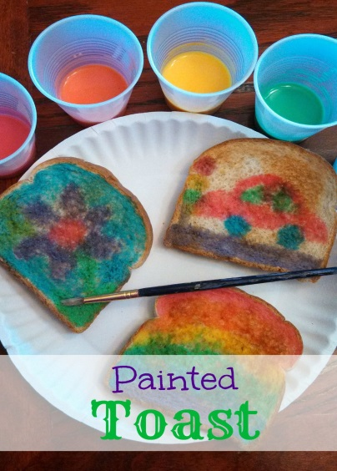
Oil in a tray – add blobs of coloured water…
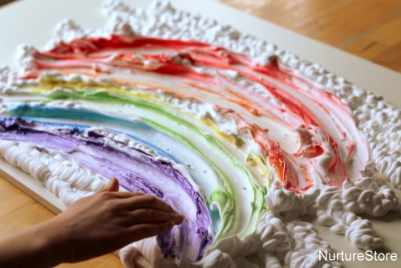 Shaving foam and paint
or food colouring

PENPALS for Handwriting
Every week the children do exercises that help to develop the strength in their arms, wrists, hands and fingers. This helps with pen grip which leads them to become good writers. Here are this weeks exercises:

https://youtu.be/hNKi2yi_JI0

https://youtu.be/v2jV2tjY8tU

https://youtu.be/x3hVSL9IlM8

Number hunt at home

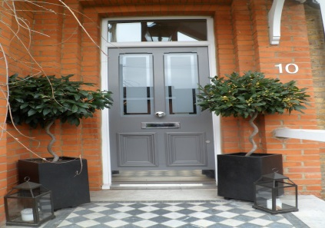 | Door numbers – Can you find your door number? Do you know what number it is? Now take a look at the numbers on your friends and family members doors. Are they the same or different? What do you notice about the numbers of your neighbour’s doors? Can you see a pattern?
 | Bus numbers – Buses have a number on the front. What do you think these numbers are for? Go to the bus stop beside your house. Which buses pass by? Can you write the number or take a photo of the number on the bus stop or on the buses?
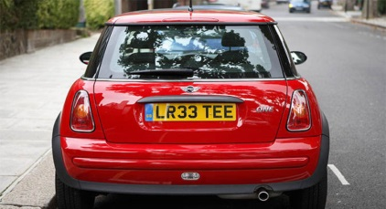 | Car license plate numbers – Each car has a special number that is only for them. We can see this number on the license plate of the car at the front and back. Do you have a car? Which numbers can you see? What numbers can you find on the cars in the street or car park?
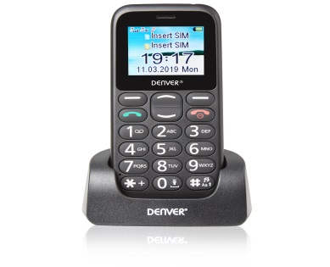 | Phone numbers – We use our phones every day for communicating with other people. Each phone has it’s own special number. Do you know any of the numbers for your family phones? What other important phone numbers do you know?

Reading stories

Please continue to read stories to your child every day. There are lots of stories being read by different teachers on the Holly Park website. Here are some of the stories that I have read:

https://youtu.be/qdZODgdwG9o
The trouble with mum

https://youtu.be/yEljGnhsc-U
We’re going on a bear hunt

Useful links

For those of you with children in the Early Years and in Years 1 and 2, the DfE have produced some you tube videos for teachers and parents on the teaching of phonics, Letters and Sounds. These can be accessed by clicking the link below.

https://www.youtube.com/channel/UCP_FbjYUP_UtldV2K_-niWw/videos

The BBC Bitesize website has a wealth of lessons and activities which are added to each day which the children may like. These can be accessed by the following link:

https://www.bbc.co.uk/bitesize

Also please see the latest guidance from the DfE on what parents and carers need to know about schools and education during the coronavirus outbreak.

https://www.gov.uk/government/publications/closure-of-educational-settings-information-for-parents-andcarers/closure-of-educational-settings-information-for-parents-and-carers

Look back on the nursery page of the Holly Park website for more ideas next Wednesday.

