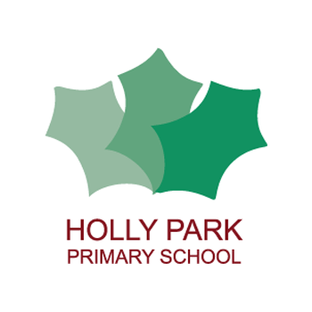Holly Park Nursery
Dear parents/carers,
I hope you have enjoyed trying some of the activities I have sent out. I have received some lovely photographs of the children playing this week. Keep them coming! Please send any photographs of your children learning through play to Mrs Pelham.
Below are some more activities for you to try and videos for your child to watch.
Enjoy!
Miss Wood
Baby animals
I hope the children have enjoyed watching the videos from last week. Below are some follow up videos. The baby Egyption Geese are getting very big and the Canada goose is still sitting on her nest. I have also put a video of a very noisy baby Coot and a video of beautiful Mandarin ducks.

Egyption Geese update
https://youtu.be/V9QCTyJKHRU
Canada Goose update
https://youtu.be/yXUanGkkQ_I
Baby Coot
https://youtu.be/jzl4dR8r5gk
Mandarin ducks
https://youtu.be/fkYysyEr9UE

Phase One Phonics
In nursery we do phase one phonics. Children need to be confident in all aspects of phase one before learning to read and write. You can find more information on the Letters and Sounds website which is on the nursery newsletter. Here are three activities that you can do at home.
- Listen to the beat Use a variety of percussion instruments to play different rhythms. Remind the children to use their listening ears and to move in time to the beat – fast, slow, skipping, marching, etc. Keep the beat simple at first (e.g. suitable for marching) then move on to more complex rhythms for the children to skip or gallop to.
- Sounds around – Alliteration Make sure that word play with initial sounds is commonplace. Include lots of simple tongue twisters to ensure that children enjoy experimenting with words that are alliterative. Use opportunities as they occur incidentally to make up tongue twisters by using children’s names, or objects that are of particular personal interest to them (e.g. David’s dangerous dinosaur, Millie’s marvellous, magic mittens).
- Making trumpets Make amplifiers (trumpet shapes) from simple cones of paper or lightweight card and experiment by making different noises through the cones. Model sounds for the children: the up and down wail of a siren, the honk of a fog horn, a peep, peep, peep of a bird. Contrast loud and soft sounds. Use the trumpets to sound out phonemes that begin each child’s name

Activity ideas in photographs

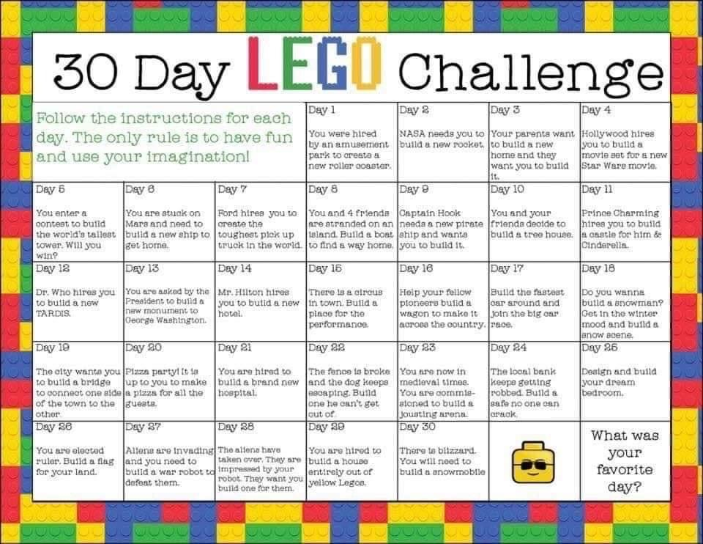
Masking tape painting
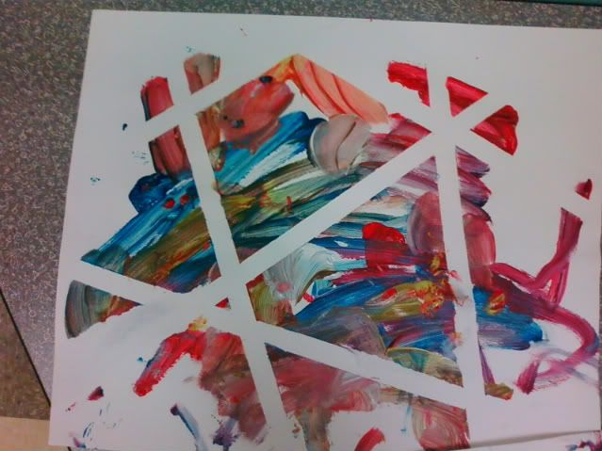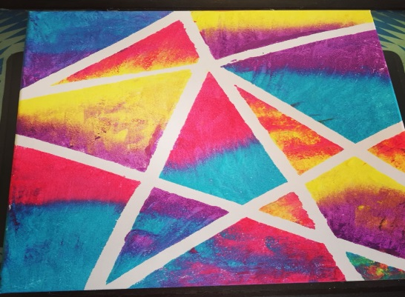

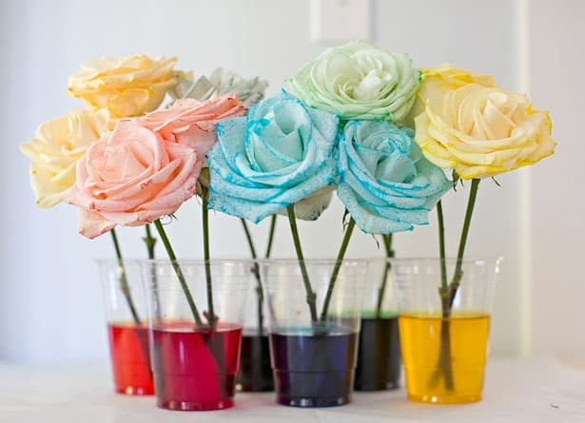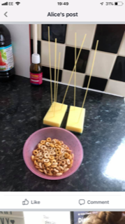
Dying flowers experiment Sponge, spaghetti, cheerios

PENPALS for Handwriting

Every week the children do exercises that help to develop the strength in their arms, wrists, hands and fingers. This helps with pen grip which leads them to become good writers. Here are this weeks exercises:

https://youtu.be/zy53YJyOOSA

https://youtu.be/Pd3LM5z6ST4

https://youtu.be/eA6eKxBeK7k

https://youtu.be/fNI5RYtZKbk

Kitchen Maths at home 2

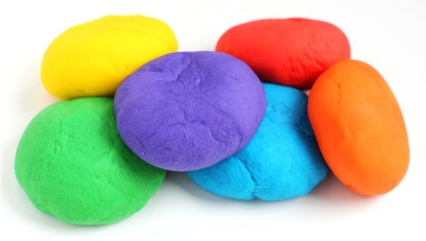 | Make some playdough – Making playdough gives an opportunity to talk about measuring and weight as children make the dough.  2 cups plain flour, 2 tablespoons vegetable oil, half a cup of salt, 2 tablespoons of cream of tartar, 1 to 1.5 cups of boiling water, food colouring. Mix the flour, salt, cream of tartar and oil in a large mixing bowl. Add food colouring to the boiling water then into the dry ingredients. Stir continuously until it becomes a sticky, combined dough. Allow it to cool down then take it out of the bowl and knead it vigourously for a couple of minutes until all of the stickiness has gone. Keep in an airtight container. There is also a playdough recipe on the nursery page of the website in the initial Lockdown letter.
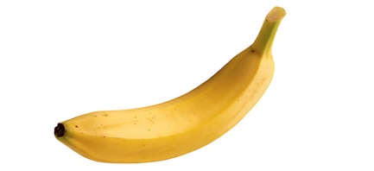 | Banana challenge – Each person in the family has a banana. The challenge is to see who can cut the banana into the most pieces!  Aside from counting and comparing numbers, fine motor skills will also be developed! Ready… steady…GO!!
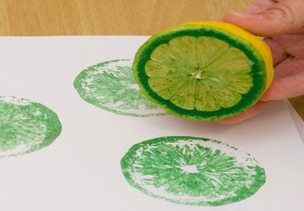 | Fruit printing – Explore ‘halves’ as children cut selected pieces of fruit/veg into two equal pieces (apples, kiwi, pears, potatoes, onion) Now you can choose to eat… or print! Dip your cuts into paint and get creative. Maybe you can even print a pattern!
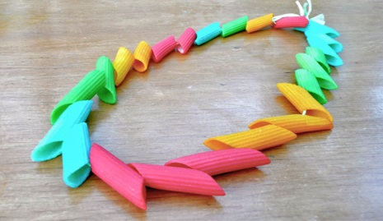 | Pasta necklaces – Counting and patterning are Maths skills that can be explored as your child threads a pasta necklace. Use dried pasta tubes of different sizes and get threading.  You can dye the pasta to make it more interesting.

Reading stories

Please continue to read stories to your child every day. There are lots of stories being read by different teachers on the Holly Park website. Here are some of the stories that I have read:

https://youtu.be/QJ7fiWAmVFU
The mole who knew it was none of his business
https://youtu.be/WetkZEoOZE0
Three Little Pigs
https://youtu.be/C5UkWYL8KkE
Dear Mother Goose

VE Day
Friday is the 75th celebration of VE day! Here are some things that you can do at home to celebrate:
Make VE day biscuits
Decorate VE day cakes
Make Red, white and Blue playdough
Do red, white and blue paintings or drawings or chalking outside
Red white and blue finger printing or splatter pictures
Make flags
make bunting
Make VE Day rosettes
Dress in red, white and blue
Set up a VE day tea party with their dolls and teddy bears
Make sandwiches and have a VE day picnic in the garden
Please could you send any photographs to head@hollypark.barnetmail.net

Useful links

Farmyard Rhyme time with Jane
http://ow.ly/Mxn950znmoH

Early Years at home (So many lovely activity ideas you can do at home)
http://instagram.com/early_years_at_home_?igshid=1dl4moz3bwdxf

Look back on the nursery page of the Holly Park website for more ideas next Wednesday.

