New Signs and Systems Around School
You will now come through the car park entrance at the start and end of the school day.
There are blue markings 2m apart – please stand on these. If you are on the street, please maintain a 2m gap.
Parents can come into the car park with their child but must leave at the gates to the school playground. Parents are not allowed on the school site.
There is a one-way system in place. The cones delineate the two sides – entry and exit.
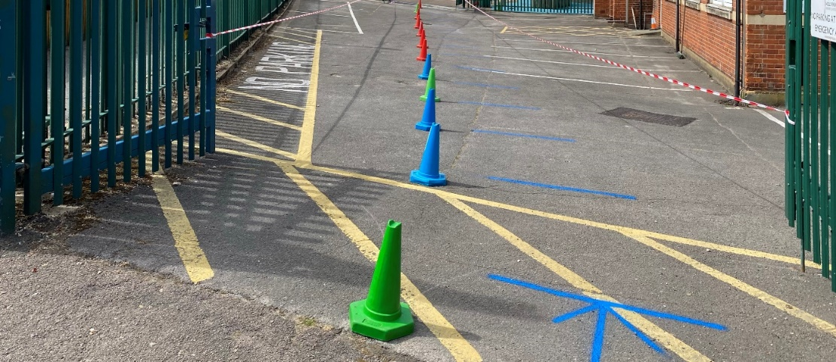
Once on site, your child will see these signs around all over the school. Please would you discuss with your child what they mean and why they are displayed - before they return.
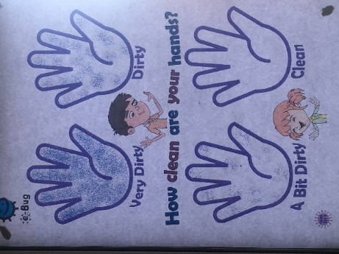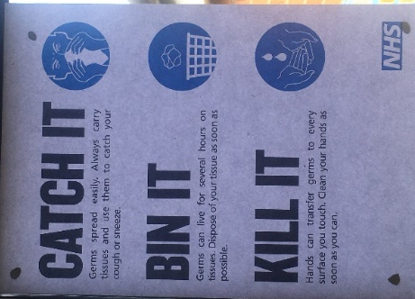
The Water Fountains are taped off. When doing First Aid, Staff will be wearing PPE
Children need to bring named water bottles. They will look like this:

