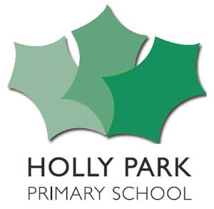  Behaviour Expectations  Article 24:  Children have the right to the best health care possible, clean water to drink, healthy food and a clean and safe environment to live in. All adults and children should have information about how to stay safe and healthy.  Article 28:  Every child has the right to an education. Primary education should be free. Discipline in schools should respect children’s rights and never use violence.  - We will listen to adults and follow instructions  - We will follow all the new routines for coming into school, leaving school and walking around school  - We will stay 2m apart from others  - We will stay in our seats  - We will not touch other people  - We will always stay in our own classrooms  - We will always stay in our own zones when we are outside  - We will only talk with people who are in our Bubble  - We will wash our hands and use hand sanitiser correctly when asked to  - We will only use our own toilet and not one that is intended for others  - We will not touch other people’s property or equipment  - We will not share our things, our food or our drinks with others  - We will always cough or sneeze into a tissue – “catch it, bin it, kill it”  - We will tell an adult if we feel unwell | Key  Values  The Holly Park Family Are…….  - Respectful  - Friendly  - Resilient  - Determined  - Accepting  - Patient  - Co-operative  - Kind  - Responsible  - Hopeful

