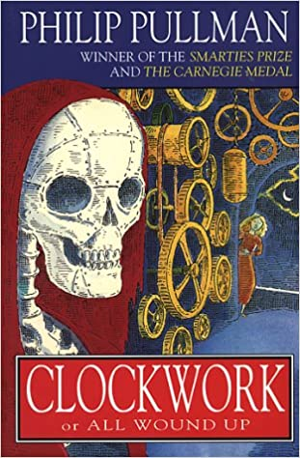

Year 5 – Summer Term

Tuesday 21st April 2020

Dear Year 5 Pupils, Parents & Carers,

Welcome back to a (slightly surreal) summer term; we hope that you and your extended families are healthy. We are well and looking forward to getting back into more of a routine after the Easter holidays.

Well done on your engagement with our Home Learning so far. Feedback has been positive and we have enjoyed seeing some of our fantastic pupils’ work – please keep sharing. Most of Maple are up and running on the Google Classroom stream and Juniper will soon be set up too – please do use it as it is a lovely way for us all to keep in touch and to share some of your work. Children can post work on this platform for us to see. We can engage in dialogue with them.
As soon as we are able, we will be phoning you over the next two weeks so feel free to ask any questions then.
In the meantime, here is a brief outline of what we plan to be covering over the coming weeks…

Reading
Please continue to read at home, every day, for a minimum of 30 minutes. Ideally, we would like children to keep up with individual reading as this is a skill that is transferable to the rest of the curriculum – checkout the booklists from the reading challenge on the school website.
Newspapers and non-fiction books are just as valuable as fiction texts and remember that new weekly editions of First News are on the front page of the Holly Park website – this is a great way of staying in touch with what is happening in the outside world while we are all stuck at home.
The link to the ‘Year 5 Reading Help’ that Ms S put together remains on the Year 5 website page and contains suggestions. Websites such as Authorfy and Lovereading4kids are free to subscribe to and have free downloadable extracts, as well as accompanying activities. We will also be working our way through Clockwork by Philip Pullman in our English Lessons. We are pleased to hear that some of you have started reading the next books in the Who Let the Gods Out series – enjoy!

English
A sequence of lessons are being put together, based on Clockwork by Philip Pullman (as mentioned, above). Ms Sampson will be filming You Tube videos of her reading the relevant extract for each lesson with links to those on the planning. Hopefully this will help you all feel more engaged with the text and assist those of you that finding reading more challenging. Friday’s lessons will continue to be a Grammar activity or Comprehension from your CGP books.
Spelling lessons will also be added to the Y5 page each week by Mrs Thomas. Also the half term spellings to learn have been emailed out – please help your child to learn these.

Maths
We will be following the maths curriculum using White Rose and other resources. This term we will be covering decimals, properties of shape, position and direction, converting units and volume as well as some mathematical investigations. Friday’s lessons will continue to be activities from your CGP books.

Foundation Subjects
We will continue to set these in weekly/fortnightly blocks, with a PE session on a Wednesday. Science will continue for this week with our space topic. Next week will be PSHE followed by more geography, when we will begin our next topic on Fairtrade.
In addition to the work on our class page, children should follow the Spanish video each week from Mrs Echanove
There will also be a weekly music session from Mr Hogan.
Mrs Thomas is reading a section a day of a book – in the story corner of our website (at the bottom of classrooms) – so do get your children to follow that. It should start this week
There is also picture news learning activities on the home learning section under classrooms – try these each week.
There are recorded video assemblies three times each week – watch these. They begin next week on Monday, Wednesday and Friday
BBC Bitesize has launched a primary section and this can support your learning too – so do try out the Y5 section.

We fully appreciate that this is a difficult time and we are trying our best to strike a balance of giving pupils work that challenges but does not overwhelm. It is particularly difficult for us to differentiate as well as we can when in a classroom. Pupils, please just continue to complete tasks as best as you can. You are all doing so well and we are incredibly proud of the effort you are all putting in.
Above all else, please just look after yourselves and try to stay positive. Know that you are all in our thoughts and we very much look forward to seeing you all again.

With very best wishes,

Ms Sampson and Mr French.

