HOLLY PARK PRIMARY SCHOOL
Dear Families, April 2020
Welcome to the Summer Term!
We hope you are all well and have managed to get some rest over the Easter Holidays. We have had some lovely weather recently and we do hope you have been able to get outside and enjoy the sunshine.
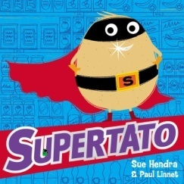
We have missed you all and are looking forward to planning lots of fun activities for you to try out at home over the coming weeks. Thank you for sending in lots of wonderful photos showing us the things you have been up to so far.
This term we will be focusing our learning around the ‘Supertato’ series of books. These stories are really exciting and very funny. We know you will love them!
We will be providing weekly activities that link to ‘Supertato’, as well as tasks relating to new books on ‘Bug Club’. The children will have the chance to practise a range of skills across the curriculum. Please continue to check the ‘Reception’ page on the Holly Park Website, every Monday, to see the new learning for that week.
As always, we thank you for your continued support.
If you have any questions, please email the school office and these will be passed on to us.
Best Wishes,
The Reception Team

