LETTERS AND SOUNDS – DAILY PHONICS LESSONS
The English Hubs with the Government’s Department for Education have produced online phonics lessons available from the 27th April which will provide lessons that would be taught in Reception and Year One in the Summer Term.
This is a guide of how to find the information for your child. Each session lasts about half an hour and focuses on phonemes and key words. The site became available yesterday. There is one lesson every week day. We would recommend watching these daily to keep up the daily phonics teaching that your children would be having at school. As you are watching, your child might need a pen and some paper to practise writing some of the words and sounds.
Obviously, these lessons are serving the needs of hundreds of children so it might not meet the needs of your child as a teacher would be able to do in a class setting. If you are not sure which lesson would be best for your child, please email the school and a message will be passed onto the class teacher, alternatively, please ask them when they phone you.
We hope that you find these videos useful and that they support your child in keeping up with their reading and writing. We will also be planning our own phonics activities and videos, but these will not be on a daily basis.
Many thanks
Emma Fitzpatrick, Sharon Casey and Xenoulla Thrasyvoulou
Read the letter on the Y1 page.

Click on the link that says Letters and Sounds for home and school
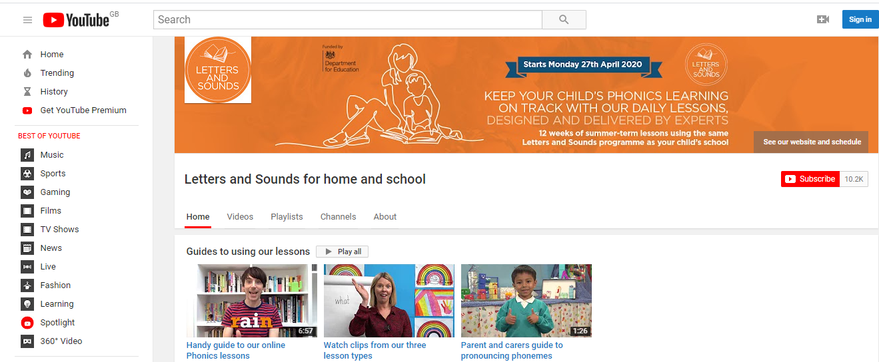 | The link will take you to this page on You Tube
 | There are some information guides about how to use the lessons.
Most children in Year One will need to watch the Year 1 Lessons.

They are labelled easily, starting with Lesson 1 Year 1.

These videos become available at 10.30 every week day.

We cannot advise you of the content as we will only be able to access it at the same time as you.

Lesson 1 will provide good revision of learning that has already taken place at Holly Park.
If your child is finding the Year One lessons tricky, there are also videos that cover Reception phonics.

These videos become available every week day at 10.00.
There are also ‘Learning to Blend’ lessons which are for children who know some phonemes but are struggling to put them together to read whole words.

These become available every week day at 11.00.

