**Child Friendly Anti Bullying Policy**

**Written by the Anti-Bullying Ambassadors**

**January 2020**



Holly Park wants all members of the school community feel welcome, safe and happy and so are able to learn and achieve. Bullying of any kind prevents this from happening. Bullying makes people feel unsafe.

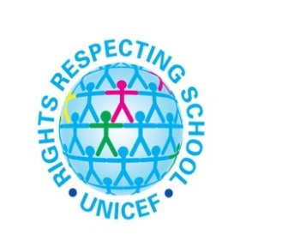

Article 3

All adults should do what is best for you. When adults make decisions, they should think about how their decisions will affect children.

Article 6

You have the right to be alive.

Article 19

You have the right to be protected from being hurt and mistreated, in body or mind.

Article 29

Your education should help you use and develop your talents and abilities. It should also help you learn to live peacefully, protect the environment and respect other people.

Article 36

You have the right to protection from any kind of exploitation (being taken advantage of).

Article 37

No one is allowed to punish you in a cruel or harmful way.

**This policy links with the UN Convention on the Rights of the Child**

**What is bullying?**

Our school definition of bullying is:

“Bullying is a repetitive series of actions, carried out on purpose, and designed to hurt someone’s feelings and make them feel ashamed of who or what they are. We will not accept it at Holly Park”

(Holly Park School Council)

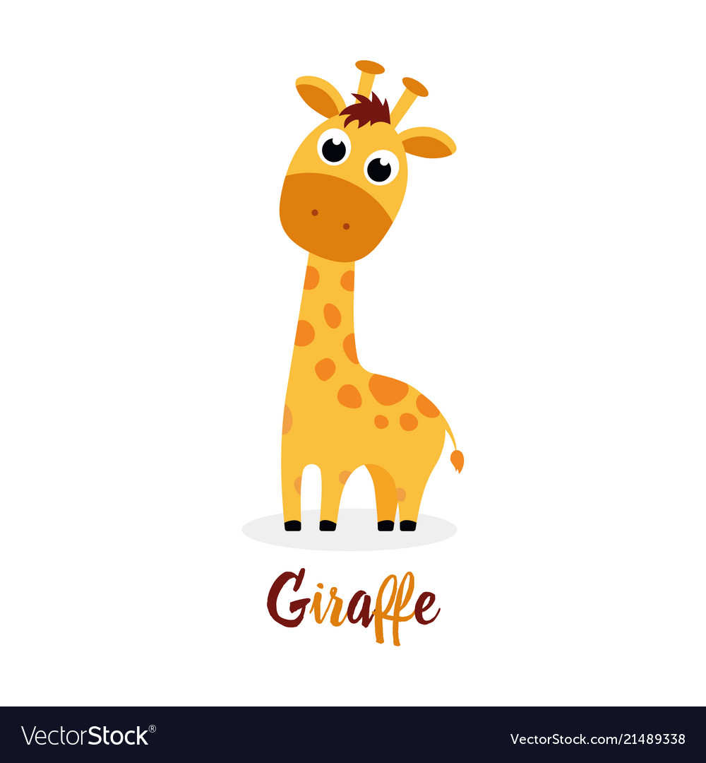

**Physical**

Pushing, poking, kicking, hitting, biting, pinching etc

**Bullying can be:**

**Verba**l

Name calling, teasing, spreading rumours, threats, belittling

**Emotional**

Leaving children out, threatening gestures, humiliation, intimidation, forcing them to do something and blackmailing them

**Online / Cyber**

Posting on social media, sending nasty messages, sending photos, excluding online

**What should I do if I think someone is being bullied?**

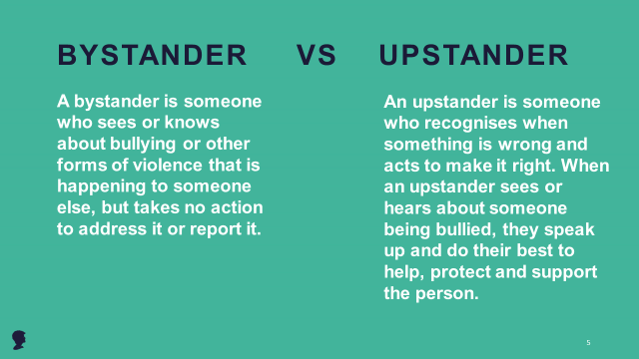

**What should I do if I am being bullied?**

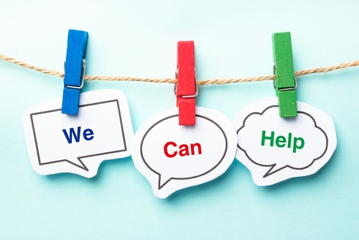

**If you are being bullied it is important to tell someone you trust. Tell an adult or friend, either at school or at home. If you have already told an adult about bullying you can still tell them again.**

You can:

1. Tell a teacher – your class teacher or any other teacher

2. Tell a friend you trust

3. Tell any other adult staff in school – such as Mrs Puzey, Teaching Assistants, mealtime supervisors or the school office

4. Tell an adult at home

**If you tell an adult at school they will be able to help you. They will tell Miss Michael or Mrs Pelham and your parent or carer so that they can help you. Telling an adult will never make bullying worse. They will talk to you and to the people bullying you to find ways to stop the bullying and keep you safe.**

**Check that the person being bullied is ok and look after them**

**Listen to them if they want to talk**

**Tell an Anti Bullying Ambassador**

**Tell a Mini Mentor**

**And always make sure you or someone else tells an adult at school who can help**