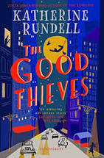
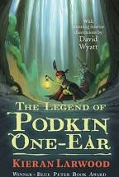
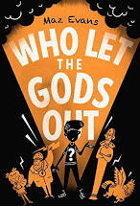

Year 5 – Reading Recommendations…
Hello Year 5!
Here are some tips for those of you that do not have many books at home or would just like ideas of how to get more:
- Audible Stories. On stories.audible.com there are free audio books to download and/or stream. This is the American site (uk not offering this yet) and there is a fairly limited selection. However, plenty of classics on there – including Alice in Wonderland read by Scarlett Johansson! Could be nice to have a lie down somewhere comfy after lunch and have a listen - my dream, really!
- Amazon Prime. I am absolutely NOT suggesting you pay to subscribe to Amazon Prime (please believe me) but if you have it you may not be aware of Prime Reading. I am a subscriber and had no idea until I was researching this and now have lots of new books in my kindle. This is included in your subscription and you get free access to a range of ebooks – downloadable to a range of devices.
- Lovereading4kids. You have to subscribe to this but it is free. You can download book extracts from 100’s of books! This can be helpful to help you decide if you would like to buy a book or not. You can also read and post reviews of books. Useful to have recommendations from people your own age, rather than me!
- Second Hand Books: You can order second hand books from a range of websites (Oxfam included). Worldofbooks.com offers free delivery on books from £3.

If you were enjoying Who Let the Gods Out (remaining Maple pupils and I finished this on Friday) then there is, of course, another 3 books in the series to enjoy. I am about to finish Brightstorm by Vashti Hardy (finally!) and then plan to read The Highland Falcon Thief (MG Leonard & Sam Sedgman) and The Lost Magician (Piers Torday). Would highly recommend any books by these authors as well as: Abi Elphinstone, Lisa Thompson, Katherine Rundell, Keiran Larwood (The Peculiars is FANTASTIC, as well as the Podkin series). Ever hear of JK Rowling? No? Well, I hear her wizarding books are worth a go….

Just enjoy – read whatever you can and know that I am reading with you! If I hear of any other tips will let you know –
Take care,
Ms Sampson

