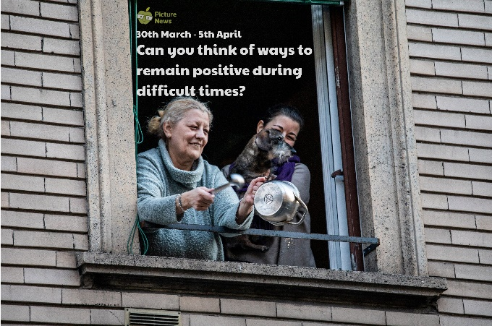

Quite often we associate different colours with different emotions. Which do you see as warm colours? Which are cold? Are they angry or happy colours? Which colours are positive? Can you use these positive colours to create a picture? Perhaps you could display it in your window for others to see?

Write a letter to someone in your family or a friend. Tell them what you have been doing. Do you think communicating with the people we love and care about is important in helping to keep us positive?

Research a period in history where communities have had to pull together in difficult times e.g. WWII. Find out when it happened, what happened and what people did to work together and help each other.

Make a video call to someone you care about. Can you tell them what you have been doing? Can you spread your positivity?

We often talk about positive and negative feelings, but we also have positive and negative numbers! Explore positive and negative numbers. Perhaps you could look at the temperature, count up or down through zero or if you like a challenge, explore what happens when you + or – negative and positive numbers!

Think about an activity or hobby that makes you feel happy and positive. Can you describe it? Why does it make you happy? Can you tell somebody else about it or show them how to do it?

**Learning from Home**

Use the ideas below, alongside this week’s resource, to support your home learning.