
Progression in Multiplication and Division

Contents

Page
- Aims
- Vocabulary
- Progression in the Early Stages (mainly EYFS and KS1)
11 Progression to Formal Methods of Multiplication (mainly Year 3 to Year 6)
13 Progression to Formal Written Methods of Division (mainly Year 4 to Year 6)
- Multiplying and Dividing Fractions (mainly Year 5 and Year 6)
- National Curriculum Progression: Addition and Subtraction

Appendix A Building up to Written Short Multiplication Appendix B Building up to Written Long Multiplication Appendix C Building up to Written Long Division Appendix D Building up to Short Division

Aims
The National Curriculum for Mathematics aims to ensure that all pupils:
▪▪ become fluent in the fundamentals of mathematics, including through varied and frequent practice with increasingly complex problems over time, so that pupils develop conceptual understanding and the ability to recall and apply knowledge rapidly and accurately.
At Holly Park we will therefore move our children beyond simple memorisation of facts and rules and ensure they have a deep-‐rooted understanding of the different branches of Mathematics, and how they connect together. For our children to become fluent, they need to understand the meaning of addition and its inverse relationship with subtraction; know by heart a variety of number facts such as number bonds to 1, 10 and 100, and the commutativity of these; and a deep understanding of our place value system, how the numbers are structured within it and how they behave in addition.

The National Curriculum for Mathematics aims to ensure that all pupils:
▪▪ reason mathematically by following a line of enquiry, conjecturing relationships and generalisations, and developing an argument, justification or proof using mathematical language.
At Holly Park we will therefore think carefully about what we want our children to think, notice and understand about the mathematics involved in the learning activities. We will help our children to get underneath what is going on, to make links, and to generalise their understanding. Mathematical talk will play a big part in our lessons and we will use a range of vocabulary.

The National Curriculum for Mathematics aims to ensure that all pupils:
▪▪ can solve problems by applying their mathematics to a variety of routine and non-‐routine problems with increasing sophistication, including breaking down problems into a series of simpler steps and persevering in seeking solutions.
At Holly Park we will therefore incorporate a wide range of investigations and problem solving activities into our lessons to enable children to think mathematically. We will emphasise the importance of being stuck, having another go and trying different approaches.

At every stage of calculation, we need to switch between the concrete, pictorial and abstract (CPA) as appropriate.
Concrete – real life objects, practical resources
Pictorial – drawing pictures of practical resources, bar models Abstract – number lines, equations with numbers and symbols

Vocabulary
“Mathematical language is crucial to children’s development of thinking. If children don’t have the vocabulary to talk about division, or perimeters, or numerical difference, they cannot make progress in understanding these areas of mathematical knowledge.” Mathematical Vocabulary, DfE 2000

The National Curriculum for Mathematics is very clear that the correct use of mathematical language is central to a meaningful and deep understanding. Having a wide vocabulary of mathematical terminology available is essential for mathematical thinking and reasoning – we think in the same words that we speak. It is not enough for children to simply hear mathematical words; they need to ‘feel’ them in their own mouths. Therefore when introducing new vocabulary, everyone needs to repeat it out loud. It is also essential that new vocabulary is explained carefully and introduced alongside relevant real life contexts, practical resources or pictures so that children really understand.
Key Vocabulary
Equality, inequality, inverse Multiplication, multiply, multiplied by Divide, divided by, divided into Times, lots of, groups of, once, twice
Ten times, … times as (big, long, wide etc) Multiple, double, halve, partition, array Share, share equally, group, equal groups of Product, factor, common factor/multiple, Power of, square/cube/prime numbers Left, left over, remainder

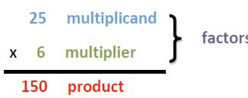
Teachers need to have high expectations and only accept what is correct.



divided by is equal to

182 ÷ 5 = 36 r 2

dividend quotient
divisor
multiplied by is equal to (times)

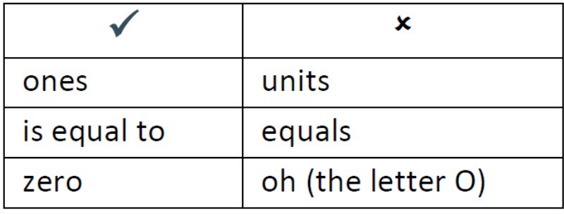
15 x 2 = 30
multiplicand product
factor multiplier factor

remainder
An equation is a mathematical statement, in symbols, that says two things are equivalent or the same [number sentence] e.g. 2=10-­‐8, 9-­‐3=6,5=5

An inequality is a mathematical statement that two things are not the same e.g. 3 < 10 -­‐ 9, 12 – 8 > 25>22<5

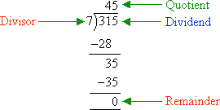

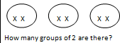

Progression in the Early Stages (mainly EYFS and KS1)

Note: children need a sound understanding of addition (and subtraction) before progressing onto multiplication (and division).

Strategy | Notes | Representations
Linking multiplication to addition through doubling |  | Practical resources e.g. Numicon:  ,
Repeated addition of the same number  Doubling and halving numbers to ten | Encourage children to read number sentences aloud in different ways  e.g. “five times two makes ten”, “ten is equal to five multiplied by two”. | Begin with mostly pictorial representations:  Record this by printing or drawing around Numicon pieces:  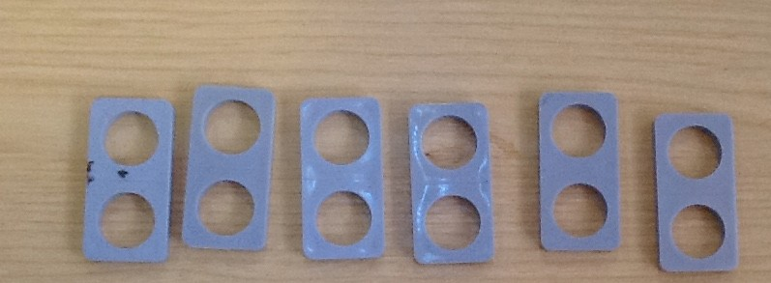  Use real life apparatus to count in repeated groups of the same number e.g.    How many wheels are there altogether? How much money do I have?  Count in twos, fives and tens aloud and with objects.  Give multiplication problems set in a real life context and encourage children to visualise the problem e.g. How many fingers on two hands? How many sides on three triangles? How many legs on four ducks?  Use arrays: x x x x  x x x x 3 lots of 4 = 12  x x x x 4 lots of 3 = 12







Strategy | Notes | Representations
Combining groups of the same size (repeated addition) | Move from addition sentences to multiplication sentences.  Ensure the language matches the picture e.g. “2 lots of 5” (say two hands) and “2 multiplied by 5” (say 5 pairs of cherries) mean different things but both give the answer 10. | Use physical objects and representations such as the number line alongside each other:  Use a counting stick:  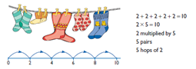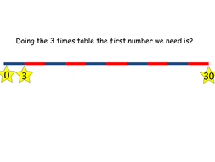  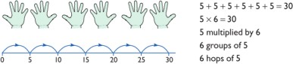
Represent odd and even numbers | Seeing this in different ways will help children understand the pattern in numbers. | Use resources e.g. Numicon  They can generalise that when counting in 2s all numbers are even  Odd Even    link to 2 times table

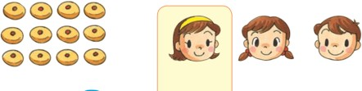
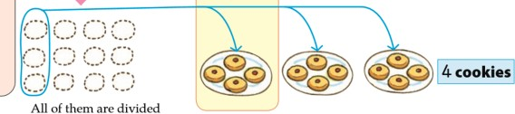

Strategy | Notes | Representations
Use arrays to | Multiplication is | 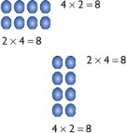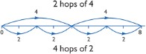
understand | commutative.
multiplication can be
done in any order
Begin to understand |  | That tower of cubes is double/half the height of the other tower:  
multiplication as
scaling in terms of
double and half
Division as sharing | Introduce intuitively with practical problems. | When 12 cookies are divided evenly among 3 people, 1 child  gets 4 cookies.
12 ÷ 3 = 4
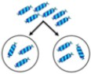

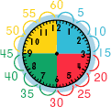
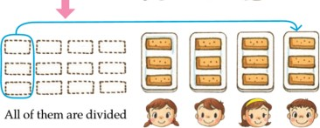

Strategy | Notes | Representations
Division as grouping | This links to idea of repeated/successive subtraction. | If 12 pastries are divided so each child gets 3, the pastries  can be shared among 4 people. 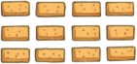  12 ÷ 3 = 4
Recall and use times table facts | Make connections between times tables to help understanding e.g. x5 then x10, x2 then x4.  Make times tables with Numicon, multilink etc | Regular counting on and back, in steps of 2, 5 and 10.  Use a clock face to support understanding of counting in 5s. Use money to support counting in 2s, 5s, 10s, 20s, 50s.
Calculate mathematical statements for multiplication and division within the times tables | Recognise multiplication and division as inverses through the use of missing number problems. | 6 ÷ 2 = = 6 ÷ 2 6 ÷ = 3 3 = 6 ÷  ÷ 2 = 3 3 = ÷ 2 ÷ 2 = 3 3 = ÷ 2

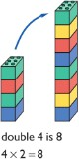
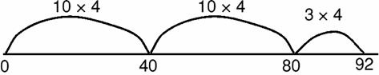

Strategy | Notes | Representations
Develop understanding of multiplication as scaling |  | e.g. 3 times bigger/taller 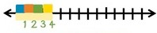
Double numbers up to 10 + 10. |  | Use known doubles to work out doubling two digit numbers  e.g. double 16 = double 10 + double 6
Efficient use of number lines |  | Multiplication – using repeated addition of larger amounts e.g. 23 x 4  Division – Children need to be able to partition the dividend in different ways.  e.g. 48 ÷ 4 = 12 
Multiply and divide by powers of 10 |  | 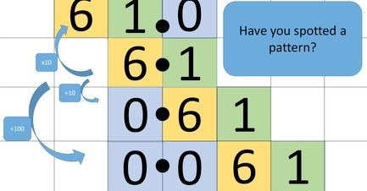

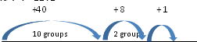
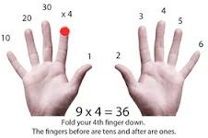
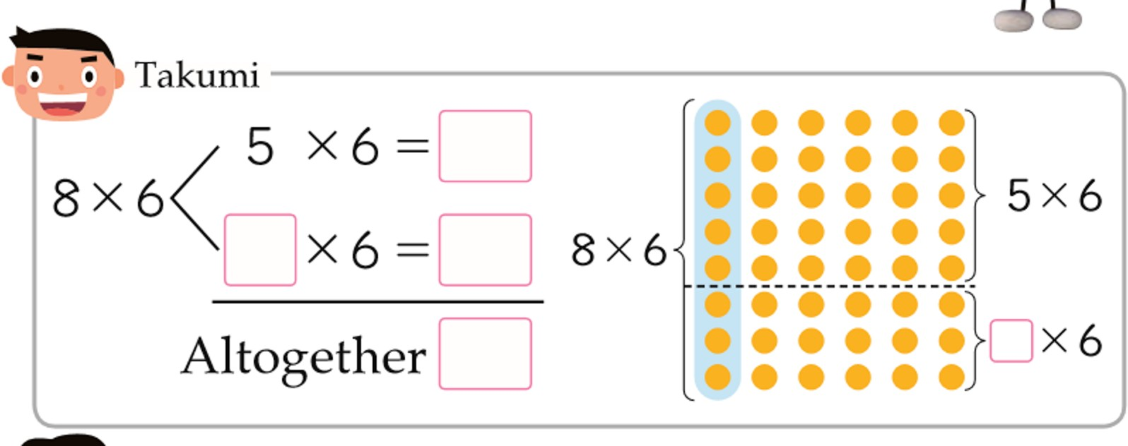

Strategy | Notes | Representations
Introduce remainders | Express results in different ways according to the context, including with remainders, as fractions, as decimals or by rounding e.g. 98 ÷ 4 = 24 r 2 = 24.5 ≈ 25 | 49 ÷ 4 = 12 r1  Sharing – 49 shared between 4. How many left over? Grouping – How many 4s make 49? Left over?  Give opportunities to solve grouping and sharing problems practically (including where there is a remainder but the answer needs to be given as a whole number) e.g. pencils are sold in packs of 10. How many packs will I need to buy for 24 children?
Further develop understanding of division to find fractions |  | Use children’s intuition to support understanding of fractions as an answer to a sharing problem  e.g. 3 apples shared between 4 people =
Develop fluency with times tables up to 12 x 12 | Pupils use multiplication and division as inverses to support the introduction of ratio in Year 6 | Develop efficient mental methods:  -‐ commutativity and associativity e.g. 4 × 12  × 5 = 4 × 5 × 12 = 20 × 12 = 240)  -‐ distributivity e.g. 39 × 7 = 30 × 7 + 9 × 7 →→  -‐ derive related facts e.g. 3 × 2 = 6, 6 ÷ 3 = 2  so 30 × 2 = 60, 60 ÷ 3 = 20  -‐ make connections e.g. x12 is double x6 which is double x3  Use the context of a week and a calendar to support the 7 times table  (e.g. how many days in 5 weeks?).  Use of finger strategy for 9 times table.

Strategy | Notes | Representations
Find common multiples | Common factors can be | 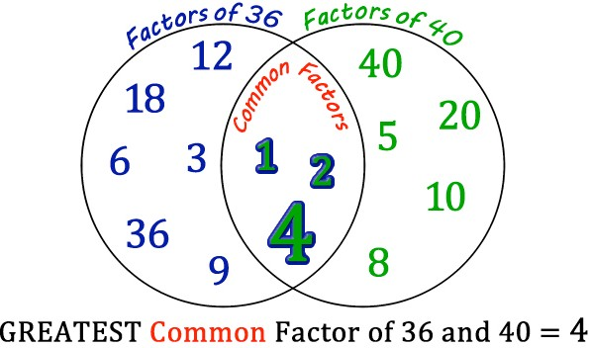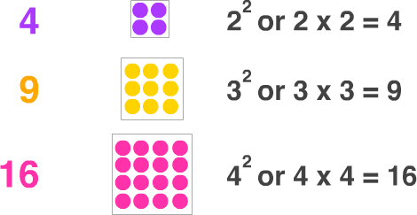
and factors; square | related to finding
numbers and cube | equivalent fractions
numbers; prime
numbers
Use the knowledge of |  | Children should experiment with order of operations, investigating the effect of positioning
the order of operations to calculate with the four operations |  | the brackets in different places, e.g. 20 – 5 x 3 = 5; (20 – 5) x 3 = 45  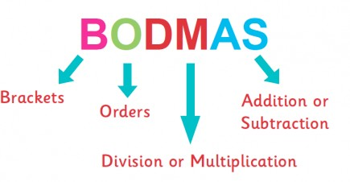

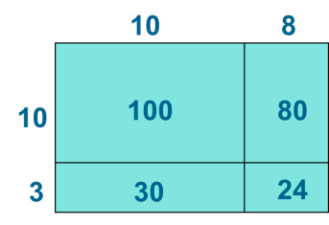

Progression to Formal Methods of Multiplication (mainly Year 3 to Year 6)
Note: Each year the range of numbers to calculate with is extended. Every time, work through the complete sequence described below to ensure children have a deep understanding of why the algorithms work, not simply how to do them. This ensures children can apply the strategies in unfamiliar problems and increases their accuracy and reliability. For example, when teaching how to multiply decimals, start at step 1, don’t just jump straight for the traditional written method and hope children make the connection with their earlier learning.

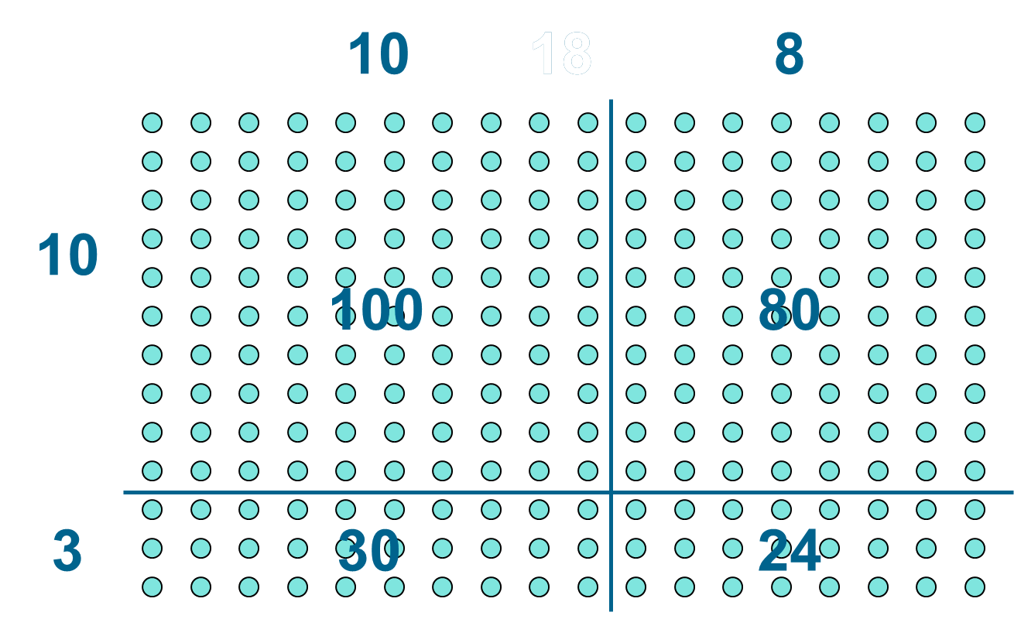
See Appendix A: Building up to Written Multiplication

Strategy | Notes | Representations
Step 1: Partition numbers visually | Lots of practice with physical objects at each level of difficulty is important to ensure conceptual understanding. | Introduce by finding the number of counters in a regular array e.g. 23 x 4 = 92 18 x 13 = 234  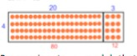  Progression to a model that uses the ‘area of a rectangle’.  Children to draw the rectangles.  Often called ‘Grid method’ e.g. 23 x 4 = 92  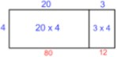 | Place value model:  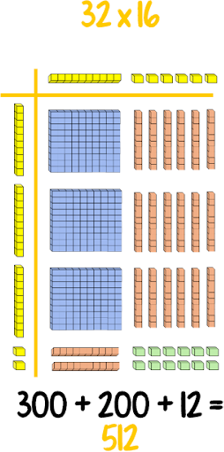

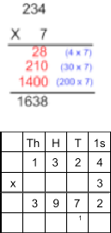

Strategy | Notes | Representations
Step 2: Place Value Counters |  | Without exchanging With exchanging  e.g. 1323 x 3 – make 3 lots of 1323 e.g. 1324 x 3 – make 3 lots of 1324  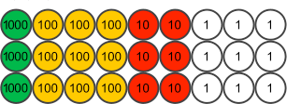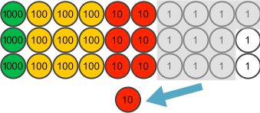  Exchange/trade/swap ten 1s for one 10
Step 3: Expanded Written Method | Compare side by side with pictorial representations – what is the same and different?
Step 4: Compact Written Method |  | 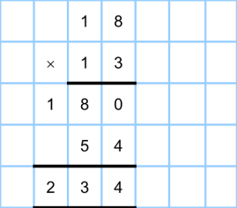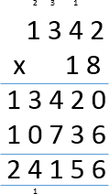

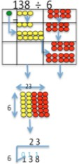

Progression to Formal Methods of Division (mainly Year 4 to Year 6)
Note: Each year the range of numbers to calculate with is extended. Every time, work through the complete sequence described below to ensure children have a deep understanding of why the algorithms work, not simply how to do them. This ensures children can apply the strategies in unfamiliar problems and increases their accuracy and reliability. For example, when teaching how to divide decimals, start at step 1, don’t just jump straight for the traditional written method and hope children make the connection with their earlier learning.

See Appendix B: Building up to Written Division

Strategy | Notes | Representations
Step 1: Partition numbers visually |  | Introduce division as an array – physically create the array and draw the bus stop around it
Step 2: Place Value Counters |  | Use place value counters to  demonstrate what is going on. e.g. exchanging:  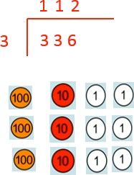

Strategy | Notes | Representations
Step 3: Compact Written Method – “Short Division” | Formal short division should only be introduced once children have a good understanding of division, its links with multiplication and the idea of ‘chunking up’ to find a target number (see use of number lines above) | 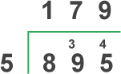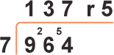

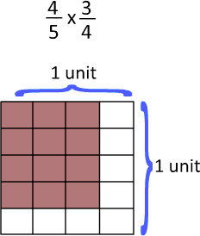

Multiplying and Dividing Fractions (mainly Year 5 and Year 6)

Strategy | Notes | Representations
Multiply proper fractions and mixed numbers by whole numbers | Use bar models and other images to support conceptual understanding before introducing rules
Associate a fraction with division |  | Explain how much pizza each person would get if they divided 4 pizzas between 5 people: 4 divided by 5 = ⅘ = 0.8
Multiply two simple fractions together |  | Across the top, shade in 4 out of 5. Vertically shade in 3 out of 4.  Then diagram shows the product: total number of spaces  is denominator and shaded number of spaces is numerator 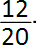  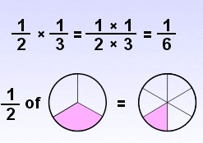
Divide proper fractions by whole numbers |  | Ronald and Jamie have ½ candy bar. If ½ a candy bar is split into 2 pieces, what is the size of each piece?  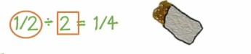  Use ‘what do you notice’ type questioning to elicit that ¼ ÷ 2 = ¼ x ½
  x | x

National Curriculum Progression: Multiplication and Division Taken from the NCETM

 | Year 1 | Year 2 | Year 3 | Year 4 | Year 5 | Year 6
Understanding multiplication and division |  |  | Choose an appropriate strategy to solve a calculation based upon the numbers involved (recall a known or related fact, calculate mentally, use a jotting, written method) | Choose an appropriate strategy to solve a calculation based upon the numbers involved (recall a known or related fact, calculate mentally, use a jotting, written method) | Choose an appropriate strategy to solve a calculation based upon the numbers involved (recall a known or related fact, calculate mentally, use a jotting, written method) | Choose an appropriate strategy to solve a calculation based upon the numbers involved (recall a known or related fact, calculate mentally, use a jotting, written method)
 |  | Understand multiplication as repeated addition  Understand division as sharing and grouping and that a division calculation can have a remainder  Show that multiplication of two numbers can be done in any order (commutative) and division of one number by another cannot | Understand that division is the inverse of multiplication and vice versa  Understand how multiplication and division statements can be represented using arrays  Understand division as sharing and grouping and use each appropriately | Recognise and use factor pairs and commutativity in mental calculations | Identify multiples and factors, including finding all factor pairs of a number, and common factors of two numbers
Multiplication and division facts |  | Recall and use multiplication and division facts for the 2, 5 and 10 multiplication tables, including recognising odd and even numbers | Recall and use multiplication and division facts for the 3, 4 and 8 multiplication tables | Recall multiplication and division facts for multiplication tables up to 12 × 12 | Know and use the vocabulary of prime numbers, prime factors and composite (non-prime) numbers  Establish whether a number up to 100 is prime and recall prime numbers up to 19 | Identify common factors, common multiples and prime numbers
Recognise and use square numbers and cube numbers, and the notation for squared (2) and
cubed (3)
 | Recall and use doubles of all numbers to 10 and corresponding halves | Derive and use doubles of simple two-digit numbers (numbers in which the ones total less than 10) | Derive and use doubles of all numbers to 100 and corresponding halves  Derive and use doubles of all | Use partitioning to double or halve any number, including decimals to one decimal place | Use partitioning to double or halve any number, including decimals to two decimal places | Use partitioning to double or halve any number

 |  | Derive and use halves of simple two-digit even numbers (numbers in which the tens are even) | multiples of 50 to 500
Mental methods |  | Calculate mathematical statements for multiplication (using repeated addition) and division within the multiplication tables and write them using the multiplication (×), division (÷) and equals (=) signs | Write and calculate mathematical statements for multiplication and division using the multiplication tables that they know, including for two-digit numbers times one-digit numbers, using mental methods | Use place value, known and derived facts to multiply and divide mentally, including:  - multiplying by 0 and 1  - dividing by 1  - multiplying together three numbers | Multiply and divide numbers mentally drawing upon known facts  Solve problems involving multiplication and division including using their knowledge of factors and multiples, squares and cubes | Perform mental calculations, including with mixed operations and large numbers
Written methods | *Written methods are informal at this stage – see mental methods for expectation of calculations | *Written methods are informal at this stage – see mental methods for expectation of calculations | Write and calculate mathematical statements for multiplication using the multiplication tables that they know, including for two-digit numbers times one-digit numbers, progressing to formal written methods | Multiply two-digit and three-digit numbers by a one-digit number using formal written layout | Multiply numbers up to 4 digits by a one- or two-digit number using a formal written method, including long multiplication for two- digit numbers | Multiply multi-digit numbers up to 4 digits by a two-digit whole number using the formal written method of long multiplication  Multiply one-digit numbers with up to two decimal places by whole numbers
 |  |  | Write and calculate mathematical statements for division using the multiplication tables that they know, including for two-digit numbers divided by one-digit numbers, progressing to formal written methods | Divide numbers up to 3 digits by a one-digit number using the formal written method of short division and interpret remainders appropriately for the context | Divide numbers up to 4 digits by a one-digit number using the formal written method of short division and interpret remainders appropriately for the context | Divide numbers up to 4 digits by a two-digit number using the formal written method of short division where appropriate, interpreting remainders according to the context  Use written division methods in cases where the answer has up to two decimal places
Estimating and checking calculations |  |  | Use estimation to check answers to calculations and determine, in the context of a problem, an appropriate | Use estimation and inverse to check answers to calculations and determine, in the context of a problem, an appropriate | Use estimation and inverse to check answers to calculations and determine, in the context of a problem, an appropriate | Use estimation and inverse to check answers to calculations and determine, in the context of a
 |  |  | degree of accuracy | degree of accuracy | degree of accuracy | problem, an appropriate
 |  |  |  |  |  | degree of accuracy

Order of operations |  |  |  |  |  | Use their knowledge of the order of operations to carry out calculations involving the four operations
Solving multiplication and division problems including those with missing numbers | Solve one-step problems involving multiplication and division, by calculating the answer using concrete objects, pictorial representations and arrays with the support of the teacher | Solve problems involving multiplication and division (including those with remainders), using materials, arrays, repeated addition, mental methods, and multiplication and division facts, including problems in contexts | Solve problems, including missing number problems, involving multiplication and division (and interpreting remainders), including positive integer scaling problems and correspondence problems in which n objects are connected to m objects | Solve problems involving multiplying and adding, including using the distributive law to multiply two digit numbers by one digit, division (including interpreting remainders), integer scaling problems and harder correspondence problems such as n objects are connected to m objects | Solve problems involving addition, subtraction, multiplication and division and a combination of these, including understanding the meaning of the equals sign  Solve problems involving multiplication and division, including scaling by simple fractions and problems involving simple rates | Solve problems involving addition, subtraction, multiplication and division

Appendices

These appendices demonstrate possible progression through calculation strategies following the Concrete-‐Pictorial-‐Abstract (CPA) approach. The aim is always for children to calculate confidently, accurately and efficiently. The most efficient strategies are usually the formal written methods of short or long multiplication and division (“abstract”). As laid out in the National Curriculum for Mathematics, using these written strategies is the expectation for children leaving Key Stage 2. It is paramount that children have a sound understanding of the concepts though, before being taught the formal methods, in order to avoid misconceptions forming. Therefore interim methods (often “concrete” and “pictorial”) are taught first. The aim is always to progress from the interim methods as soon as children are confident.

The first step when teaching any calculation strategy is always to demonstrate it using concrete apparatus (e.g. Dienes). This helps to ensure conceptual understanding, not just procedural recall. Once confident with the concrete, move to the pictorial -‐ first by drawing the apparatus alongside manipulating it and then just drawing it to as a guide. When the pictures are no longer needed, move to the abstract (the formal written procedures). It is important that the movement between each step is flexible. In other words, there needs to be opportunities for progress without blocking the way back to the sources in which understanding is grounded. For example, when children encounter a complex problem or new situation that they are uncomfortable solving solely in the abstract, they should draw a representational picture or use concrete apparatus to guide them.

Each appendix here starts with an example of how to represent the concrete Dienes apparatus pictorially and moves through other interim methods, ending with the formal written method.
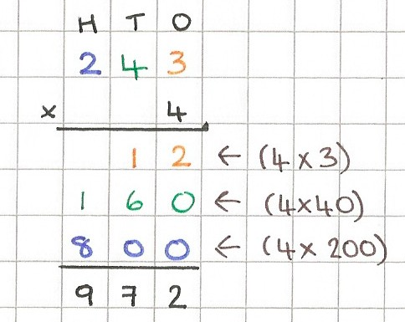

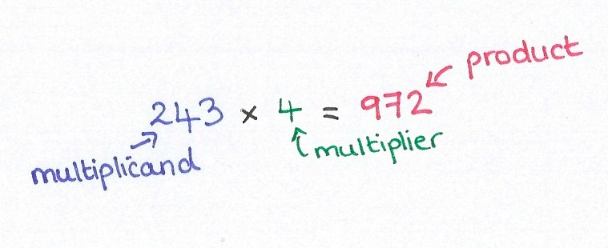
Appendix A: Building up to Written Short Multiplication

Expanded Methods
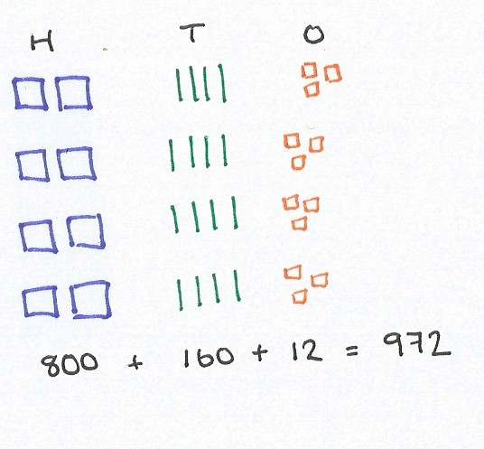

The expanded written method is an interim method before introducing the formal written algorithm because each partial product is visible.
243
Dienes apparatus could be placed (or drawn) alongside to show what is going on.

Partition (split up) the multiplicand according to its place value
e.g. 243 is made up of two hundreds, four tens and three ones.

We want this 4 times – we are multiplying the ones by 4, the tens by 4 and the hundreds by 4.

Line up the hundreds, tens and ones and find the total of each. Recombine to give the final product.


Multiply each digit of the multiplicand by the multiplier in turn.

Record these partial products underneath each other and add together to get the final product.

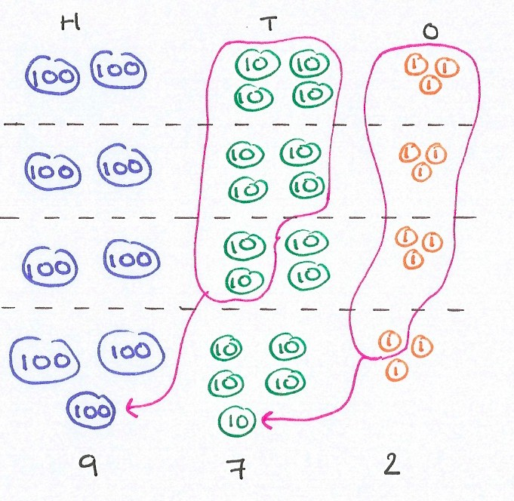
Compact Methods
243
Place value counters are an excellent stepping-‐stone between the concrete Dienes apparatus and the abstract formal written method.

Partition the multiplicand 243 according to its place value.
Do this 4 times (because we are multiplying by 4) and line up in columns.

We can regroup to make the numbers easier to work with. Bundle up ten (1) discs and exchange them for one (10) disc. Likewise regroup ten (10) discs for one (100) disc.

Now instead of 8 hundreds, 16 tens and 12 ones, we have 9 hundreds, 7 tens and 2 ones.
The total value has not changed; we have just renamed it.

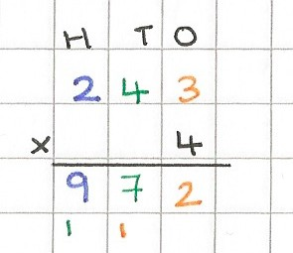

Add up how many hundreds, tens and ones there are altogether. Recombine to give the final product.
Record the exchanges underneath

Multiply each digit of the multiplicand by the multiplier in turn.

Build up the final product as we go along – record the ones digit in the ones column, the tens digits in the tens column etc.

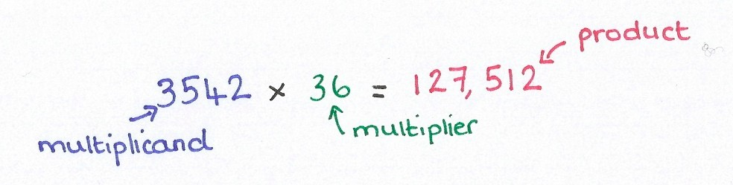
Appendix B: Building up to Written Long Multiplication
Short multiplication only works when the multiplier has 1 digit. For bigger numbers, you need long multiplication – it is the same process, just repeated for the extra digits. Dienes and place value
counters become inappropriate so we need to make sure that short multiplication is secure before moving on!

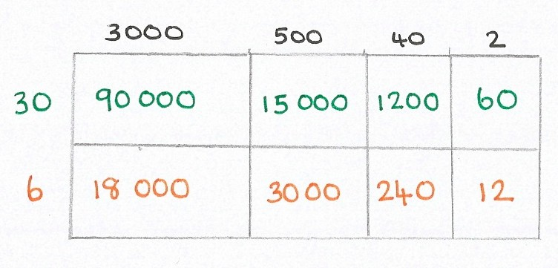


Grid Method (or Area Model)
Partition multiplicand
Partition multiplier
This is a visual version of the expanded written method of long multiplication and as such should be introduced first. It links to calculating the area of a rectangle, where you multiply the length by the width.


Partition both the multiplicand and multiplier according to their place value.
For example: 40 x 30 = 1200
40 x 6 = 240

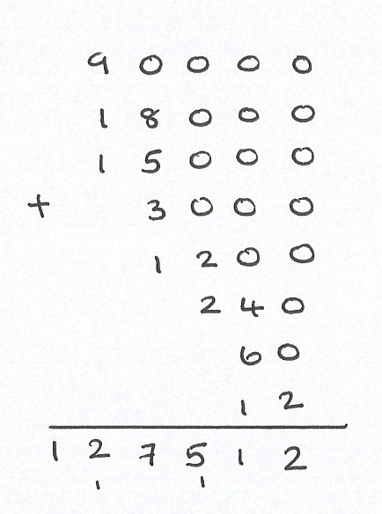
Multiply each part of the multiplicand by each part of the multiplier and record partial products in the boxes.

Finally add up all the partial products using column addition

Expanded Method
The expanded written methods is a stepping-‐stone between the grid method and the formal written algorithm because each partial product is visible.

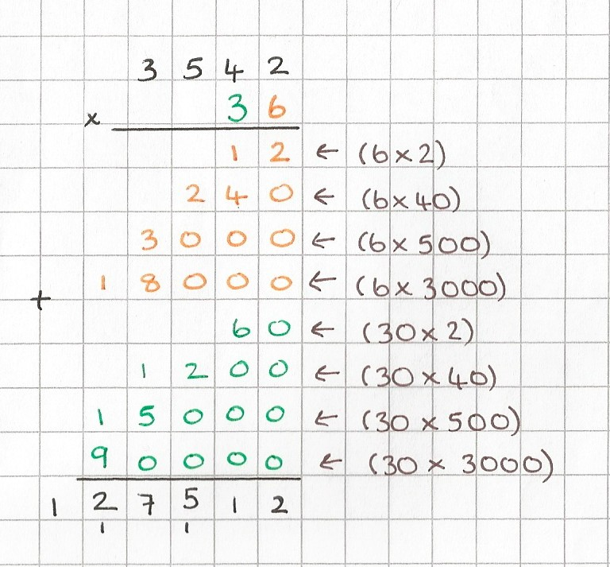
Write the multiplicand above the multiplier, lining up each digit according to its place value.

Start at the right hand side and work left:
Multiply each digit of the multiplicand by the multiplier’s ones digit (shown opposite in orange).

Record these partial products underneath each other.

Then multiply each digit of the multiplicand by the multiplier’s tens digit, again starting at the right hand side (shown in green).

Add these partial products to the list.

Then use column addition to find the sum of all the partial products.

Compact Method

Write the multiplicand above the multiplier, lining up each digit according to its place value.

Start at the right hand side and work left:
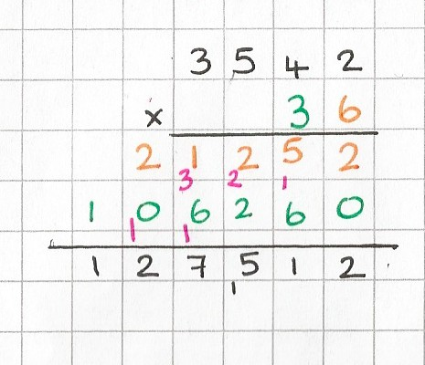



-‐ Multiply each digit of the multiplicand by the multiplier’s ones digit (shown opposite in orange).
3542 x 6
3542 x 30
3542 x 36
Record the exchanges underneath
-‐ Build up the product as we go along – record the ones digit in the ones column, the tens digits in the tens column etc.
-‐ As we do this, regroup as appropriate
(e.g. exchange 10 ones for 1 ten, 10 tens for 1 hundred etc).
-‐ Then multiply each digit of the multiplicand by
the multiplier’s tens digit (shown opposite in green).
-‐ Build up this product as we go along -‐ record the ones digit in the ones column, the tens digits in the tens column etc.
-‐ As we do this, regroup as appropriate
(e.g. exchange 10 ones for 1 ten, 10 tens for 1 hundred etc).
-‐ Finally, use column addition to find the sum of the two products.

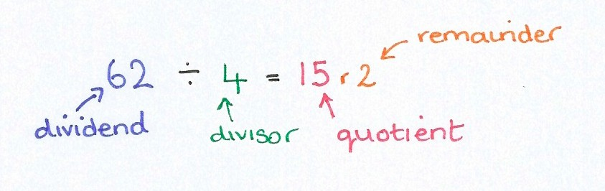
Appendix C: Building up to Written Long Division

Place Value Counters
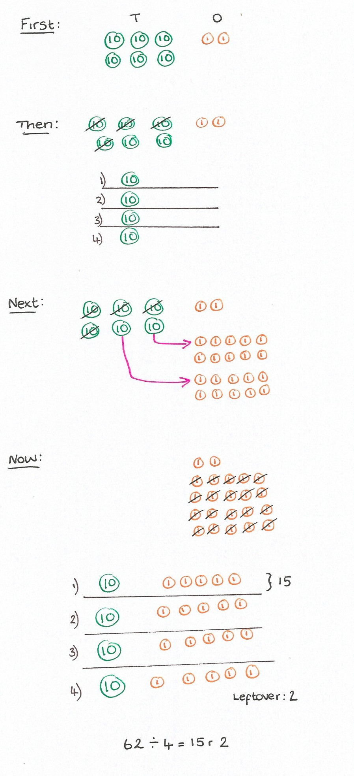
Place value counters are a great tool to develop conceptual understanding of how long division works.

Partition the dividend according to its place value.

Starting with the biggest value, here the tens, share them into 4 equal groups (because 4 is our divisor).

Once we have shared out all we can so that every group has the same, regroup any remaining tens – exchange each (10) disc for ten (1) discs.

Then share out the ones into 4 equal groups.

Check the number of discs in each group is equal. Here we have one 10 and five 1s in each so the quotient is
15. Record any leftover discs as the remainder – here there is a remainder of 2.

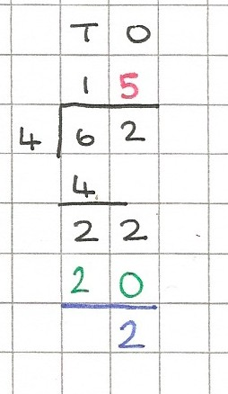
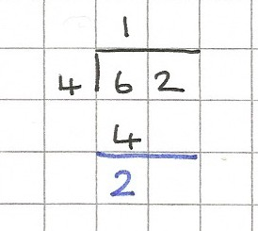
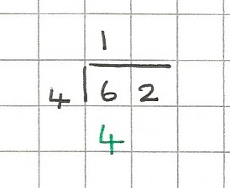
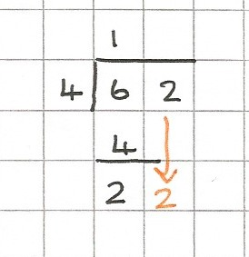

Written Recording of Place Value Counters
Divide: how many 4s in 6 tens? 1 ten
Multiply: 4 x 1 = 4
4 x 1 ten = 4 tens)
Subtract: 6 – 4 = 2
(6 tens – 4 tens = 2 tens)
Bring down the next digit. Now we have 22 ones (just like previous exchanging)
Repeat!
Divide: how many 4s in 22? 5 Multiply: 4 x 5 = 20
Subtract: 22 – 20 = 2
There is nothing to bring down so we are finished.
Remainder: 2
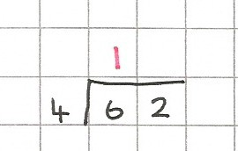
Alongside the physical maneuvering/drawing of the place value counters, record each step in the following way:
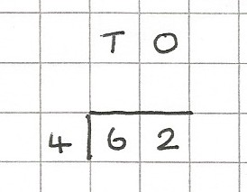

We use a bus stop with the dividend inside and the divisor outside. Our answer (the quotient) is written on the top and the intermediary calculations below.

Long Division Algorithm
To help us remember the long division algorithm, we can the menemonic: Dangerous Monkeys Swipe Bananas Randomly.

It stands for the four repeated stages that make up the process
– Divide, Multiply, Subtract, Bring down, Repeat or Remainders.
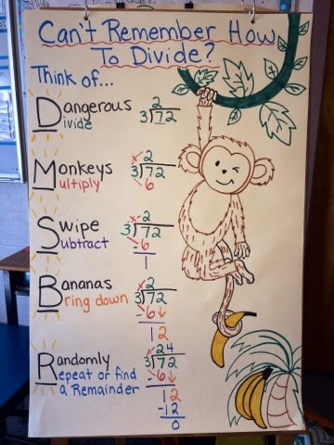

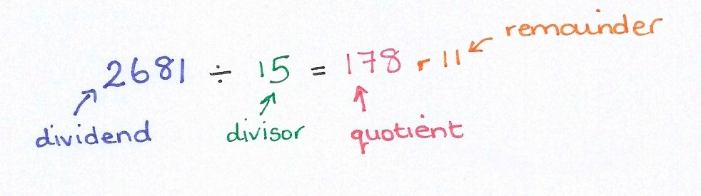
Before we start, it is helpful to jot down the 15 times table. That way we can concentrate on the long division process:
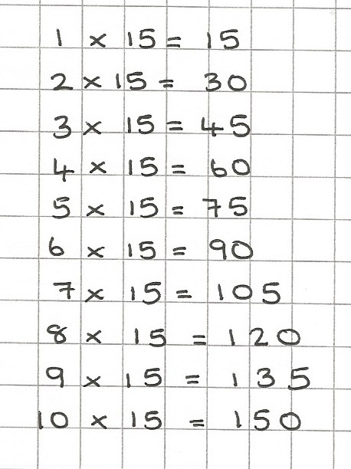

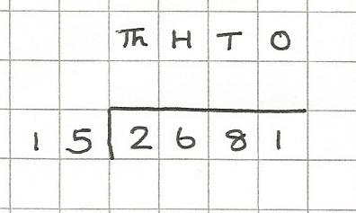
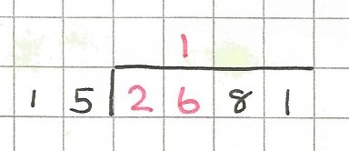
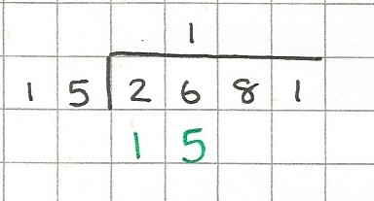
We use a bus stop with the dividend inside and the divisor outside. Our answer (the quotient) is written on the top and the intermediary calculations below.


cont…
Divide: how many 15s in 26? 1
Multiply: 15 x 1 = 15
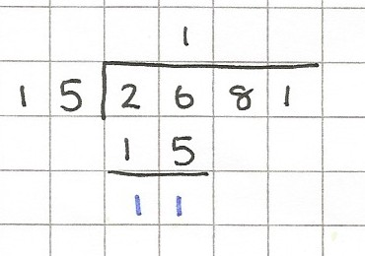
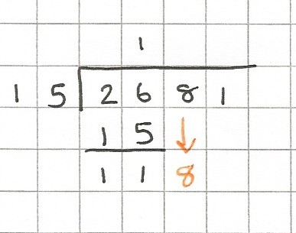
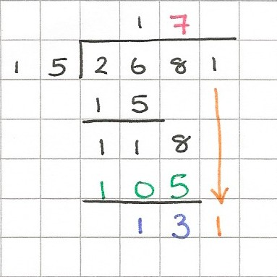
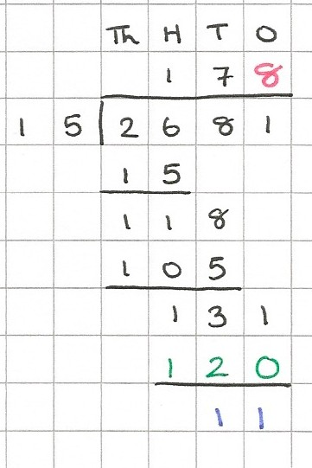

Subtract: 26 – 15 = 11
Bring down next digit.
Repeat
Divide: how many 15s in 118? 7 Multiply: 15 x 7 = 105
Subtract: 118 – 105 = 13 Bring down the next digit.
Repeat.
Divide: how many 15s in 131? 8 Multiply: 15 x 8 = 120
Subtract: 131 – 120 = 11
There is nothing to rbign down so we are finished.
Remainder: 11

Appendix D: Building up to Written Short Division
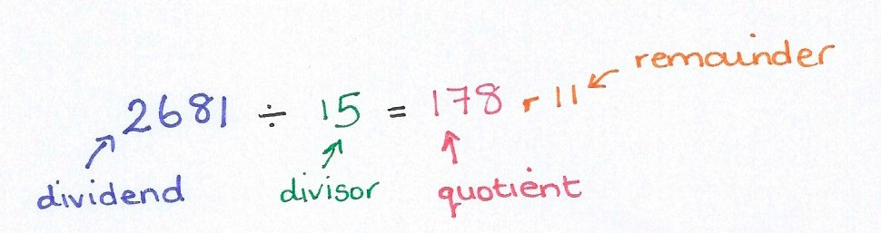
Unlike with multiplication, short division comes conceptually after long division. It follows the same process as long division, but the quotient is written directly without the succession of intermediary workings.
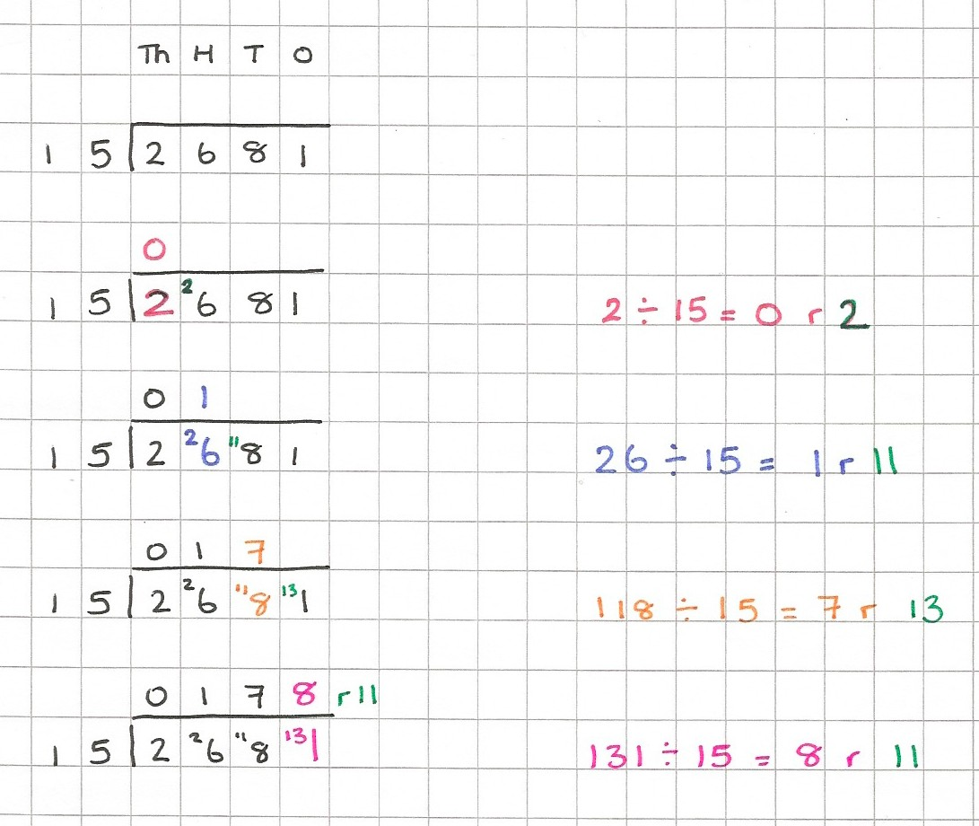

We can express the remainder as a fraction or a decimal:

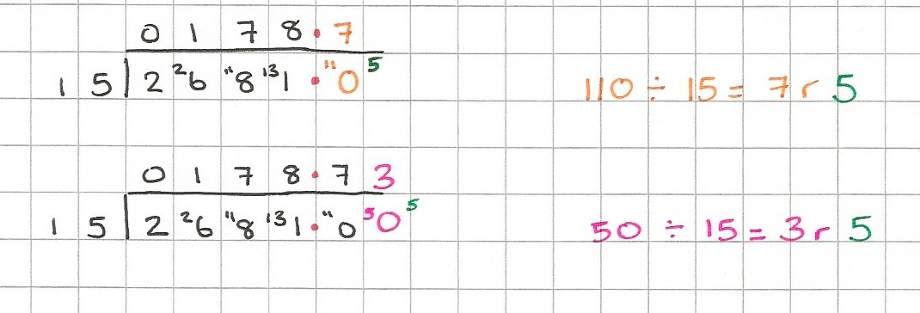
Extend the dividend [2681.00 = 2681]. Make sure the decimal points line up. We usually round our answer to 2 decimal places so 2681 ÷ 15 = 178.73.

