Safety notice for the beginning of nursery sessions
The safety of the children is very important to us at Holly Park and we all need to work together to ensure that the children are safe at all times but particularly at the busy start of session times.
By following the guidance below, you will be helping us to keep all of the nursery children safe at the beginning of each nursery session.
- Turn up on time – the nursery starts at 8.45am and this is the time we expect the nursery children to be in the classroom. If you have an older child in the school, please drop your nursery child off first.
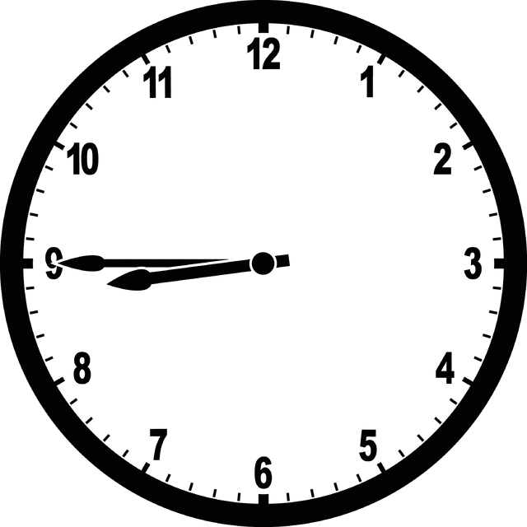
- Do not unlock the doors – the doors are locked so that children cannot get out. Only one set of doors will be open at the beginning of the session. Please do not open other doors to let yourself out.
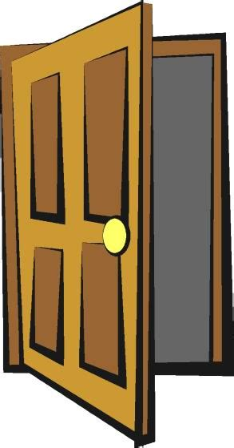
- If you need to speak to a nursery adult, please speak to one of the key workers inside the nursery – Mirsije will be welcoming families into the nursery at the door. Please do not stop and chat to Mirisje as she is there for the safety of the children

Thank you for your support and co-operation.

