Measuring the impact of the Sport Grant 2018/19
PE and school sport play an important part in the life of Holly Park. We believe that PE plays an important part in the holistic development of our children and through this they learn more about values such as respect, co-operation, team spirit, friendship, courage, determination etc

Non – Stop Action Sport Coached Sessions
Most of our PE and Sport Premium Funding is used for ‘Non Stop Action’ Coached PE lessons across the school and to participate in borough wider competitions.
In the last academic year 420 children benefit from specialist PE coaching at Holly Park.
Across the year we have had Non-stop Action coaches in to teach a variety of Outdoor sports and also following staff feedback - indoor dance classes. The standard of coaching was outstanding and teachers were involved in the lessons – teaching parts of the lessons and having access to the planning. Classes completed between one and three units of work each throughout the year, with most classes experiencing at least one indoor and one outdoor topic each.

IMPACT -This has increased both teacher subject knowledge and pupil skill levels particularly in dance (see evaluations and data below).

In the last academic year 420 children benefit from specialist PE coaching at Holly Park.

Impact of coached sessions on Pedagogical Needs (CPD):

Gymnastics (Autumn 1)
Teachers showed a 65% increase in their confidence to create a short gymnastics sequence for their class to perform. The biggest area of improvement for most teachers has been a 67% increase in their confidence to plan a stimulating Floor Gymnastics lesson for their year group.
In the post teaching questionnaires one teacher said, "The lessons have all been of high quality. The children have enjoyed them and been learning." Another teacher said, "Great to watch and learn from the gymnastics teacher, thank you."

Graph showing average score of teachers across a range of parameters before and after the CPD intervention with Non Stop Action

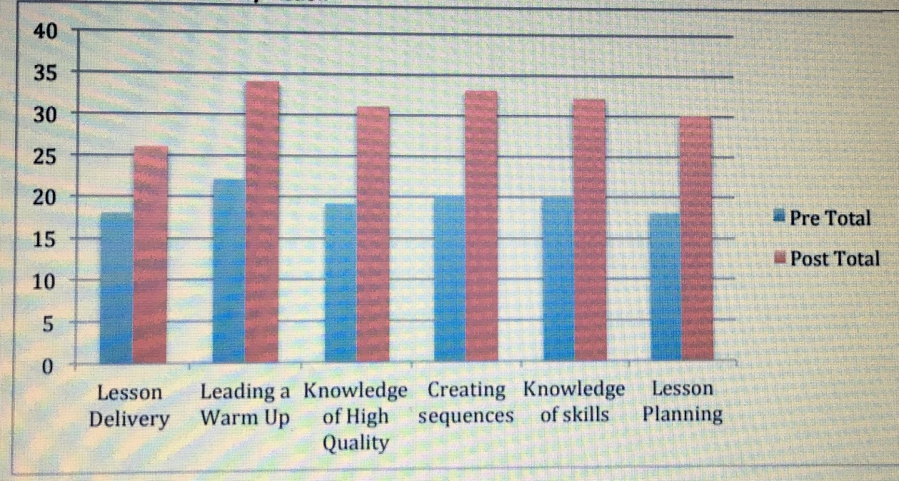

Football (Autumn 2)
Teachers showed a 55% increase in their knowledge of what makes a safe and high quality football lesson for their class, and their ability to assess them. From the findings shown in the chart below, the biggest area of improvement for most teachers has been a 67% increase in their ability to differentiate a football lesson for higher and lower ability students in their class.

Graph showing average score of teachers across a range of pedagogical parameters before and after the CPD intervention with Non Stop Action
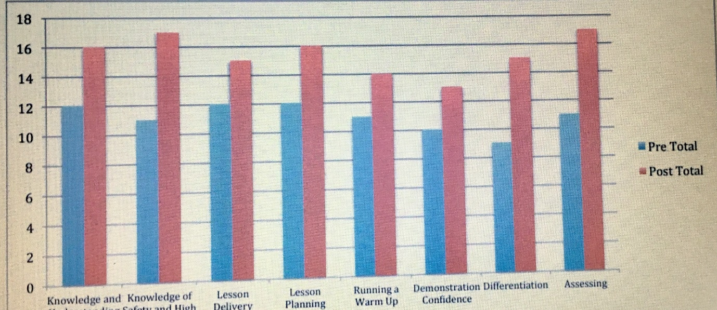

Basketball (Spring 1)
Teachers showed a 100% increase in their ability to differentiate a Basketball lesson for their class. From the findings shown in the chart below, the biggest area of improvement for most teachers has been a 107% increase in their knowledge of what makes a safe and high quality Basketball lesson.
In the post teaching questionnaires one teacher said, "Definitely more confident on the breakdown of skills - observing the coach has helped with this. I have seen pupils' progression over the sessions so now know what to expect in the future." Other teachers said, "I have learned a lot for each of the three focuses. The skill progressions have been really clear, thank you."

Graph showing average score of teachers across a range of pedagogical parameters before and after the CPD intervention with Non Stop Action
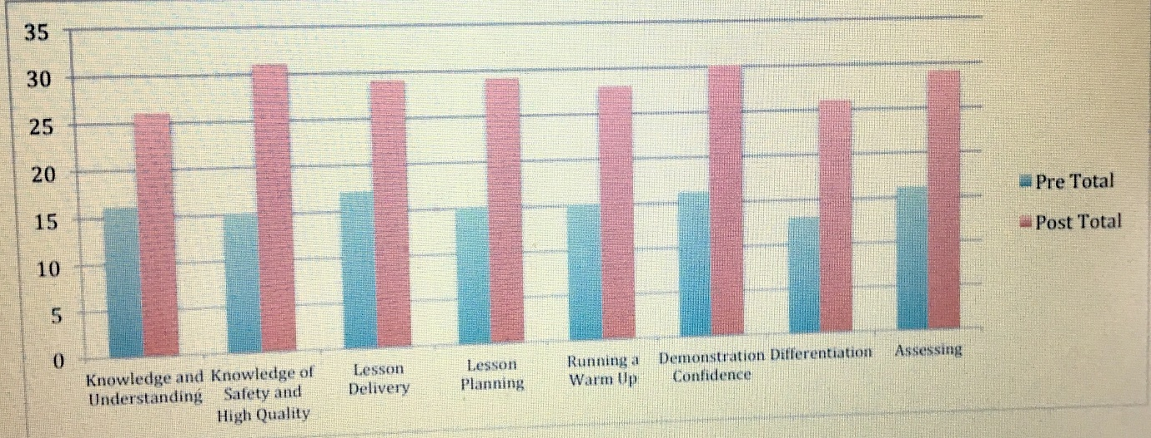

Gymnastics (Spring 2)
Teachers showed an 85% increase in their ability to plan a stimulating floor gymnastics lesson for their class. From the findings shown in the chart below, the biggest area of improvement for most teachers has been a 100% increase in their ability to differentiate floor gymnastics skills for their class.
In the post teaching questionnaires one teacher said, "Fantastic, clear demonstrations from Chiara when modelling specific rolls and movements. Brilliant sessions, throughout the half term." Other teachers said, "Fantastic unit - thank you so much! Best Non Stop CPD I've had." "I have a clearer idea of rolls, balances to teach and what expected level is for Year 6."

Graph showing average score of teachers across a range of pedagogical parameters before and after the CPD intervention with Non Stop Action
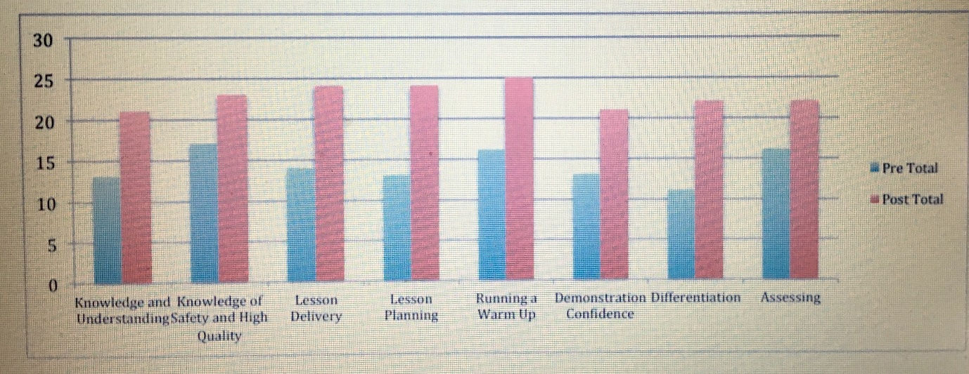

Floor Gymnastics ( Summer 1)
Teachers showed a 55% increase in their ability to assess their children’s progress in Floor Gymnastics. From the findings shown in the chart below, the biggest area of improvement for most teachers has been a 78% increase in their knowledge and understanding of what makes a high quality Floor Gymnastics sequence for their Key Stage.
In the post teaching questionnaires one teacher said, "More confident in getting the children to work as a team to balance and make sequences, making them more independent." Other teachers said, "The instructor Miss Vainella was excellent!"

Graph showing average score of teachers across a range of pedagogical parameters before and after the CPD intervention with Non Stop Action
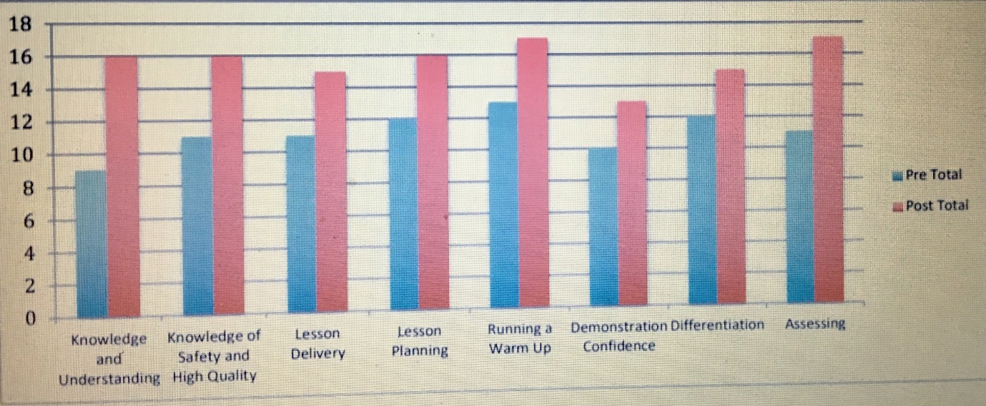

Tennis (Summer 2)
Teachers showed a 75% increase in their ability to assess their children’s progress in tennis. From the findings shown in the chart below, the biggest area of improvement for most teachers has been a 88% increase in their confidence to demonstrate Tennis and Dribbling, Hitting, and Kicking skills to their children.
In the post teaching questionnaires one teacher said, one teacher said, "Much more confident about tennis skills for Year 3 and activities to help children develop these skills. Great teaching, thank you!" Other teachers said, "I feel I have a better bank of ideas for teaching the children - Mr Prior has been excellent in showing technique and skills."

Graph showing average score of teachers across a range of pedagogical parameters before and after the CPD intervention with Non Stop Action
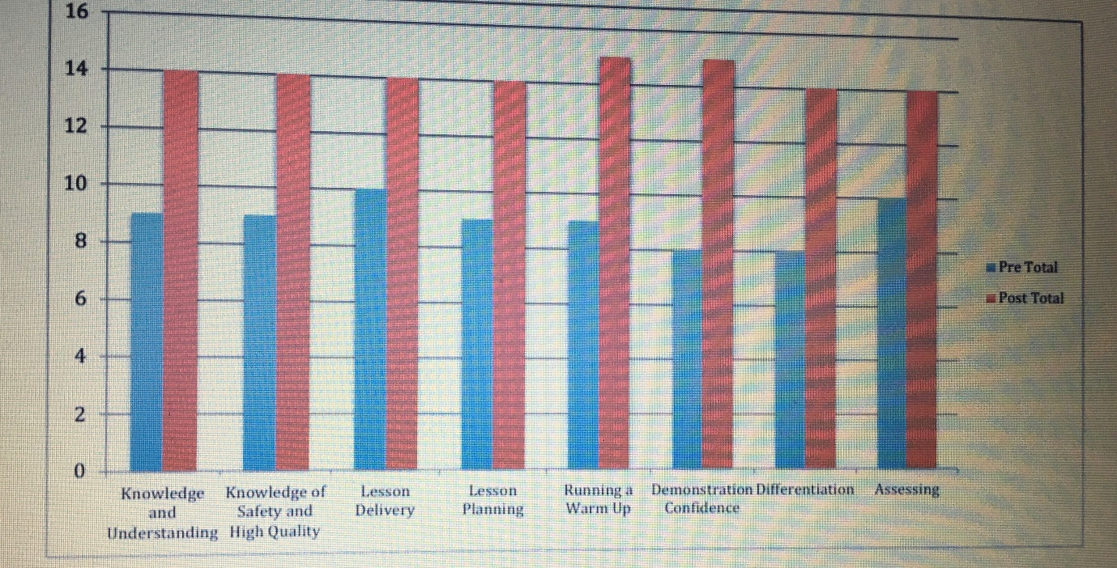

Pupil Data

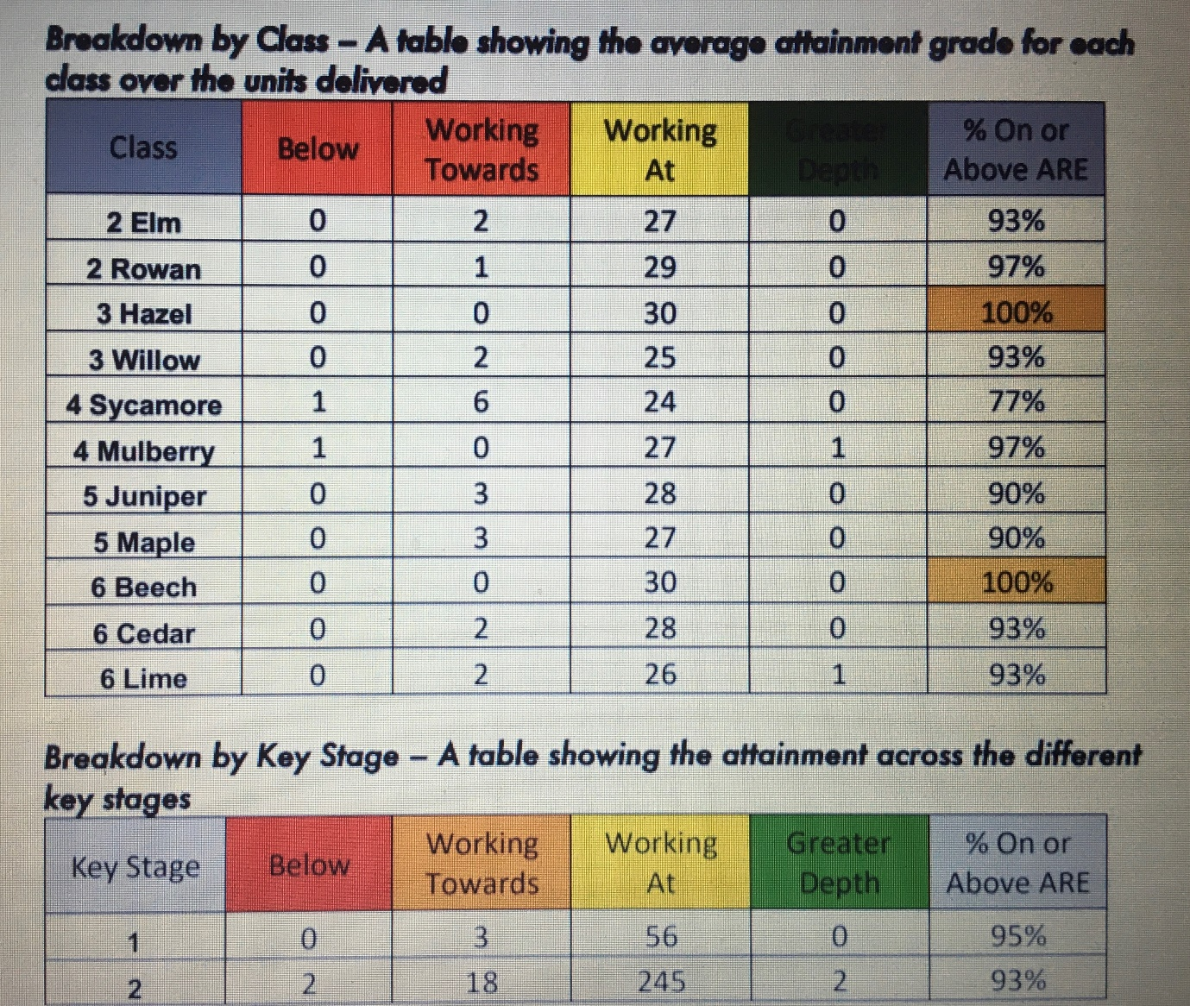

All activities were assisted/team-taught by the regular class teacher, many classes with additional support from teaching assistants.

Barnet Partnership for School Sport
We use our Sports Grant to buy into the Barnet Partnership for School Sport. This allows us to take part in various competitions across Barnet. Last year we took part in many competitions with other schools – lots of football, netball, cross country, gymnastics and athletics. We also participated in the Barnet School’s Dance Festival. We joined a new cheerleading competition this year.

IMPACT –
This continued to keep the profile of sport high and kept the school community updated about it through the weekly newsletter, on the website and in the termly Holly Park highlights. Many pupils did well on an individual basis. Teams also did very well.
Our Cross Country Team competed against 26 other Barnet schools and came 1st place in the borough We won the girls relay trophy
Our netball team continued to enjoy competing against other schools and came 2nd in their division.
Our girls football team won the Barnet East Girls Large School League and the Barnet East Y5&6 Girls Tournament
We entered the Barnet Gymnastics Competition again this year.
The inter school Barnet athletics competition was a massive success for Holly Park again this year We came second of all Barnet medium sized schools. We won the girls relay trophy

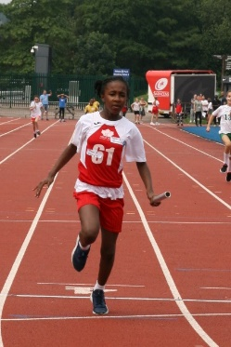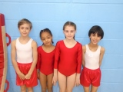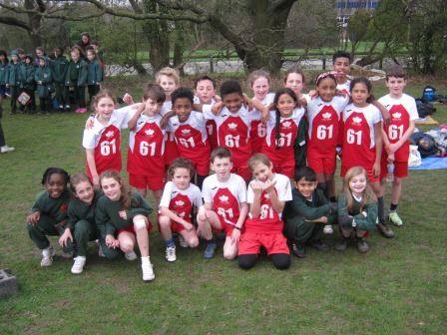

General Sport and Physical Activity Success 2018-19-
IMPACT
This year we have again been awarded the Silver School Games Mark.
We again held two very successful sports days where 420 children took part in non stop physical activity for 90 minutes.
The annaula sports days enabled all children to take part in a competitive way – earning points for their house. Well done to all the teams but particularly to Griffin who won this year
We also had scooter training for Year 2 children and bikeability for Year 3, 4 and Year 5 children.
We had balance bike training for EYFS staff
We encouraged Walk to School and Bike to School Weeks throughout the year.
We also promoted Adventurous Outdoor activity with our residential trips for Years 5 & 6.
Y3 and Y4 took part in extra team games on the Y3 teambuilding day and the Y4 sleepover
We have continued to run Forest Schools every week for our children. Year 5 and Year 1 children all had half a term of Forest School Learning
Swimming has continued for Year 3 and Year 4.
We took part in several inter school sports events (children not usually selected for school teams) with our local partnership schools including a Y1 super hero fun run and a triathlon which we won!
Most year groups have continued doing the daily km for the Mayor of Barnet’s Golden Kilometre Challenge
We took part again in the Barnet Dance Festival with 20 Y6 children participating
We entered a new cheerleading competition
We reapplied for our AFPE award and were successful

