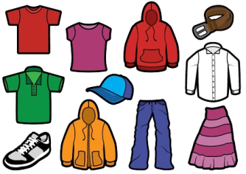 Clothes & The Seaside 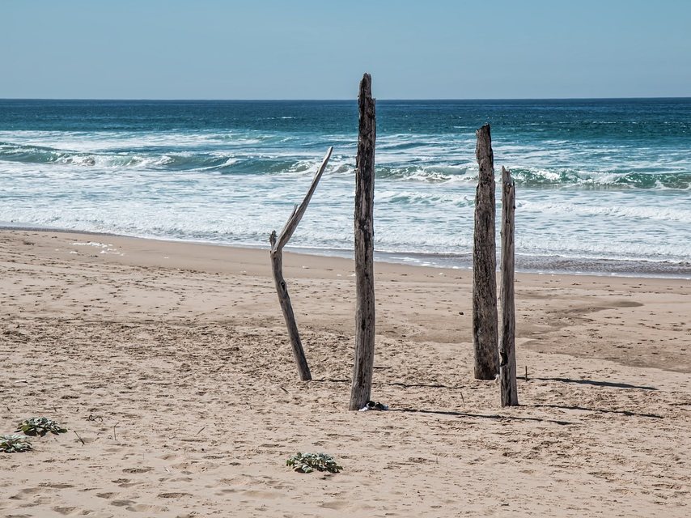

Dear Parents/Carers,

Welcome to the Summer term in Year Two. Our Learning Projects this term are all about Clothes and The Seaside. Please see below for how this links to different areas of the curriculum.

Best wishes,

Avalon Mountford, Hannah Bawcombe and Lewis Turner
English | Maths |  | Science
Proof Reading work  Adding Suffixes  Joining Handwriting  Reading for Meaning  Reading with Pace and Fluency | Time  Shape  Money  Measuring Length | Capacity and Mass  Position and Direction | Food chains  Field work on mini-beasts  Materials
Art & Design | Design & Technology | RE | PSHE
Textiles  Looking at influential designers and their work | Joining Techniques  Strengthening Materials  Shaping Techniques  Colouring by Dying  Running Stitch  Looking at existing Products | Symbols | Sex and Relationship Education
Computing | Geography | History | PE
Keeping Safe  Logging On  Reporting Information  Creating, Storing and Manipulating digital content | Clothes around the world  Naming the continents  Naming Countries  Naming the Oceans  Using NSEW  Grid References  Drawing Simple Map | Timeline of clothes  Using Historical Vocabulary | Rocking and Rolling  Athletics  Games
 | Key dates | Community Links | Visits and Events
 | Sports day 3rd July | International Day | Fashion show  Seaside

Other Information:
PE for Rowan Class will take place on Tuesdays and Friday
PE for Elm Class will take place on Thursdays and Friday

Homework will go home on Fridays. It needs to be returned to school by Thursday the following week.

For Sports day – your child will need their red PE shorts, white trainers and a plain T-shirt in the colour of their House.

Requests:
We would like contributions of the following…tissues, Tesco Extra Value Washing Up Liquid, junk modelling, sellotape, paper, wool, rubber bands and pens for the writing area. THANK YOU!

