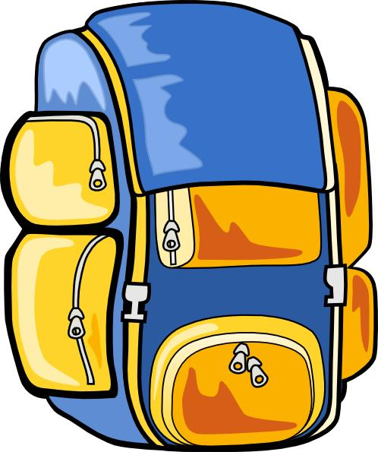 What to pack

Here’s a list of things you’ll need to pack – along with a few that aren’t essential but could be useful.

Things you need:

- Sleeping bag and pillowcase
- A water bottle (essential in the summer)
- Torch
- Rucksack
- Toiletries etc (please note deodorants must be roll-on, no aerosols)
- Old clothes for activity sessions – (long-sleeved shirts/jumpers, trousers / jogging bottoms (Not denim jeans), T-Shirts and closed-toe shoes are required for nearly all sessions so bring plenty). Long sleeved tops and long trousers are COMPULSORY for some activities, even in hot weather. Clothes, shoes and underwear for other times.
- Waterproof clothing (jacket / trousers)
- Large plastic bag for dirty clothes
- Bath towels x 2
- Sunglasses, sun cream and hat in the summer
- Pyjamas and slippers
- Hard wearing waterproof watch
- COMPULSORY – a teddy
- Books, playing cards and other quiet activities
- Personal stereo / MP3 player for the journey there and back

Useful notes:
- No wellies
- Please name all clothing
- Denim jeans are not ideal for outdoor use
- Children are NOT allowed to bring mobile phones, electronic toys or games

Manor Adventure can’t accept liability for the loss of any personal property brought to our centres – so please don’t bring any valuable items, expensive clothing and footwear, mobile phone, handheld games consoles etc. We’re unable to store them and they won’t be insured whilst on centre.

