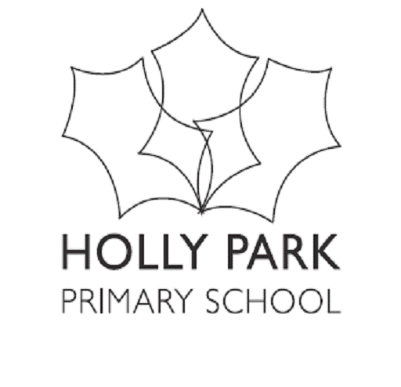
Bellevue Road, Friern Barnet, London N11 3HG
t: 020 8368 1434 f: 020 8361 6329 e: office@hollypark.barnetmail.net
www.hollyparkschool.co.uk
February 2019
Dear parents
World Book Day 2019

World Book Day is on Thursday 7th March. At Holly Park we believe that it is very important to celebrate this event. We always ask the children to dress up with a book related theme. Over the years we have covered a wide variety of themes.

This year our theme is a little unusual. As you know, we have been working on increasing vocabulary. This is part of our school improvement plan.

Books are full of vocabulary.

So – this year we want each child to choose a word that they think is interesting or adventurous or a new word to them. We want them to come to school dressed as that word. Costumes can be shop bought or homemade or a combination of both. We would like each child to come with a label on their costume which has the word on it – to make it clear what the word is. This is perhaps a little bit more challenging than in previous years but will allow for a lot of creativity and fun together at home.

For example the word:
ABODE – a child could come dressed in a cardboard box decorated as a house
FEROCIOUS – a child could come dressed as a tiger with the word ferocious written on a label
FLEET – a child could come wearing all blue clothing with cut out ships pinned to them and wearing a sailor cap
FLORA – a child could come dressed as a flower
TRANSPARENT – a child could come dressed all in white – but wrapped in clear plastic
EXTINCT – a child could come dressed as a dinosaur with the word extinct pinned to them
FURIOUS – a child could come dressed all in red with red face paint – with the label furious
FRIVOLOUS – a child could be multi-coloured with ribbons, scarves etc – with the label frivolous pinned on
MELANCHOLY – a child could come dressed all in grey with a sad face – face painted on
JUSTICE – a child could come dressed as a judge
PUNCTUAL – a child could come dressed all in black but with a huge clock face made out of cardboard on the front

The possibilities are endless. Have a good think over half term and be as creative as you can. Choose a tricky new word for your child – but age appropriate. You might spend some time looking at a dictionary together to choose a word. It might link to the topic they are doing at school. Have fun!

Do remember that the child needs to wear a big label with the chosen word on. They also need to know what the word means. In school that day we will do some work around the words that the children come dressed as.

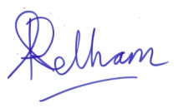

Ann Pelham
Headteacher

