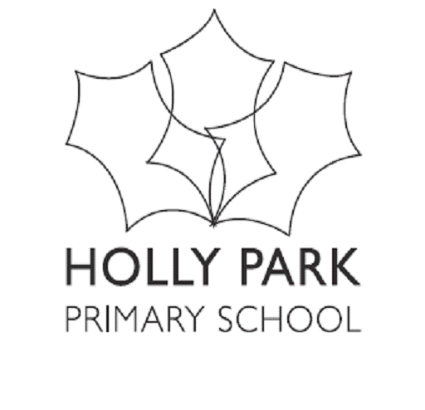

Bellevue Road, Friern Barnet, London N11 3HG
t: 020 8368 1434 f: 020 8361 6329 e: office@hollypark.barnetmail.net
www.hollyparkschool.co.uk
January 2019
Dear Parents and Carers,
Parent Questionnaire 2018

As part of our Ofsted Inspection at the end of November, there was opportunity for parents to complete the Ofsted online parent questionnaire – called Parent View. As a school we always do our own parent questionnaire at the end of the Autumn term using the same Ofsted questions. As parents have had opportunity to do this questionnaire and speak to Ofsted inspectors we decided not to do our own questionnaire but to count the Ofsted questionnaire as our questionnaire for this academic year. Thank you to everyone who completed these parent questionnaires. There were 154 responses which is 28 more than 2017 and 41 more responses than 2016.

It is our strong belief that working closely with parents/carers is vital to the successful education and development of all our pupils. To support this I am keen to engage with parents and carers in a variety of ways including parents’ evenings, coffee mornings, information meetings, informal conversations to name but a few.

A particular focus, on an annual basis, is placed on formal consultation in the form of the parent questionnaire and it asks parents/carers to consider a variety of issues. Along with all of the other channels of information sharing mentioned above, these questionnaires can help to inform plans for the future direction of the school.

The results from this year’s Parent Questionnaire were as follows:
November 2018 Parent Questionnaire – OFSTED Parent View  (Each person who answered represents approx 0.65%) | % Strongly agree | % Agree | Total  Positive  Responses | %  Disagree | %  Strongly Disagree | Total  Negative  Responses | %  Don't know | Total
My child is happy at Holly Park | 70 | 25 | 95% | 4 | 1 | 5% | 1 | 100%
My child feels safe at Holly Park | 72 | 23 | 95% | 3 | 2 | 5% | 0 | 100%
My child makes good progress at Holly Park | 46 | 45 | 91% | 6 | 2 | 8% | 1 | 100%
My child is well looked after at Holly Park | 67 | 27 | 94% | 4 | 1 | 5% | 1 | 100%
My child is taught well at Holly Park | 52 | 38 | 90% | 4 | 3 | 7% | 3 | 100%
My child receives appropriate homework for their age | 42 | 45 | 87% | 10 | 1 | 11% | 1 | 100%
Holly Park makes sure its pupils are well behaved | 56 | 34 | 90% | 4 | 3 | 7% | 4 | 100%
Holly Park deals effectively with bullying | 41 | 31 | 72% | 5 | 3 | 8% | 19 | 100%
Holly Park is well led and managed | 53 | 36 | 89% | 4 | 5 | 9% | 2 | 100%
Holly Park responds to any concerns I raise | 53 | 31 | 84% | 6 | 7 | 13% | 3 | 100%
I receive information (verbally or written) about my child's progress | 42 | 45 | 87% | 10 | 1 | 11% | 2 | 100%
Would you recommend this school to another parent? | 94% |  |  | 6% |  |  |  | 100%

We also thank those of you who shared many positive comments with inspectors in the school playgrounds. We are pleased that many of the areas we feel are important are also recognised and appreciated by parents. Inspectors commented in the report that:
‘Parents have a very positive view of the school and the overwhelming majority of those who spoke to inspectors or who responded to the online questionnaire would recommend the school to other parents’

The inspectors shared the comments that they received from parents with myself and Miss Michael in the final meeting we had with them. The overwhelming majority of comments were positive comments.

A sample of the positive comments the inspectors received and reported to us were –
- Holly Park fosters an atmosphere of love, learning, kindness and community that every single member of staff works so hard to foster and sustain
- Communication from the school is excellent
- As a family we are so happy to have our kids at Holly Park
- A wonderful and loving community has grown out of Holly Park School as a natural and organic result of the atmosphere they actively cultivate and encourage within the school gates
- It is clear how seriously the school takes its responsibility to be as good as it can be, and create a healthy and happy learning environment
- I have a happy child and that’s all that matters
- I am very happy with the teaching
- My child has someone to go and speak to if they need to
- The curriculum is exciting, there are lots of clubs and school trips
- My child enjoys coming to school
- The care and support at the school is excellent
- As a parent I feel welcome at the school
- The atmosphere within the school and the happy demeanour of Holly Park kids is a testament to the school’s success at creating a nurturing and inspiring learning setting.

Thank you once again for your responses.

If you feel that at any time that you have any further queries or comments about the school, or your child’s experiences at Holly Park, please do speak to one of our senior members of staff or one of our parent governors.

Yours sincerely

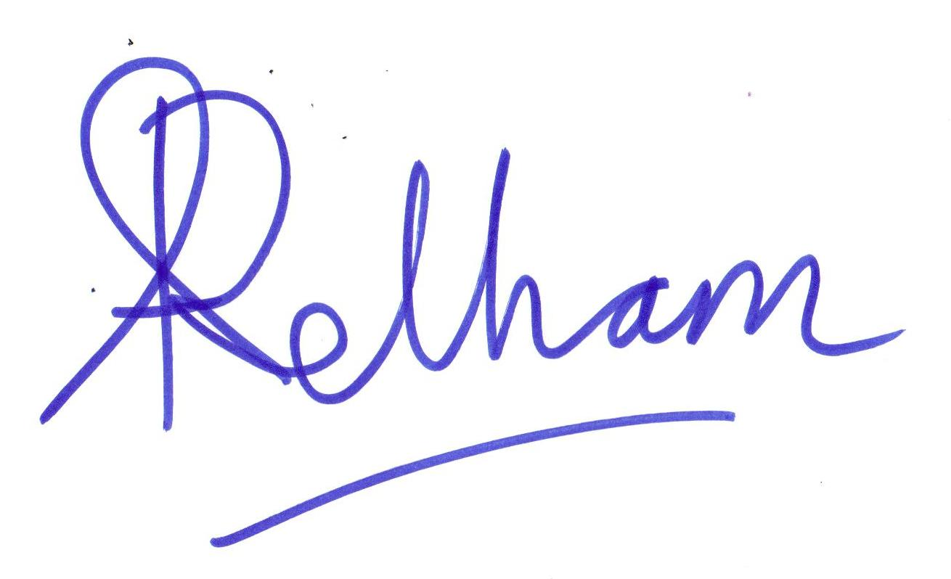
Ann Pelham
Head teacher

