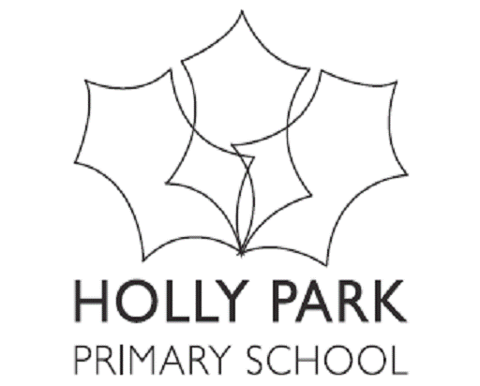 Holly Park School – Governors Premises Committee Date – 29th October 2018
Present- Fiona Quinton. Ann Pelham, Maria Michael, Simon Reid
Apologies – Fiona Vettiankel, Claire Wischhusen, John Harte.
AGENDA ITEMS | KEY DISCUSSION POINTS | ACTION (who? /timescale?)
Actions from previous Agenda:  - I) Investigate details of the electricity bill with Barnet Council  - Ii) Look at linking green procurement policy with premises management policy in places  - Iii) Wooden edging to be fitted to flower beds outside foyer area | - Query whether this should be on the finance agenda?  - Deferred to next summer. However to note that Barnet Council is taking back the food bins as the service is being suspended. We will have to source new bins and the food will go into landfill.  - This has been completed.
Actions relating to SIP for this committee:  - To develop the EYFS provision even further in the outdoor area | There is a budget of £15k (£14k from the sports grant and £1k from the PTA) which is being spent on EY. This must be done next summer so needs to be ordered by Easter. | SR meeting a playground specialist.
- Summer works report – Simon | SR reported that all summer works had gone according to plan – decorating and re-carpeting Ms Thomas’ room, Mr Hogan’s room, the Literacy base and dining hall; the canopy and fencing outside Elm class; fencing repairs in the junior playground; repairs to the wet pour surface in the infant playground and a new kitchen in SR’s house. The gate has now been replaced but alterations to the buzzer system are urgently needed. | SR to chase changes to gate buzzer.
- Staff H&S training September | In September all staff were trained in using fire extinguishers.
- Review of policies  - Critical Incident  - Site Security  - Lockdown | To follow. | AP to forward policies
- The bid for a sanctuary space | MM and FQ reported that an architect had visited and suggested a new site for the sanctuary in the space occupied by the PTA shed, packed lunch shelter and football shed. It was agreed that this was a more viable plan if it was packaged with extending the playground, providing outdoor space for 2 (?) more classrooms and finding a place to relocate the sandwich shelter and PTA shed. | FQ to draft a list of jobs needed for this which SR will review and put rough prices on.
- Health & Safety Audit | This is an external audit by Barnet Council which will take place on Nov 21. Mainly a paperwork review. AP asked FQ to attend.
- Matters to be taken to full govs | Progress on the Sanctuary.  We will have a spare classroom by September.
- AOB

