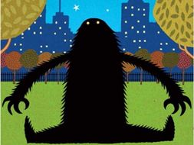
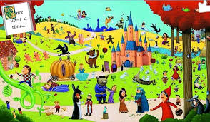
Heroes and Villains

Dear Parents/Carers,
Welcome to the Autumn term in Year 2. Our Learning Project across the whole term is Heroes and Villains. This half term we will be focusing on two books: The Lonely Beast and The Dark. Next half term we will be focusing on mixed up Fairy Tales and Special People. Please see below for how this links to different areas of the curriculum.
Best wishes,
Lewis Turner and Hannah Bawcombe

English | Maths |  | Science
Stories with familiar settings  Traditional stories / Extended stories (mixed up)  To discuss the sequence of events in books and how items of information are related. | Place Value – tens and ones  Addition and Subtraction  To recall and use multiplication and division facts for the 2, 5 and 10 multiplication tables, including recognising odd and even numbers. | Multiplication  Division  Statistics (reading a scale), Time (counting in 5s), Capacity & Mass (reading a scale) | Animals and humans
Art & Design | Design & Technology | RE | PSHE
Printing and Patterns  Painting  Sculpture- clay  Drawing | Design, Make and Evaluate (moving pics) | Special People including trip to the synagogue | Being Responsible, writing our class charter  Recognising and Managing feelings
Computing | Geography | History | PE
Coding – writing instructions for BeeBot  E-safety |  | People in history- rebel stories for girls  Black History Month | Throwing and Catching  Flight (jumping)
Spanish | Music | Other Information | Visits and events
To be able greet someone in Spanish, to have a basic conversation (name, how are you, how old are you) and to sing a greetings song  To be able to say ´yes and no´´  To be able to count from 1 to10 and sing a song about numbers  To be able to say please and thank you and other general vocabulary  To be able to say in Spanish “It´s hot, its cold” | To understand that music is made up of long and short sounds.  To create sequences of long/short sounds.  To be able to combine long/short sounds within a steady pulse.  To begin to distinguish between rhythm patterns and the musical pulse. To combine rhythm patterns and the pulse.  To use word phrases to compose rhythm patterns. | Homework will be sent home each Wednesday and needs to be returned each Monday, please.  We will need additional parents helpers on our trips, please support us in this if you are able. We will send more information nearer the time. | Visit to Synagogue  Kew Gardens  Key Dates:  WB: 1st October 2018 – Year Two End of Year Expectations Meeting

