 Holly Park School
Child Protection & Safeguarding Policy

Designated Safeguarding Lead Sally Thomas (Families Co-ordinator)

Deputy Designated Lead Ann Pelham (Headteacher)

Deputy Designated Lead Maria Michael (Deputy Headteacher)

Deputy Designated Lead Diana Kelly (Children’s Co-ordinator)

Deputy Designated Lead Kathy Puzey (Learning Mentor)

Deputy Designated Lead Clare Mornington (Nursery Nurse)

Named Governor for Safeguarding Clare Wischhusen

* All of the above have completed Level 3 training

Online Safety Co-ordinators Lewis Turner & Dominic Carini

Named Governor for Online Safety Fiona Quinton

PREVENT DUTY Single Point of Contact Ann Pelham (Headteacher)

Named Governor for Looked After Children Clare Wischhusen

Chair of Barnet Safeguarding Board Andrew Fraser

Barnet Safeguarding Officer Jane Morris

Barnet LADO Shrimitie Bissefar

Barnet PREVENT Education Officer Peryn Jasper (83597311)

*This policy has been updated in response to the release of KCSIE 2018.

Contents Page
What to do if you have a concern at Holly Park page 4
Introduction and ethos page 5
Access to safeguarding documents page 6
Definition page 6
Contextual Safeguarding page 6
Aims page 6
Role and responsibilities page 9
Early Help page 13
Inter Agency working page 14
Abuse and neglect page 14
School Procedures page 15
Staff Training page 17
Confidentiality & information sharing page 18
Record Keeping page 19
Safer Recruitment page 19
Volunteers recruitment & checks page 21
Single Central Record page 21
Safer Working Practice and Allegations against staff page 22
Disqualification by Association page 23
Extremism and Radicalisation (PREVENT Duty) page 23
Children with SEN and disabilities (SEND) page 28
Child Missing in Education page 29
Child Sexual Exploitation (CSE) page 30
Honour Based Violence (HBV) page 31
Forced Marriage page 32
Female Genital Mutilation (FGM) page 33
Health & Safety page 34
First Aid page 34
Site Security page 35
Attendance page 35
Volunteers welcome & induction page 36
Welcoming Visitors page 36
Curriculum page 36
Online Safety page 37
Positive Handling page 38
Behaviour page 38
Anti-bullying page 38
Peer on Peer Abuse page 39
Sexting page 40
Racial Tolerance page 44
Photos/videos page 44
Whistle blowing page 45
Intimate care page 45
Use of mobile phones page 45
Personal transport page 46
Home Visits page 46
One to one working page 46
Supervision page 46
CAFs page 47
Private Fostering page 48
Children Affected By gang Activity and Youth Violence page 48
Homelessness page 49
County Lines Criminal Activity page 49
Pupils with Family Members in Prison page 49
Pupils required to give evidence in Court page 49
Alternative Provision page 50
Transfer of Information page 50
GDPR page 50
Policy Monitoring page 50
Links to UN Rights of the Child page 50
Other Associated policies page 53

Appendices

Appendix 1: School Alert Form

Appendix 2: Body Map

Appendix 3: Categories of Abuse

Appendix 4: Keeping yourself safe when responding to disclosures

Appendix 5: EYFS Supervision Contract

Appendix 6: EYFS Supervision Agenda

Appendix 7: Private Fostering

Immediately record your concerns on schools reporting form
Follow the schools procedure (Alert Form)
Clarify concerns if necessary (TED: Tell, Explain, Describe)
Use child’s own words
Sign and date your records
Reassure the child
Inform the Designated Safeguarding Lead (Sally Thomas)
Consider: is the child is at immediate risk of harm e.g. unsafe to go home?
If so, then the DSL must be informed immediately.
Designated Safeguarding Lead

Consider LSCB Threshold document and procedures:
Refer to other agencies as appropriate e.g. DO (LADO), Early Help Notification Form / CAF form or Inter-Agency Referral Form / MASH referral form

If you are unhappy with the response

Staff:
Seek advice from the Education Safeguarding Team

Pupils and Parents:
Follow school complaints procedures
At all stages the child’s circumstances will be kept under review
The DSL/Staff will re-refer if required to ensure the child’s safety is paramount
Record decision making and action taken on the Alert Form and put in child protection/safeguarding file
Monitor
Be clear about:
What you will monitor e.g. behaviour trends, appearance etc.
How long you will monitor
If/who to feedback to and how you will record
Review and Re-refer (if necessary)
Why are you concerned?
For example
Disclosure
Child’s appearance
Behaviour change
Witnessed concerning behaviour
What to do if you have a Child Protection concern at Holly Park

Introduction and Ethos
Holly Park is a community and all those directly connected (staff, governors, parents, families and pupils) have an essential role to play in making it safe and secure.
Holly Park recognises our moral and statutory responsibility to safeguard and promote the welfare of all children.
Holly Park recognises the importance of providing an ethos and environment within school that will help children to feel safe, secure and respected; encourage them to talk openly; and enable them to feel confident that they will be listened to. We are alert to the signs of abuse and neglect and follow our procedures to ensure that children receive effective support, protection and justice.
Our school core safeguarding principles are:
- It is a whole school responsibility to safeguard and promote the welfare of children as its paramount concern
- All children (defined as those up to the age of 18) regardless of age, gender, ability, culture, race, language, religion or sexual identity, have equal rights to protection
- All children have a right to be heard and to have their wishes and feelings taken into account
- All staff understand safe professional practice and adhere to our code of conduct and other associated policies
All staff have a responsibility to recognise vulnerability in children and act on any concern in
accordance with this guidance
There are four main elements to our safeguarding policy:
Prevention (e.g. positive, supportive, safe school culture, curriculum and pastoral opportunities for children, safer recruitment procedures);
Protection (by following the agreed procedures, ensuring all staff are trained and supported to respond appropriately and sensitively to safeguarding concerns);
Support (for all pupils, parents and staff, and where appropriate specific intervention for those who may be at risk of harm);
Working with parents and other agencies (to ensure appropriate communications and actions are undertaken).
The procedures contained in this policy apply to all staff and governors and are consistent with
those of the Barnet Safeguarding Children Board

It will be achieved by:
- Creating a culture of safer recruitment by adopting procedures that help deter, reject or identify people who might pose a risk to children.
- Raising awareness of child protection issues
- Educating pupils on how to keep safe and to recognise behaviour that is unacceptable.
- Identifying and making provision for any pupil that has been subject to abuse.
- Ensuring that members of the governing body, the Headteacher and staff members understand their responsibilities under safeguarding legislation and statutory guidance, and are alert to the signs of child abuse and know to refer concerns to the designated safeguarding lead (DSL).
- Ensuring that the Headteacher and any new staff members and volunteers are only appointed when all the appropriate checks have been satisfactorily completed.
- Developing and then implementing procedures for identifying and reporting cases, or suspected cases, of abuse.
- Establishing a safe and secure environment in which all children can learn and develop

All school staff have a responsibility to provide a safe environment in which children can
learn.

We have a team of six people on our safeguarding team. A member of the schools safeguarding
team will be available at all times in school to support staff with concerns

The Teachers’ Standards 2012 state that teachers, including Headteachers, should safeguard
children’s wellbeing and maintain public trust in the teaching profession as part of their
professional duties

All staff are required to read and sign the Staff Key Policy list which includes this safeguarding
policy, Keeping Children safe in Education and the Staff Code of Conduct

Access to the Safeguarding Documents
This policy and all related documents can be found in the shared area of the school network. All associated safeguarding documents are kept together in one accessible file. They are also available to access via the school website
Parents have access to the policy via the school website. If any parent does not have access to
the website they can pick up a copy at the school office on request.

Definition
“Safeguarding is not just about protecting children from deliberate harm. It includes a wide range of issues relating to pupil’s welfare, health and safety.” (Inspecting safeguarding in early years, education and skills, Ofsted, September 2016)
For the purpose of this policy, Holly Park will define “safeguarding and protecting the welfare of children” as:
- Protecting pupils from maltreatment.
- Preventing the impairment of pupils’ health or development.
- Ensuring that pupils grow up in circumstances consistent with the provision of safe and effective care.
- Taking action to enable all pupils to have the best outcomes

Contextual safeguarding
Safeguarding incidents can occur outside of school and can be associated with outside factors. School staff, particularly the DSL and their deputy(s), will always consider the context of incidents – this is known as contextual safeguarding. Assessment of pupils’ behaviour will consider whether there are wider environmental factors that are a threat to their safety and/or welfare. The school will provide as much contextual information as possible when making referrals.

Aims
At Holly Park we are committed to Safeguarding and promoting the welfare of all of our
children. Each child’s welfare is of paramount importance to us. We believe in providing the
best for every child. We recognise that some children may be especially vulnerable to abuse
and recognise that these particular children will need additional support to be positive about
themselves and fulfil their potential. We will always take a considered and sensitive approach in
order that we can support all of our children.

We take great pride in encouraging all our children to feel part of, and to contribute
positively to fundamental British values.

As a community school we are committed to the development of community cohesion and the
prevention of extremism and radicalisation both within our school’s physical boundaries and
within our local, national and global environments. We are also committed to respond to
community concerns or local disturbances in a positive way which supports British democratic
society.

We aim to develop our policy and practice in line with current legislation and guidance but also
in line with the experiences, training and expertise of our staff.

We recognise that the safeguarding of all children, staff, parents, visitors and volunteers
should be a priority at all times. This will include steps taken to ensure the safety and
protection of all members of the school community on a daily basis such as:
- Home visits for all new starters across the school
- Registers taken at the start of the morning and afternoon sessions
- First day calling to establish the situation for absent pupils
- The requirement for parents to sign in children arriving late and being taken out of school early
- The wearing of identity lanyards by all staff
- The carrying out of Disability and Baring Service and identity checks for all adults working in the school
- The use of an entry system to monitor visitors to the site
- The requirement for all visitors to sign in and out of the school
- The maintenance of a single central record
- Termly fire drills, lock down drills and emergency evacuation plans displayed in all rooms
- Regular premises tours by the site manager, Headteacher and Chair of the premises sub-committee to identify health and safety risks, trip hazards etc
- The management of the premises, including writing risk assessments eg for the pond area, play equipment, snow
- Risk assessments written and carried out prior to all trips
- Staff/pupil ratios adhered to especially on trips and visits
- Frequent head counts on trips
- Regular reminders about the use of the internet, social media, cameras etc. Staff are expected to sign forms yearly to accept safe use of technology including the prohibition of the use of mobile phones to take photos of children or used in directed hours. (see data security policy and acceptable use agreement)
- Parents sign permission forms on entry to the school – for such things as permission for the child’s photo to be put on the website
- Acceptable use of technology charts are displayed in all classrooms and pupils are reminded of the computer rules. Pupils and parents sign a form.
- Anti bullying is kept high profile including annual participation in National Anti Bullying week
- Participation in National awareness campaigns – e.g Safer Internet day, World Peace day, National Road safety Week.
- We send out contact detail forms yearly for all pupils to ensure we have the most up to date contact and emergency contact information.
- Safer recruitment procedures followed with regard to employing staff and staff files maintained with DBS checks, proof of identity, references and qualifications.
- Individual behaviour plans and risk assessments for individuals as needed
- Food hygiene training for appropriate staff
- First aid and paediatric first aid training for appropriate staff
- We record accidents daily in an accident book. Accidents are analysed and reported to governors
- We keep records of behaviour including racist and homophobic behaviour and these are also analysed and reported to governors
- Health care plans as needed
- Staff training on asthma and the use of epi-pens
- The taking of medicines on trips
- Permission to administer medicine forms filled in before prescribed medicines are given

Pupils at Holly Park will be taught about safeguarding issues. Children will be regularly
reminded about Safeguarding, especially e-safety and personal safety through a variety of
curriculum opportunities eg PHSE and Police visits and assembly e.g NSPCC & PANTS.

We recognise that children who are abused or witness violence may find it difficult to
develop a sense of self worth. They may feel helplessness, humiliation and some sense of
blame. The school may be the only stable, secure and predictable element in the lives of
children at risk. When at school their behaviour may be challenging and defiant or they may
be withdrawn. The school will endeavour to support the pupil through:
- The content of the curriculum.
- The school ethos which promotes a positive, supportive and secure environment and gives pupils a sense of being valued.
- The school behaviour policy which is aimed at supporting vulnerable pupils in the school. The school will ensure that the pupil knows that some behaviour is unacceptable but they are valued and not to be blamed for any abuse which has occurred.
- Liaison with other agencies that support the pupil such as social services, Child and Adolescent Mental Health Service, education welfare service and educational psychology service etc.

We recognise that because of the day to day contact with children, school staff are well
placed to observe the outward signs of neglect, abuse, changes in behaviour and a failure to
develop. All staff are advised to maintain an attitude of ‘it could happen here’ with regard to
safeguarding.
The school will therefore:
- Establish and maintain an environment where children feel secure, are encouraged to talk, and are listened to.
- Ensure children know that there are adults in the school whom they can approach if they are worried.
- Include opportunities in the PSHE curriculum for children to develop the skills they need to recognise and stay safe from abuse.
- Include opportunities to find out how parents and pupils feel about safety through our annual questionnaires

Roles and Responsibilities
Everyone who comes into contact with children and their families has a role to play in safeguarding children. Schools and colleges form part of the wider safeguarding system for children.

The governing body has a duty to:
- Ensure that the school complies with its duties under the above child protection and safeguarding legislation.
- Guarantee that the policies, procedures and training opportunities in the school are effective and comply with the law at all times.
- Guarantee that the school contributes to inter-agency working in line with the statutory guidance Working Together to Safeguard Children 2015.
- Confirm that the school’s safeguarding arrangements take into account the procedures and practice of the LA as part of the inter-agency safeguarding procedures established by the Barnet Safeguarding Children Board (BSCB).
- Comply with its obligations under section 14B of the Children Act 2004 to supply the BSCB with information to fulfil its functions.
- Ensure that a member of the governing body is nominated to liaise with the LA and/or partner agencies on issues of child protection, and in the event of allegations of abuse made against the headteacher or other governor.
- Guarantee that there are effective child protection policies and procedures in place together with a staff code of conduct.
- Ensure that there is a senior board level lead responsible for safeguarding arrangements.
- Appoint a member of staff from the senior leadership team (SLT) to the role of DSL as an explicit part of the role-holder’s job description – there should always be cover for the DSL.
- Appoint one or more deputy DSLs to provide support to the DSL, and ensure that they are trained to the same standard as the DSL and that the role is explicit in their job description(s).
- Make sure that pupils are taught about safeguarding, including protection against dangers online, through teaching and learning opportunities, as part of providing a broad and balanced curriculum.
- Adhere to statutory responsibilities to check staff who work with children, taking proportionate decisions on whether to ask for any checks beyond what is required.
- Guarantee that volunteers are appropriately supervised.
- Make sure that at least one person on any appointment panel has undertaken safer recruitment training.
- Ensure that all staff members receive safeguarding and child protection training updates, such as e-bulletins, emails and staff meetings, as required, but at least annually.
- Certify that there are procedures in place to handle allegations against members of staff or volunteers.
- Confirm that there are procedures in place to make a referral to the Disclosure and Barring Service (DBS) if a person in regulated activity has been dismissed or removed due to safeguarding concerns, or would have been had they not resigned.
- Guarantee that there are procedures in place to handle allegations against other pupils.
- Make sure that pupils’ wishes or feelings are taken into account when determining what action to take, and what services to provide to protect individual pupils.
- Guarantee that there are systems in place for pupils to express their views and give feedback.
- Establish an early help procedure and inform all staff of the procedures it involves.
- Appoint a designated teacher to promote the educational achievement of looked after children (LAC) and ensure that this person has undergone appropriate training.
- Ensure that the designated teacher works with the virtual school head to discuss how the pupil premium funding can best be used to support LAC.
- Introduce mechanisms to assist staff in understanding and discharging their roles and responsibilities.
- Make sure that staff members have the skills, knowledge and understanding necessary to keep LAC safe, particularly with regard to the pupil’s legal status, contact details and care arrangements.
- Put in place appropriate safeguarding responses for pupils who go missing from school, particularly on repeat occasions, to help identify any risk of abuse and neglect, including sexual abuse or exploitation, and prevent the risks of their disappearance in future.
- Ensure that all members of the governing body have been subject to an enhanced DBS check.

The Headteacher has a duty to:
- Safeguard pupils’ wellbeing and maintain public trust in the teaching profession.
- Ensure that the policies and procedures adopted by the governing body, particularly concerning referrals of cases of suspected abuse and neglect, are followed by staff members.
- Provide staff with the Child Protection and Safeguarding Policy, Staff Behaviour Policy, information regarding the role of the DSL and part one of the Keeping Children Safe in Education (KCSIE) 2016 guidance at induction.
- Provide staff, upon induction, with the Child Protection and Safeguarding Policy, Staff Code of Conduct, part one of the Keeping Children Safe in Education (KCSIE) (2018) guidance, Behavioural Policy, the safeguarding response to children who go missing from education, online safety training, and the identity of the DSL and any deputies.

The Role of the Designated Safeguarding Lead
The Lead Designated safeguarding Officer at Holly Park is Sally Thomas. The Deputy
Designated Officers are Ann Pelham (HT) and Maria Michael (DHT). Together with Diana
Kelly (SENCO), Clare Mornington (NN) and Kathy Puzey (Learning Mentor) they comprise the
Child Protection team.
There will also be a named Governor who is responsible for Child Protection and Safeguarding
in the school. This is currently Clare Wischhusen. Safeguarding is always an agenda item at
SMT meetings and on the agenda for the governors Staffing & Pupil Welfare Committee and in
the Headteacher report to governors.

The DSL has a duty to:
- Refer all cases of suspected abuse to Children’s Social Care, the LA designated officer (LADO) for child protection concerns, the DBS, and the police in cases where a crime has been committed.
- Refer cases of radicalisation to the Channel programme.
- Liaise with the Headteacher to inform him/her of safeguarding issues, especially ongoing enquiries under section 47 of the Children Act 1989 and police investigations.
- Act as a source of support, advice and expertise to staff members on matters of safeguarding by liaising with relevant agencies.
- Understand the assessment process for providing early help and intervention.
- Support staff members in liaising with other agencies and setting up inter-agency assessment where early help is deemed appropriate.
- Keep cases of early help under constant review and refer them to the Children’s Social Care if the situation does not appear to be improving.
- Have a working knowledge of how LAs conduct a child protection case conference and a child protection review conference, and be able to attend and contribute to these effectively when required to do so.
- Ensure each member of staff has access to and understands the school’s Child Protection and Safeguarding Policy and procedures – this will be discussed during the staff induction process.
- Be alert to the specific requirements of children in need, including those with special educational needs and disabilities (SEND) and young carers.
- Be able to keep detailed, accurate and secure records of concerns and referrals.
- Obtain access to resources and attend any relevant training courses.
- Encourage a culture of listening to children and taking account of their wishes and feelings.
- Work with the governing body to ensure the school’s Child Protection and Safeguarding Policy is reviewed annually and the procedures are updated regularly.
- Ensure the school’s Child Protection and Safeguarding Policy is available publicly, and parents/carers are aware that the school may make referrals for suspected cases of abuse or neglect, as well as the role the school plays in these referrals.
- Link with the BSCB to make sure that staff members are aware of the training opportunities available and made aware of the latest local policies on safeguarding.
- Ensure that a pupil’s child protection file is copied when transferring to a new school.
- Be available at all times during school hours to discuss any safeguarding concerns.
- Receive appropriate training carried out every two years
- Hold the details of the LA personal advisor and liaise with them as necessary.
- The designated teacher has a responsibility for promoting the educational achievement of LAC and previously LAC, and for children who have left care through adoption, special guardianship or child arrangement orders or who were adopted from state care outside England and Wales

At Holly Park the role of the Lead Designated Professional is also:
- To ensure the school operates within the legislative framework and recommended guidance
- To ensure every member of staff (including temporary, supply staff and volunteers) and the governing body knows the name of the Senior Designated Professional responsible for child protection and their role
- To ensure all staff have been given a copy of ‘Keeping Children Safe in Education’ (2016) and ‘Working together to safeguard children’ (DfE 2015) and advised to read it. In addition, all staff MUST also read Annex A which covers further information on forms of abuse and safeguarding issues.
- To ensure new staff receive a safeguarding information card about what to do and who to go to on their first day at school and this is followed up by face to face training within the first two weeks.
- To ensure all staff and volunteers understand their responsibilities in being alert to the signs of abuse and responsibility for referring any concerns to the Senior Designated Professional responsible for child protection
- To ensure that parents have an understanding of the responsibility placed on the school and staff for child protection by setting out its obligations on the school website
- To ensure that the appropriate information, training and support is given to all staff. Holly Park will ensure that all Designated Professionals receive appropriate training at least every two years, and that all staff receive an update annually and in depth training every three years. In this way the school can support whole –school understanding of the relevant documents through training, quizzes etc. A signed attendance sheet will be kept from this training
- To ensure that the office staff give out a leaflet about what to do and who to go to on their first day in the school
- To ensure that information about who the key safeguarding personnel are and to have this displayed around the school.
- To ensure that the Senior Management Team are kept fully informed of any concerns and ongoing issues, and when appropriate, decide with them when to take further action about specific concerns
- To develop effective working partnerships with other agencies and services
- To ensure accurate records relating to individual children are kept separate from academic files in a secure place. This information will be shared with other agencies as appropriate on a ‘need to know’ basis and on the understanding that it is to remain strictly confidential
- To submit reports to, and ensure the schools attendance at, Child Protection conferences and other meetings as appropriate
- To ensure the school effectively monitors children about whom there are concerns
- To provide guidance for parents and carers, children and staff about receiving support
- To work with the Governor responsible for Safeguarding, and report to the Staffing and Pupil Welfare sub-committee termly
- To notify social services if there is an unexplained absence of a pupil who is the subject of a child protection plan
- To transfer information immediately when a pupil on a child protection plan leaves, and to inform the child's social worker. The Local Authority will also be contacted immediately if a child on a child protection plan leaves the country
- To ensure the Child Protection Team develop and then follow procedures where an allegation is made against a member of staff or volunteer
- To ensure the school and its Governing Body always follow safer recruitment practices
- The school completes an annual safeguarding audit

Other staff members have a responsibility to:
- Act immediately if they have any concern about a child’s welfare, by speaking to the DSL or a deputy.
- Safeguard pupils’ wellbeing and maintain public trust in the teaching profession as part of their professional duties.
- Provide a safe environment in which pupils can learn.
- Maintain an attitude of ‘it could happen here’ where safeguarding is concerned and always act in the child’s ‘best interests’.
- Be aware of the signs of abuse and neglect.
- Be aware of the early help process, and understand their role in it.
- Act as the lead professional in undertaking an early help assessment, where necessary.
- Be aware of, and understand, the process for making referrals to Children’s Social Care, as well as for making statutory assessments under the Children Act 1989 and their role in these assessments.
- Support social workers to take decisions about individual children, in collaboration with the DSL.
- If at any point there is a risk of immediate serious harm to a child, make a referral to Children’s Social Care and/or the police immediately.
- Be aware of and understand the procedure to follow in the event that a child confides they are being abused or neglected.
- Support social workers in making decisions about individual children, in collaboration with the DSL.
- Maintain appropriate levels of confidentiality when dealing with individual cases, and always act in the best interest of the child.
- Follow the school’s procedure for, and approach to, preventing radicalisation.

Children and young people (pupils) have a responsibility to:
- Contribute to the development of school safeguarding policies
- Adhere to (at a level appropriate to their age and ability) the schools policies and procedures
- Seek help from a trusted adult if things go wrong, and support others that may be experiencing safeguarding concerns
- Develop and take responsibility (at a level that is appropriate to their individual age, ability and vulnerabilities) for keeping themselves and others safe, including online

Parents/carers have a responsibility to:
- Read the relevant school/policies and procures, encouraging their children to adhere to them, and adhering to them themselves where appropriate
- Discuss safeguarding issues with their children, support the school in their safeguarding approaches, and reinforce appropriate safe behaviours at home
- Identify changes in behaviour which could indicate that their child is at risk of harm online
- Seek help and support from the school, or other appropriate agencies, if they or their child encounters any safeguarding concern
- Contribute to the development of the schools safeguarding policies
- Parents can obtain a copy of the school Child Protection Policy and other related policies on request and can view them via the school website

Early Help
Early help means providing support as soon as a problem emerges, at any point in a child’s life.
Any pupil may benefit from early help, but in particular staff will be alert to the potential need for early help for pupils who:
- Are disabled and have specific additional needs.
- Have SEND (whether or not they have a statutory EHC plan).
- Are Young Carers.
- Show signs of being drawn into anti-social or criminal behaviour, including gang involvement and association with organised crime groups.
- Are frequently missing/going missing from care or from home.
- Are at risk of modern slavery, trafficking or exploitation.
- Are in a family circumstance presenting challenges such as substance abuse, adult mental health problems or domestic abuse.
- Are returned home to their family from care.
- Show early signs of abuse and/or neglect.
- Are at risk of being radicalised or exploited.
- Are privately fostered.
Early help will also be used to address non-violent harmful sexual behaviour to prevent escalation. All staff will be made aware of the local early help process and understand their role in it.
The DSL will take the lead where early help is appropriate.

At Holly Park, whenever possible, we will ensure that early intervention is actioned to prevent
situations from escalating into larger problems. Therefore the school will consider the following:
• Undertake an assessment of the need for early help
• Provide early help services e.g. school nurse, learning mentor, SENCO, breakfast club, pastoral team etc
• Refer to appropriate services e.g. CAMHS, HEWS etc.
Identifying children and young people who are suffering or likely to suffer significant harm at the
earliest opportunity, and taking appropriate action with the aim of making sure they are kept
safe both at home and in our school setting is essential.

Inter-agency working
Holly Park contributes to inter-agency working as part of its statutory duty. There is a joint
responsibility on all these agencies to share information to ensure the safeguarding of all
children. As a school we will cooperate with Social Care where they are conducting child
protection enquiries. Furthermore school will endeavour to attend appropriate inter-agency
meetings such as Early Intervention Panels, Early Intervention Single Assessment (EISA) and TAC
meetings, Child In Need reviews and Initial and Review Child Protection Case Conferences. We
will provide written reports as required for these meetings and, wherever possible,
- The school will work with Children’s Social Care, the police, health services and other services to protect the welfare of its pupils, through the early help process and by contributing to inter-agency plans to provide additional support.
- The school recognises the importance of information sharing between professionals and local agencies in order to effectively meet pupils’ needs.
- In light of the above, staff members are aware that whilst the Data Protection Act 1998 places a duty on schools to process personal information fairly and lawfully, it is not a barrier to sharing information where failure to do so would result in the pupil being placed at risk of harm.
- Staff members will ensure that fear of sharing information does not stand in the way of their responsibility to promote the welfare and safety of pupils.
- The school also recognises the particular importance of inter-agency working in identifying and preventing child sexual exploitation (CSE).

Abuse and neglect
- All members of staff will be aware that abuse, neglect and safeguarding issues are rarely standalone events that can be given a specific label and, as such, multiple issues often overlap one another.
- All members of staff will also be aware of peer-on-peer abuse, most likely to include actions such as bullying, gender based violence, sexual assaults and sexting.
- All staff will be aware of the actions involving peer-on-peer abuse, and the necessary procedures to follow to prevent such abuse, as outlined in the school’s Anti-Bullying Policy.
- All staff will be aware of the behaviours linked to drug taking, alcohol abuse, truancy and sexting, and will understand that these put pupils in danger.

Abuse:
All staff in school should be aware of the definitions and signs and symptoms of abuse. There are four categories of abuse:
Physical abuse
Sexual abuse
Emotional abuse
Neglect
The most up to date definitions and possible indicators and signs of abuse are found in the Appendices of this policy. Staff should also refer to Part 1 and Annex A within ‘Keeping children safe in education’ 2016

Members of staff are made aware that that child welfare concerns may arise in many different contexts, and can vary greatly in terms of their nature and seriousness. Children may be abused in a family or in an institutional or community setting, by those known to them or by a stranger. They may be abused by an adult or adults, or another child or children. Children may be abused via the internet by their peers, family members or by unknown and in some cases unidentifiable individuals. In the case of honour based violence, including forced marriage and female genital mutilation, children may be taken out of the country to be abused. An abused child will often experience more than one type of abuse, as well as other difficulties in their lives.

Abuse and neglect can happen over a period of time, but can also be a one-off event. Child abuse and neglect can have major long-term impacts on all aspects of a child's health, development and well-being.

The warning signs and symptoms of child abuse and neglect can vary from child to child. Children also develop and mature at different rates so what appears to be worrying for a younger child might be normal behaviour for an older child. Parental behaviours may also indicate child abuse or neglect, so staff should also be alert to parent-child interactions which are concerning and other parental behaviours. This could include parents who are under the influence of drugs or alcohol or if there is a sudden change in their mental health.
By understanding the warning signs, we can respond to problems as early as possible and provide the right support and services for the child and their family. It is important to recognise that a warning sign doesn’t automatically mean a child is being abused.

School Procedures
- If a member of staff has any concern about a child’s welfare, they will act on them immediately by speaking to the DSL or a deputy.
- Holly Park adheres to the Barnet Safeguarding Children Procedures.
- ‘What to do if you are worried about a child being abused’ (DfE 2015) p.12 identifies that there are four key steps for professionals to follow to help identify and respond appropriately to possible abuse and/or neglect.
- All members of staff are expected to be aware of and follow this approach:
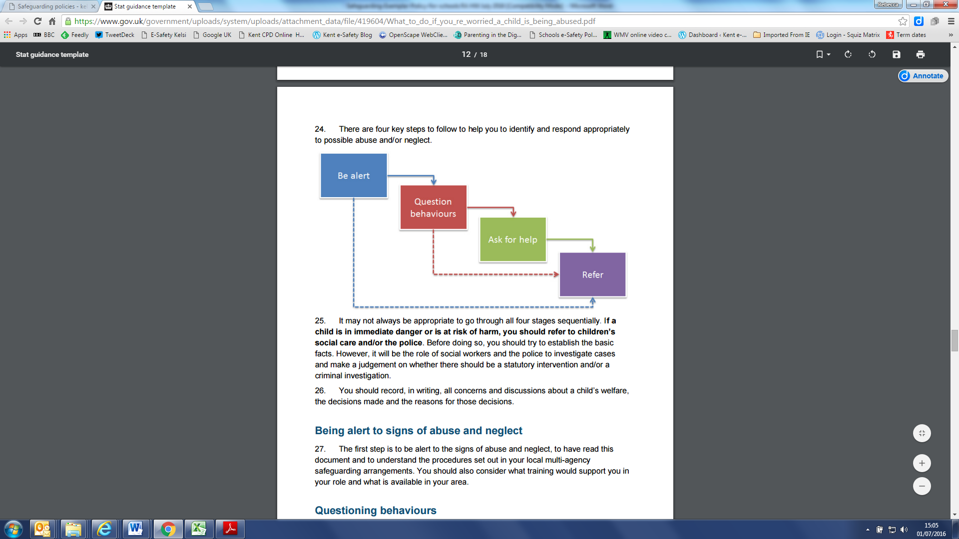
- It may not always be appropriate to go through all four stages sequentially and if a child is in immediate danger or is at risk of harm, a referral should be made immediately to children’s social care and/or the police.
- The role of the school in situations where there are child protection concerns is NOT to investigate but to recognise and refer.
- It is the responsibility of the DSL to receive and collate information regarding individual children, to make immediate and on-going assessments of potential risk and to decide actions necessary (with parents / carers in most cases). This includes the need to make referrals to partner agencies and services.
  - To help with this decision she may choose to consult with the MASH team

- All members of staff are made aware of the early help process, and understand their role within it. This includes identifying emerging problems, liaising with the designated safeguarding lead, sharing information with other professionals to support early identification and assessment and, in some cases, acting as the lead professional in undertaking an early help assessment.
- If early help is assessed to be appropriate then the DSL will support staff members involved with the family in liaising with other agencies and submitting an Early Help Notification Form. The DSL will keep all early help cases under constant review and will give consideration to making a referral to MASH if the situation doesn’t appear to be improving for the child.
- New referrals to services will be made using the agreed Barnet County Council process i.e. the Early Help Notification form or inter-agency referral form for referrals to MASH. These will be made with reference to the Barnet Interagency Threshold Criteria for Children in Need. In situations where there are felt to be urgent or grave concerns, a telephone referral will be made prior to the form being completed and sent to the County Duty Social Work Team. Concerns for children who are already known to services will be passed to the allocated worker / Team.
- All members of staff are aware of the process for making referrals to MASH for statutory assessments under the Children Act 19895 that may follow a referral, along with the role they might be expected to play in such assessments.
- In all but the most exceptional circumstances, parents /carers will be made aware of the concerns felt for a child or young person at the earliest possible stage. In the event of a referral to MASH being necessary, parents/carers will be informed and consent to this will be sought unless there is a valid reason not to do so.
- In the absence of the availability of the DSL to discuss an immediate and urgent concern, staff can seek advice from the MASH Team. If anyone other than the DSL makes a referral to external services, then they will inform the DSL as soon as possible.
- On occasion, staff may pass information about a child to the DSL, but remain anxious about action subsequently taken. Staff should feel able to clarify with the DSL further progress, so that they can reassure themselves the child is safe and their welfare is being considered.
- If following this process, the staff member remains concerned that appropriate action is not being taken then the member of staff should seek further direct consultation from a member of the MASH team who will be able to discuss the concern and provide further advice on appropriate action to be taken.
- If after a referral a child’s situation does not appear to be improving then the DSL (or the person that made the referral) will press for reconsideration to ensure that the schools concerns have been addressed and, most importantly, that the child’s situation improves. Professional disagreements (escalation/Resolution) will happen if necessary. The school will continue to support a child after a referral has been made if appropriate.

The school has a policy of – if in doubt pass on the information to the Barnet MASH team and get advice

The school undertakes an annual Safeguarding Audit to ensure that procedures are up to date.
Ongoing attention will be paid to the attendance and development of any child about whom the
school has any concern. The school will maintain a Pastoral Team to meet regularly to oversee
these children and allocate a key worker who will hold information and be a point of reference
for staff.

STAFF TRAINING
Staff members will undergo safeguarding and child protection training at induction. The induction training will cover:
- The Child Protection and Safeguarding Policy
- The Behavioural Policy
- The Staff Behaviour Policy (Code of Conduct)
- The safeguarding response to children who go missing from education
- The identity of the DSL and any deputies
- The role of the DSL and deputy DSLs

All staff members will receive appropriate safeguarding and child protection training (organised by the DSL) which will enable them to:
Recognise potential safeguarding and child protection concerns involving pupils and adults (colleagues, other professionals and parents/carers)
Respond appropriately to safeguarding issues and take action in line with this policy
Record concerns in line with the school policies
Refer concerns to the DSL and be able to seek support external to the school if required

Training will cover, at a minimum:
- The issues surrounding sexual violence and sexual harassment.
- Contextual safeguarding.
- How to keep previously LAC safe.
- Child criminal exploitation and the need to refer cases to the National Referral Mechanism.

All staff members will also receive regular safeguarding and child protection updates as required, but at least annually. This will be regularly updated on a termly basis for all staff via Inset Day sessions, Twilights, small updates at weekly briefings or e-mails. Updates will be in line with advice from the BSCB. The staff training will also include school responsibilities, the school child protection procedures, online safety, safe working practice and external reporting mechanisms.
Staff will receive opportunities to contribute towards and inform the safeguarding arrangements in the school. All members of staff will be made aware of the schools expectations regarding safe and professional practice via the staff code of conduct and Acceptable Use Policy (AUP)

The DSL will undergo updated child protection training every two years, as well as additional training to refresh their skills and knowledge at regular intervals (at least annually) by Barnet Safeguarding Newsletters, Barnet safeguarding breakfast meetings, and e- bulletins via Andrew Hall, to allow them to keep up with any developments relevant to their role. Further details about the role of the DSL can be found in ‘Keeping Children Safe in Education’ 2016, part two

All Deputy DSLs will also undergo the same training as the DSL and, therefore, will be trained
to the same standard, though ultimately, the DSL will lead safeguarding practices at the school.

Te DSL will also undergo regular Prevent awareness training which will enable them to
understand and support the school with regards to the Prevent duty, and equip them with the
knowledge needed to advise staff.

The DSL and their deputy(s) will undergo online safety training to help them recognise the additional risks that pupils with SEND face online, for example, from online bullying, grooming and radicalisation, to ensure they have the capability to support pupils with SEND to stay safe online

Online training in Prevent and Online Safety will also be conducted for ALL staff members as
Part of the overall safeguarding approach.

Training courses are kept up to date. The HT keeps a spreadsheet register of courses and dates. The DSL keeps certificates of training. The DSL and Head Teacher will provide an annual report to the Governing Body detailing safeguarding training undertaken by all staff.

Although the school has a nominated lead for the safeguarding governor, all members of the governing body will access appropriate safeguarding training which covers their specific strategic responsibilities on a regular basis.

CONFIDENTIALITY AND INFORMATION SHARING
Holly Park recognises that all matters relating to child protection are confidential. The Headteacher or DSL will only disclose information about a pupil to other members of staff on a need to know basis.

All members of staff must be aware that whilst they have duties to keep any information about children, families and colleagues which have access to as a result of their role confidential, they also have a professional responsibility to share information with other agencies in order to safeguard children. All staff must be aware that they cannot promise a child to keep secrets which might compromise the child’s safety or wellbeing.

DfE Guidance on Information Sharing (March 2015) provides further detail.

If the school is made aware of any safeguarding concerns which they feel need to be shared with the wider community (including other local schools) then advice will be sought from the Education Safeguarding team to ensure that the integrity of any subsequent investigations are maintained and that all members of the community are safeguarded.

Record keeping
A Single Central Record of staff will be kept.

A record of all looked after children, children involved within the CAF framework and children
in respect of who there may be safeguarding concerns will be kept securely and updated as
appropriate.

- Staff will record any welfare concern that they have about a child on the school’s safeguarding incident/concern form (with a body map where injuries have been observed) and pass them without delay to the DSL. Records will be completed as soon as possible after the incident/event, using the child’s words and will be signed and dated.
- All safeguarding concerns, discussions and decisions made and the reasons for those decisions will be recorded in writing. If members of staff are in any doubt about recording requirements staff then they will discuss their concerns with DSL.
- Incident/concern forms are kept on the school hard drive, in the Arboretum, in the staff room, in the office area and are e-mailed to staff too.
- Safeguarding records are kept for individual children and separate from all other records relating to the child in school. They are retained centrally and securely by the DSL and are shared with staff on a ‘need to know’ basis only.
- For children with more than one alert form, Chronologies are developed to show actions that have taken place
- The Headteacher will be kept informed of any significant issues by the DSL.
- All safeguarding records will be forwarded in accordance with data protection legislation to a child’s subsequent school/setting, under confidential and separate cover to the new DSL or Headteacher and a receipt of delivery will be obtained.

Safer Recruitment An enhanced DBS check with barred list information will be undertaken for all staff members engaged in regulated activity. A person will be considered to be in ‘regulated activity’ if, as a result of their work, they:
- Are responsible on a daily basis for the care or supervision of children.
- Regularly work in the school at times when children are on the premises.
- Regularly come into contact with children under 18 years of age.

The DfE’s DBS Workforce Guides will be consulted when determining whether a position fits
the child workforce criteria.

At least one person who has had Safer Recruitment sits on any panel at interview.

Pre-employment checks
The governing body will assess the suitability of prospective employees by:
- Verifying the candidate’s identity, preferably from current photographic ID and proof of address except where, for exceptional reasons, none is available.
- Obtaining a certificate for an enhanced DBS check with barred list information where the person will be engaged in regulated activity.
- Obtaining a separate barred list check if an individual will start work in regulated activity before the DBS certificate is available.
- Checking that a candidate to be employed as a teacher is not subject to a prohibition order issued by the Secretary of State, using the Teacher Services’ System.

Verifying the candidate’s mental and physical fitness to undertake their working responsibilities, including asking relevant questions about disability and health to establish whether they have the physical and mental capacity for the specific role.
- Checking the person’s right to work in the UK. If there is uncertainty about whether an individual needs permission to work in the UK, the advice set out on the Gov.UK website will be followed.
- If the person has lived or worked outside the UK, making any further checks that the school considers appropriate; this includes checking for any teacher sanctions or restrictions that an EEA professional regulating authority has imposed. This is at the discretion of the Headteacher.
- Checking professional experience and qualifications as appropriate.
A DBS certificate will be obtained from candidates before or as soon as practicable after appointment. An online update check may be undertaken through the DBS update service if an applicant has subscribed to it and gives their permission.
An enhanced DBS certificate and barred list check will be obtained for all trainee teachers.
An enhanced criminal records DBS check will be carried out on for each member of the governing body.
The school will refer to the DBS anyone who has harmed a child, poses a risk of harm to a child, or if there is reason to believe the member of staff has committed an offence and has been removed from working in regulated activity. A supervised volunteer who regularly teaches or looks after children is not in regulated activity.
For those who have lived or worked outside of the UK, additional checks regarding teacher sanctions or restrictions will be conducted; this includes checking for any teacher sanctions or restrictions that an EEA professional regulating authority has imposed.
Any current staff member who has been arrested, charged or convicted should inform the Headteacher within 24 hours.

Barred list check
An enhanced DBS check may be requested for anyone working in the school that is not in regulated activity, but not with a barred list check.

If there are concerns about an applicant, an enhanced DBS check with barred list information
may be requested, even if he/she has worked in regulated activity in the three months prior to
appointment. Written information about their previous employment history will be obtained
from candidates and the appropriate checks undertaken to ensure information is not
contradictory or incomplete.

References
References will be obtained directly from referees and scrutinised, with all concerns satisfactorily resolved prior to confirmation of employment. References will only be accepted from a senior person and not from a colleague. References will be obtained prior to interviews taking place and discussed during interviews

References will be sought on all short-listed candidates, including internal ones, before interview and checked on receipt to ensure that all specific questions were answered satisfactorily.
Information about past disciplinary action or allegations will be considered carefully when assessing an applicant’s suitability for a post.

Open testimonials will not be considered. Information sourced directly from a candidate or online source will be carefully vetted to ensure they originate from a credible source.

If an individual moves from a position within the school that did not involve the provision of education to one that does, it will be treated as if the individual were a new member of staff and all required pre-appointment checks will be carried out. Aside from this specific circumstance, the school is not required to request a DBS check or barred list check for staff moving roles internally. References from internal candidates will always be scrutinised before appointment.

An enhanced DBS check will be carried out for each member of the governing board. Where a governor also engages in regulated activity, a barred list check will also be requested. The school will also contact the TRA using Teacher Services to check if a proposed governor is barred as a result of being subject to a section 128 direction. Where a barred list check has been performed, the section 128 direction will also be shown and will not require a separate check.

Volunteers
No volunteer will be left unsupervised or allowed to work in regulated activity until the necessary checks have been obtained. A supervised volunteer who regularly teaches or looks after children is not in regulated activity.
An enhanced DBS certificate with barred list check will be obtained for all new volunteers in regulated activity that will regularly teach or look after children on an unsupervised basis or provide personal care on a one-off basis.
An enhanced DBS certificate will be obtained for new volunteers not in regulated activity.
The school will consider obtaining an enhanced DBS certificate with barred list check for existing volunteers that provide pastoral care.
Unless there is cause for concern, the school will not request a DBS certificate with barred list check for other unsupervised volunteers that are continuing with their current studies, as the volunteer should already have been checked.
A risk assessment will be undertaken for volunteers not engaged in regulated activity when deciding whether to seek an enhanced DBS check. If risk assessments are conducted to assess whether a volunteer should be subject to a DBS check, the risk assessment will be recorded.

The school will ensure that policies and procedures are in place to protect pupils from harm during work experience placements.
The school will ensure that any contractor or employee of the contractor working on the
premises has been subject to the appropriate level of DBS check. Contractors without a DBS
check will be supervised if they will have contact with children. The identity of the contractor
will be checked upon their arrival at the school.
DBS certificates will be securely destroyed as soon as practicable, but not retained for longer than six months from receipt, as outlined in The Data Protection Act 1998.
A copy of the other documents used to verify the successful candidate’s identity, right to work and required qualifications will be kept for the personnel file.

Single central record (SCR)
The school keeps an SCR which records all staff, including supply staff and teacher trainees on salaried routes, who work at the school.
The following information is recorded on the SCR:
- An identity check
- A barred list check
- An enhanced DBS check
- A prohibition from teaching check
- A check of professional qualifications
- A check to determine the individual’s right to work in the UK
- Additional checks for those who have lived or worked outside of the UK

For supply staff, the school will also record whether written confirmation from the employment business supplying the member of staff has been received, which indicates that all of the necessary checks have been conducted and the date that confirmation was received.

If any checks have been conducted for volunteers, this will also be recorded on the SCR.

Safer Working Practice and Allegations against school staff/volunteers
All members of staff are required to work within clear guidelines on Safe Working Practice / the school’s Code of Conduct.

Children may make allegations against staff in situations where they feel vulnerable or where they perceive there to be a possible risk to their welfare. As such, all staff should take care not to place themselves in a vulnerable position regarding child protection or potential allegations. For example, it is always advisable for interviews or work with individual children or parents to be conducted in view of other adults.

Physical intervention should only be used when the child is endangering him/herself or others and such events should be recorded and signed by a witness. Staff should be aware of the school’s Behaviour Management and Physical Intervention Policies, and any physical interventions must be in line with agreed policy and procedure in which appropriate training should be provided.

Full advice and guidance can be found in Guidance for Safer Working Practice for Adults who Work with Children and Young People in Education Settings (2015) which can be found on the school hard drive.

Staff should be particularly aware of the professional risks associated with the use of social media and electronic communication (email, mobile phones, texting, social network sites etc.) and should familiarise themselves with advice and professional expectations outlined in Guidance for Safer Working Practice for Adults who Work with Children and Young People in Education Settings, the school’s Online Safety Policy and Acceptable Use Policy and Safe Practice with Technology – Guidance for Adults who Work with Children and Young People

If an allegation of abuse is made against a member of staff/volunteer, the person receiving the allegation must take it seriously and immediately inform the Headteacher.

If any member of staff/volunteer has reason to believe that another member of staff/volunteer may have abused a child at the school, or elsewhere, they must immediately inform the Headteacher. They should also make a record of the concerns including noting anyone else who witnessed the incident/alleged incident. The Headteacher will decide if the matter needs to be referred to the Local Authority (LADO) or whether there needs to be an internal investigation.

If the concerns are about the Headteacher, the Local Authority (LADO) and Chair of Governors must be contacted straight away.

Where the allegation concerns a member of staff no longer working at the school then the Headteacher will refer the matter directly to the police.

The purpose of an initial discussion is for the LADO and the case manager to consider the nature, content and context of the allegation and agree a course of action. They will identify together whether it is necessary to inform the police, and what action should be taken in respect of the accused person. An individual will only be suspended if there is no reasonable alternative.

Substantiated allegations will be recorded on file and included in references
Malicious allegations will not be recorded on file and not recorded in references
False allegations will be recorded on file and not included in references
Unsubstantiated allegations will be recorded on file but not recorded in references

Where an allegation is substantiated and the individual is dismissed or resigns, the school will consider referring the matter to the Teaching Regulation Agency (TRA) for consideration for a prohibition order.
If a case manager is concerned about the welfare of other children in the community following a staff member’s suspension, they may report this concern to CSCS.

Disqualification By Association
New statutory guidance came into effect on 31st August 2018 which replaces the version of Disqualification under the Childcare Act 2006. The new guidance removes disqualification by association for individuals working in childcare in non-domestic settings.

Therefore, under the new regulations, schools are no longer required to establish whether a member of staff providing or employed to work in childcare is disqualified by association.

Going forward we will: -

- Amend our recruitment polices and forms to remove the requirement for new employees to disclose whether members of their household hold relevant convictions or cautions;
- Ensure that any requirement for existing employees to provide conviction and caution information in relation to members of their household is discontinued;
- Continue to seek information, from new and existing staff in relation to their own convictions or cautions;
- Ensure that the SCR is updated to reflect the changes.

Extremism & Radicalisation (Prevent Duty and Counter Extremism Strategy)

As part of Holly Park’s commitment to safeguarding and child protection we fully support the
government's Prevent Strategy. The Prevent strategy is a government strategy designed to stop
people becoming terrorists or supporting terrorism. It:
- responds to the ideological challenge we face from terrorism and aspects of extremism, and the threat we face from those who promote these views
- provides practical help to prevent people from being drawn into terrorism and ensure they are given appropriate advice and support
- works with a wide range of sectors (including education, criminal justice, faith, charities, online and health)
- is about all kinds of extremism including that of the ‘Far Right’
Delivery of PREVENT is a legal requirement under the Counter Terrorism and Security Act 2015

As part of our safeguarding ethos we encourage pupils to respect the fundamental British
values of democracy, the rule of law, individual liberty and mutual respect, and tolerance of
those with different faiths and beliefs. (see British Values Policy) We ensure that partisan
political views are not promoted in the teaching of any subject in the school and where political
issues are brought to the attention of the pupils, reasonably practicable steps have been taken
to offer a balanced presentation of opposing views to pupils.
We are aware of the need to promote equality for all, not allow any hate preaching or
incitement to racial hatred and to promote the following of British law.

Holly Park recognises that exposure of children (and adults) to extremist ideology can hinder
their social development and educational attainment alongside posing a very real risk that they
could support or partake in an act of violence. Radicalisation of young people can be compared
to grooming for sexual exploitation.

Holly Park will ensure all staff complete an e-learning training package developed by The
National Counter Terrorism Policing Headquarters (NCTPHQ), in conjunction with the
College of Policing which includes guidance on how to identify people who may be vulnerable to
being drawn into terrorism, and how to refer them into the Channel process.

Every member of staff at Holly Park recognises that children exposed to radicalisation and
extremism is no different to safeguarding against any other vulnerability and should be
approached in the same way as protecting children from other risks. All members of the
community will report concerns regarding radicalisation and extremism to the DSL who will
follow local and national guidance.

As a school we have 4 duties:
Risk Assessment: This means demonstrating a general understanding of the risks to
children in the area and also a specific understanding of how to identify specific children
who may be at risk of radicalisation and how to support them. School staff undertake
training so that they understand when it is appropriate to make a referral to the Channel
programme. Risk assessment is about knowing the school community.

Working in partnership: The prevent Duty builds on existing partnerships with the
Local safeguarding Boards. Prevent lead Officers can support and advise schools on
implementing the duty. Effective relationships with children and families is also key. School
nurses, GPs, the MASH team and the police are all effective links.

Staff Training: It is expected that schools have at least one member of staff who has
received Prevent awareness training and who can then support the staff team. The
Headteacher and Safeguarding lead have had higher level Prevent training and all staff have
had some training.

ICT policies: All schools have a duty to ensure that children are safe from terrorist and
extremist material when accessing the internet in schools. At Holly Park we have suitable
filters in place. More generally we have an important role to play in equipping children to
stay safe on line. Internet safety is integral to our ICT curriculum. Our staff are aware of
the risks posed by online activity of extremists and have a duty to take action if they believe
the well being of any pupil is being compromised. (see online safety policy)

Risk indicators
Indicators of an identity crisis:
- Distancing themselves from their cultural/religious heritage
- Uncomfortable with their place in society

Indicators of a personal crisis:
- Family tensions
- A sense of isolation
- Low self-esteem
- Disassociation from existing friendship groups
- Searching for answers to questions about identify, faith and belonging

Indicators of vulnerability through personal circumstances:
- Migration
- Local community tensions
- Events affecting their country or region of origin
- Alienation from UK values
- A sense of grievance triggered by personal experience of racism or discrimination

Indicators of vulnerability through unmet aspirations:
- Perceptions of injustice
- Feelings of failure
- Rejection of civic life

Indicators of vulnerability through criminality:
- Experiences of dealing with the police
- Involvement with criminal groups

Making a judgement
When making a judgement, staff will ask themselves the following questions:
- Does the pupil have access to extremist influences?
- Does the pupil access the internet for the purposes of extremist activities (e.g. using closed network groups, accessing or distributing extremist material, contacting covertly using Skype)?
- Is there a reason to believe that the pupil has been, or is likely to be, involved with extremist organisations?
- Is the pupil known to have possessed, or be actively seeking, extremist literature/other media likely to incite racial or religious hatred?
- Does the pupil sympathise with or support illegal/illicit groups?
- Does the pupil support groups with links to extremist activity?
- Has the pupil encountered peer, social, family or faith group rejection?
- Is there evidence of extremist ideological, political or religious influence on the pupil?
- Have international events in areas of conflict and civil unrest had a noticeable impact on the pupil?
- Has there been a significant shift in the pupil’s outward appearance that suggests a new social, political or religious influence?
- Has the pupil come into conflict with family over religious beliefs, lifestyle or dress choices?
- Does the pupil vocally support terrorist attacks; either verbally or in their written work?
- Has the pupil witnessed or been the victim of racial or religious hate crime?
- Is there a pattern of regular or extended travel within the UK?
- Has the pupil travelled for extended periods of time to international locations?
- Has the pupil employed any methods to disguise their identity?
- Does the pupil have experience of poverty, disadvantage, discrimination or social exclusion?
- Does the pupil display a lack of affinity or understanding for others?
- Is the pupil the victim of social isolation?
- Does the pupil demonstrate a simplistic or flawed understanding of religion or politics?
- Is the pupil a foreign national or refugee, or awaiting a decision on their/their family’s immigration status?
- Does the pupil have insecure, conflicted or absent family relationships?
- Has the pupil experienced any trauma in their lives, particularly trauma associated with war or sectarian conflict?
- Is there evidence that a significant adult or other person in the pupil’s life has extremist views or sympathies?

Channel programme
Safeguarding children is a key role for both the school and the LA, which is implemented through the use of the Channel programme. This service shall be used where a vulnerable pupil is at risk of being involved in terrorist activities.

The contact for Channel and advice is: Ben Taylor, Prevent co-ordinator, 020 8359 2995.

In cases where the school believes a pupil is potentially at serious risk of being radicalised, the Headteacher or DSL will contact the Channel programme.

The DSL will also support any staff making referrals to the Channel programme.
The Channel programme ensures that vulnerable children and adults of any faith, ethnicity or background, receive support before their vulnerabilities are exploited by those that would want them to embrace terrorism, and before they become involved in criminal terrorist-related activity. The programme identifies individuals at risk, assesses the extent of that risk, and develops the most appropriate support plan for the individuals concerned, with multi-agency cooperation and support from Holly Park.

The delivery of the Channel programme may often overlap with the implementation of the LA’s
or school’s wider safeguarding duty, especially where vulnerabilities have been identified that
require intervention from social services, or where the individual is already known to social
services.

Extremist speakers
The Lettings Policy prevents speakers who may promote extremist views from using the
school premises.
We will ensure that our school premises will not be a platform for extremists. Speakers to the
school will need prior approval from the Headteacher and they will be subject to the
appropriate safeguarding checks. Use of school premises for lettings will be monitored and any
behaviours found not to be in keeping with safeguarding policy will result in a termination of the
letting contract and possible contact with the police and local authority.

Although incidents involving radicalisation have not occurred at Holly Park School to date, it is
important for us to be constantly vigilant and remain fully informed about the issues which affect
the local area, city and society in which we teach. Staff are reminded to suspend any
‘professional disbelief’ that instances of radicalisation ‘could not happen here’ and to be
‘professionally inquisitive’ where concerns arise, referring any concerns through the appropriate
channels. We are required to develop the confidence to challenge and intervene and to identify
any early indicators in pupils.

In all cases professional judgements have to be used proportionately and in a balanced way.

In Implementing the Prevent Duty at Holly Park we:
Acknowledge controversial issues and train staff accordingly and keep discussions on going
Consider this as part of our safeguarding procedures
Aim to build resilience and critical thinking skills into our curriculum
Help children to see multiple perspectives about situations
Uphold and promote British Values
Keep up to date with online safety
Promote monthly our Holly Park School Values
Uphold the UN Rights of the child and being a Rights Respecting School
Share ideas with our school partnership
Keep abreast of local knowledge through Barnet LA
Are developing links with the wider community with global citizenship
Recognise the importance of safer recruitment and whistleblowing in terms of extremism
and radicalization.

Our curriculum is “broad and balanced”. It promotes respect, tolerance and diversity. Children
are encouraged to share their views and recognise that they are entitled to have their own
different beliefs which should not be used to influence others. Our PSHE provision is embedded
across the curriculum. It directs our assemblies and underpins the ethos of the school. We
strive to equip our pupils with confidence, self-belief, respect and tolerance as well as setting
high standards and expectations for themselves. Children are regularly taught about how to stay
safe when using the internet and are encouraged to recognise that people are not always who
they say they are online. They are taught to seek adult help if they are upset or concerned
about anything they read or see on the internet. There are clear rules for using computers in
school. We use appropriate filtering.
We actively promote, teach and plan for our Holly Park learning skills and the Enabling
Enterprise skills so that the children engage with them. We are particularly keen that in terms of
reducing a child’s vulnerability to extremism and radicalization that they are enquirers, reflective,
committed and are team workers. Children need to be resilient. Along with this we are a Rights
Respecting School, a ‘Values’ based school and a school with global links. The Values are
communicated to our whole school community.

We aim to facilitate understanding of controversial issues within the context of learning about
the values on which our society is founded and our systems of democratic government.

Building children’s resilience
Holly Park will:
- Provide a safe environment for debating controversial issues.
- Promote fundamental British values, alongside pupils’ spiritual, moral, social and cultural development.
- Allow pupils time to explore sensitive and controversial issues.
- Provide pupils with the knowledge and skills to understand and manage potentially difficult situations, recognise risk, make safe choices and recognise where pressure from others threatens their personal safety and wellbeing.
- Equip pupils to explore political and social issues critically, weigh evidence, debate, and make reasoned arguments.
- Teach pupils about how democracy, government and law making/enforcement occurs.
- Teach pupils about mutual respect and understanding for the diverse national, regional, religious and ethnic identities of the UK

Early Years and Prevent Duty:
The Counter Terrorism Act places a duty on Early years providers ‘to have due regard to the need to prevent people from being drawn into terrorism.’

Making Decisions Together (Democracy)
As part of our focus on self confidence and self awareness in PSED we encourage children to - see their role in the bigger picture, to know that their views count, value each other’s views, talk abot their feelings. Children practice democracy by showing their views with a simple show of hands. We encourage turn taking, sharing and collaboration. Questions are valued.

Understand rules matter (Rule of Law)
As part of managing feelings and behavior we help children to understand behavior and its consequences and to distinguish right from wrong. Children have to learn that rules apply to everyone.

Freedom for all (Individual Liberty)
As part of self confidence and awareness of people and communities, we help our children to develop a positive sense of themselves. We support children to take risks and talk about their learning experiences. We encourage a range of experiences that explore feelings, reflection on differences and responsibility.

Treat others as you wish to be treated (Mutual respect and tolerance)
As part of understanding the world, managing feelings and behavior, people and communities, we
try to create an ethos of inclusivity and tolerance of other faiths and cultures. We help children
to understand similarities and differences between themselves and others – among families,
faiths, cultures and traditions, festivals and celebrations. We encourage children to respect each
other. We challenge stereotypes.

Holly Park will utilise the following resources:
- The BSCB
- Local police (contacted via 101 for non-emergencies)
- The DfE’s dedicated helpline (020 7340 7264)
- The Channel awareness programme
- The Educate Against Hate website

Children with special educational needs and disabilities
Holly Park acknowledges that children with special educational needs (SEN) and disabilities can face additional safeguarding challenges as they may have an impaired capacity to resist or avoid abuse. They may have speech, language and communication needs which may make it difficult to tell others what is happening. Additional barriers can exist when recognising abuse and neglect in this group of children.

Members of staff are encouraged to be aware that children with SEN and disabilities can be disproportionally impacted by safeguarding concerns such as bullying. All members of staff will be encouraged to appropriately explore possible indicators of abuse such as behaviour/mood change or injuries and not to assume that they are related to the child’s disability and be aware that children with SEN and disabilities may not always outwardly display indicators of abuse.

Holly Park will ensure that children with SEN and disabilities, specifically those with communication difficulties will be supported to ensure that their voice is heard and acted upon.
When reporting concerns or making referrals for pupils with SEND, staff at Holly Park need to
take the above factors into consideration.

Child Missing from Education
Holly Park recognises that all children, regardless of their circumstances, are entitled to a full
time education which is suitable to their age, ability, aptitude and any special educational needs
they may have. Holly Park is aware that a child going missing from education is a potential
indicator of abuse or neglect, as such, these children are increasingly at risk of being victims of harm, exploitation or radicalisation.

Holly Park follows the Barnet guidance for responding to unauthorised absence and for dealing with children that go missing from education, particularly on repeat occasions, to help identify the risk of abuse and neglect, including sexual exploitation, and to help prevent the risks of their going missing in future.

Holly Park will inform the LA (Education Welfare Team 020 8359 7684)) of any pupil who fails
to attend regularly, or has been absent without the school’s permission for a continuous period
of 10 school days or more.

Admissions register
Pupils are placed on the admissions register at the beginning of the first day that is agreed by
the school, or when the school has been notified that the pupil will first be attending.

The school will notify the EWO within one working day of when a pupil’s name is added to the admissions register.

The school will ensure that the admissions register is kept up-to-date and accurate at all times, and will inform parents/carers when any changes occur.

Staff will monitor pupils who do not attend the school on the agreed date, and will notify the EWO at the earliest opportunity.

If a parent/carer notifies the school that their child will live at a different address, the school will record the following information on the admissions register:
- The full name of the parent/carer with whom the pupil will live
- The new address
- The date from when the pupil will live at this address

If a parent/carer notifies the school that their child will be attending a different school, or is already registered a different school, the following information will be recorded on the admissions register:
- The name of the new school
- The date on which the pupil first attended, or is due to attend, that school

Where a pupil moves to a new school, the school will securely transfer the pupils’ data.

In order to ensure accurate data is collected to allow effective safeguarding, the school will inform EWO of any pupil who is going to be deleted from the admission register, in accordance with the Education (Pupil Registration) (England) Regulations 2006 (as amended), where they:
- Have been taken out of the school by their parents/carers, and are being educated outside the national education system, e.g. home education.
- Have ceased to attend the school, and no longer live within a reasonable distance of the premises.
- Have been certified by the school’s medical officer as unlikely to be in a fit state of health to attend, before ceasing to be of compulsory school age, and neither he/she nor his/her parent/carer has indicated the intention to continue to attend the school after ceasing to be of compulsory school age.
- Have been in custody for a period of more than four months due to a final court order and the school does not reasonably believe they will be returning to the school at the end of that period.
- Have been permanently excluded.

The school will also remove a pupil from the admissions register where the school and LA has been unable to establish the pupil’s whereabouts after making reasonable enquiries into their attendance.

If a pupil is to be removed from the admissions register, the school will provide EWO with the following information:
- The full name of the pupil
- The full name and address of any parent/carer with whom the pupil lives
- At least one telephone number of the parent/carer with whom the pupil lives
- The full name and address of the parent/carer with whom the pupil is going to live, and the date that the pupil will start living there, if applicable
- The name of the pupil’s new school and the pupil’s expected start date there, if applicable
- The grounds for removal from the admissions register under regulation 8 of the Education (Pupil Registration) (England) Regulations 2006 (as amended)

The school will work with the LA to establish methods of making returns for pupils back into the school. The school will highlight to the LA where they have been unable to obtain necessary information from parents/carers, e.g. where an address is unknown. The school will also highlight any other necessary, contextual information, including safeguarding
concerns.

Further information can be found in ‘Child missing in Education: statutory guidance for local authorities – September 2016.’
Two emergency contact details will be held for each pupil where possible.
Child Sexual Exploitation
Holly Park identifies that CSE involves exploitative situations, contexts and relationships where
young people receive something (for example food, accommodation, drugs, alcohol, gifts, money
or in some cases simply affection) as a result of engaging in sexual activities.

Holly Park is aware that sexual exploitation can take many forms ranging from the seemingly
‘consensual’ relationship where sex is exchanged for affection or gifts, to serious organised
crime by gangs and groups. What marks out exploitation is an imbalance of power in the
relationship. The perpetrator always holds some kind of power over the victim which increases
as the exploitative relationship develops. Sexual exploitation may involve varying degrees of
coercion, intimidation or enticement, including unwanted pressure from peers to have sex,
sexting, sexual bullying including cyberbullying and grooming. However, it also important to
recognise that some young people who are being sexually exploited do not exhibit any external
signs of this abuse or recognise this as abusive.

Every member of staff at Holly Park recognises that children at risk of CSE need to be identified
and issues relating to CSE should be approached in the same way as protecting children from
other risks.

Holly Park has adopted the following procedure for handling cases of CSE, as outlined by the DfE:

1. Identifying cases
School staff members are aware of and look for the key indicators of CSE; these are as follows:
- Going missing for periods of time or regularly going home late
- Regularly missing lessons
- Appearing with unexplained gifts and new possessions
- Associating with other young people involved in exploitation
- Having older boyfriends or girlfriends
- Undergoing mood swings or drastic changes in emotional wellbeing
- Displaying inappropriate sexualised behaviour
- Suffering from sexually transmitted infections or becoming pregnant
- Displaying changes in emotional wellbeing
- Misusing drugs or alcohol

Any child or young person can be a victim of sexual exploitation, but children are believed to be at greater risk of being sexually exploited if they:
- are homeless
- have feelings of low self-esteem
- have had a recent bereavement or loss
- are in care
- are a young carer

2. Referring cases
Where CSE, or the risk of it, is suspected, staff will discuss the case with the dedicated member of staff for child protection. If after discussion a concern still remains, a referral to MASH will be triggered, including referral to the CSE co-ordinator (020 8359 7207).

Honour Based Violence
Members of staff at Holly Park are aware that ‘Honour-based’ violence (HBV) encompasses a
range of crimes which have been committed to protect or defend the honour of the family
and/or the community, including Female Genital Mutilation (FGM), forced marriage, and
practices such as breast ironing.

The indicators of HBV and associated factors will be covered with staff within the school
safeguarding training. All members of staff are alert to the possibility of a child being at risk of
HBV, or already having suffered HBV. All members of staff are aware that all forms of HBV are
abuse (regardless of the motivation) and will be handled and escalated as such. Staff will speak
with DSL if they are concerned about HBV.

All members of staff will follow the school and LSCB procedures, using existing national and
local protocols for multi-agency liaison with police and children’s social care.

Honour Based Violence (HBV) is a term used to describe violence committed within the context
of the extended family which are motivated by a perceived need to restore standing within the
community, which is presumed to have been lost through the behaviour of the victim. Most
victims of HBV are women or girls, although men may also be at risk. Women and girls may lose
honour through expressions of autonomy, particularly if this autonomy occurs within the area of
sexuality.

Common triggers for HBV include:
- Refusing an arranged marriage
- Having a relationship outside the approved group
- Loss of virginity
- Pregnancy
- Spending time without the supervision of a family member
- Reporting domestic violence
- Attempting to divorce
- Pushing for custody of children after divorce
- Refusing to divorce when ordered to do so by family members

However, some families may resolve to abuse or kill a member on what would appear to be
very trivial grounds. It is important to take fears of HBV seriously, even when it seems unlikely.
Victims of HBV are more likely to underestimate the risks to their safety than overstate them
and even the ‘offence’ seems trivial to you, this does not mean it is trivial to his or her family.

Forced Marriage
For the purpose of this policy, a “forced marriage” is defined as a marriage that is entered into without the full and free consent of one or both parties, and where violence, threats or any other form of coercion is used to cause a person to enter into the marriage. Forced marriage is classed as a crime in the UK.

As part of Honour Based Violence, staff will be alert to the signs of forced marriage, including, but not limited to, the following:
- Becoming anxious, depressed and emotionally withdrawn with low self-esteem
- Showing signs of mental health disorders and behaviours such as self-harm or anorexia
- Displaying a sudden decline in their educational performance, aspirations or motivation
- Regularly being absent from school
- Displaying a decline in punctuality
- An obvious family history of older siblings leaving education early and marrying early

If staff members have any concerns regarding a child who may have undergone, is currently undergoing, or is at risk of, forced marriage, they will speak to the DSL and a MASH referral will be made.

The Forced Marriage Unit has published Multi-agency guidelines, with pages 32-36 focusing on
the role of schools and colleges. Staff should report concerns regarding forced marriage to the
DSL or can contact the Forced Marriage Unit if they need advice or information. Contact: 020
7008 0151 or email: fmu@fco.gov.uk

Female Genital Mutilation (FGM)
The practice is illegal in the UK. An estimated 137,000 women in the UK are affected by female genital mutilation (FGM). However, the true extent is unknown, due to the "hidden" nature of the crime. FGM is usually carried out on young girls between infancy and the age of 15, most commonly before puberty starts.

- For the purpose of this policy, “female genital mutilation”, commonly referred to as FGM, is defined as the partial or total removal of the external female genitalia, or any other injury to the female genital organs.

- All staff will be alert to the possibility of a girl being at risk of FGM, or already having suffered FGM. If staff members are worried about someone who is at risk of FGM or who has been a victim of FGM, they are required to share this information with social care or the police.

- Teaching staff are legally required to report to the police any discovery, whether through disclosure by the victim or visual evidence, of FGM on a girl under the age of 18. Teachers failing to report such cases will face disciplinary action.

- Teachers must personally report to the police by dialling 101 cases where they discover that an act of FGM appears to have been carried out. Unless the teacher has a good reason not to, they should also still consider and discuss any such case with the DSL and involve children’s social care as appropriate. The duty does not apply in relation to at risk or suspected cases (i.e. where the teacher does not discover that an act of FGM appears to have been carried out, either through disclosure by the victim or visual evidence) or in cases where the woman is 18 or over. In these cases, teachers should follow local safeguarding procedures.

- There are a range of potential indicators that a pupil may be at risk of FGM. While individually they may not indicate risk, if two or more indicators are present, this could signal a risk to the pupil.
- Victims of FGM are most likely to come from communities that are known to adopt this practice. It is important to note that the pupil may not yet be aware of the practice or that it may be conducted on them, so it is important for staff to be sensitive when broaching the subject.

Indicators that may show a heightened risk of FGM include the following:
- The position of the family and their level of integration into UK society
- Any girl with a mother or sister who has been subjected to FGM
- Any girl withdrawn from personal, social and health education (PSHE)

Indicators that may show FGM could take place soon:
- The risk of FGM increases when a female family elder is visiting from a country of origin
- A girl may confide that she is to have a ‘special procedure’ or a ceremony to ‘become a woman’
- A girl may request help from a teacher if she is aware or suspects that she is at immediate risk
- A girl, or her family member, may talk about a long holiday to her country of origin or another country where the practice is prevalent

It is important that staff look for signs that FGM has already taken place so that help can be offered, enquiries can be made to protect others, and criminal investigations can begin.

Indicators that FGM may have already taken place include the following:
- Difficulty walking, sitting or standing
- Spending longer than normal in the bathroom or toilet
- Spending long periods of time away from a classroom during the day with bladder or menstrual problems
- Prolonged or repeated absences from school followed by withdrawal or depression
- Reluctance to undergo normal medical examinations
- Asking for help, but not being explicit about the problem due to embarrassment or fear

Teachers will not examine pupils, and so it is rare that they will see any visual evidence, but they will report to the police where an act of FGM appears to have been carried out. Unless the teacher has a good reason not to, they should also consider and discuss any such case with the DSL and involve Children’s Social Care as appropriate.

FGM is also included in the definition of ‘honour-based’ violence (HBV), which involves crimes that have been committed to defend the honour of the family and/or community, alongside forced marriage and breast ironing.

All forms of HBV are forms of abuse, and will be treated and escalated as such.
Staff will be alert to the signs of HBV, including concerns that a child is at risk of HBV, or has already suffered from HBV, and will activate local safeguarding procedures if concerns arise.

We have information for parents about FGM on our school website. Refer to the NSPCC and TES websites for more information

Safeguarding Overview

Health and Safety Policy
The school has a health and safety policy, which is monitored each term by the relevant
committee of the school governors. The governors will also carry out an annual audit. The
school has two members of staff plus a governor who are responsible for health and safety
matters, Simon Reid (Site Manager) and Ann Pelham (Headteacher) and who oversee this
comprehensive list. Any concerns from staff are reported to any of the above and the site
manager carries out an initial examination, assessing what remedial action needs to take place.
Each half term there is a fire drill that practices efficient evacuation from the buildings and
lockdown drill that practices remaining inside the building. The school conducts an annual Fire
Risk Assessment.
The school has a critical incidents plan and an evacuation plan. This details what staff and parents
should do in the case of emergencies.

First Aid
There are always members of staff on duty who oversee first aid. We ensure that we meet the
statutory requirements for the Early Years Foundation Stage and staff hold current paediatric
first aid qualifications. We have a well-resourced medical area. When a child is poorly, or has
suffered an accident in school or on the playground there is a protocol for staff to follow:
- A trained first aider is consulted and first aid is administered
- The incident is logged in the accident book
- Incident/Illness – parents are contacted by phone.
- With all head injuries a text message is sent. Children wear a sticker on their uniform to inform staff. In the case of serious head injuries or other serious injuries parents are contacted immediately by telephone and an ambulance called if required.
- If there is any doubt at all a parent is always contacted.

At Holly Park it is the policy for a recognised named first aider/member of staff to administer
medicines which are brought into school. Medication should only be in school when absolutely
essential. We administer medicine in line with that policy. Parents are, however, welcome to
come into school at lunchtime if they wish to administer medicine themselves outside of these
arrangements. Parents must complete a request for administration of medicines (available from
the office). (See policy)

Site Security
Holly Park provides a secure site, but the site is only as secure as the people who use it.
Therefore all people on the site have to adhere to the rules, which govern it. Laxity can cause
potential problems to safeguarding.
All members of staff have a responsibility for maintaining awareness of buildings and grounds security and for reporting concerns that may come to light. We operate within a whole-school community ethos and welcome comments from pupils/students, parents and others about areas that may need improvement as well as what we are doing well.

Appropriate checks will be undertaken in respect of visitors and volunteers coming into school as outlined within guidance. Visitors will be expected to sign in and out via the office visitors log and to display a visitors badge whilst on school site. Any individual who is not known or identifiable should be challenged for clarification and reassurance.

The school will not accept the behaviour of any individual (parent or other) that threatens school security or leads others (child or adult) to feel unsafe. Such behaviour will be treated as a serious concern and may result in a decision to refuse access for that individual to the school site.

Holly Park staff wear school lanyards so that they can be easily identified.

A child who has run out of school should be reported immediately to the school office. Parents
and police will then be informed of the circumstances.

Attendance
Excellent attendance is expected of all children, but when children are unwell parents are
expected to inform the school their child will be absent on the first day before 9.15am.
The school works closely with the Local Authority’s Education Welfare Officer whenever a
child’s attendance and punctuality causes concern. Attendance rates are reported each term,
annually to the governors and to all parents. Positive measures are in place to encourage
children to attend regularly and punctually and the school is aware of its right to take legal action
against parents who do not ensure good attendance and punctuality. Attendance alligator is won
weekly by the class who has the best attendance. (see policy)

Induction of Volunteers
Volunteers who help in school on a regular basis must also have an Enhanced DBS clearance and
the same checks for disqualification apply. At Holly Park even occasional or one off visits
warrant a check The school office will provide all the paperwork necessary for the check.
Visitors who do not yet have clearance will under no circumstance be left alone with a child or
group of children.

Welcoming Visitors
We have a CCTV camera at our school gates and visitors need to buzz in. All visitors need to
come to the main office and will sign in at the office and will fill in a label to wear.
Staff visiting on a regular basis must have an Enhanced DBS check.
Unless school has evidence that visitors have an enhanced clearance they will not have
unsupervised access to children.

The Design of the Curriculum
We recognise that schools play an essential role in helping children to understand and identify the parameters of what is appropriate child and adult behaviour; what is ‘safe’; to recognise when they and others close to them are not safe; and how to seek advice and support when they are concerned.
Holly Park will use the curriculum to provide opportunities for increasing self-awareness, self-esteem, social and emotional understanding, assertiveness and decision making so that students have a range of contacts and strategies to ensure their own protection and understand the importance of protecting others, including online.
Pupils will be educated at a level appropriate to their age and ability about a range of safeguarding concerns through personal, social, health and economic education (PSHE), and through sex and relationship education (SRE). This will include, but is not limited, to bullying (including online bullying),radicalisation, child sexual exploitation (CSE), stranger danger, road safety, sexual abuse, neglect, gender based violence/sexual assaults and sexting.

Secondly, the curriculum is designed so that safety issues within the subjects are discussed and
safe practices taught, such as using equipment properly in PE and Design and Technology. This includes safety online. Appropriate risk assessments are written.

When the curriculum is taking place out of school appropriate and agreed pupil/adult ratios are maintained and risk assessments are written using the Barnet EVOLVE system.

Systems have been established to support the empowerment of children to talk to a range of staff. Children at Holly Park will be listened to and heard and their concerns will be taken seriously and acted upon as appropriate.
Specific systems outside of expected day to day classroom interaction and support will include:
School Council
Worry boxes
Bubble Time
Circle Times
Mini Mentors
S[pecial PSHE events
Regular feedback questionnaires with groups of children
Anti Bullying Week
Safer Internet Day.

Online Safety
As part of a broad and balanced curriculum, all pupils will be made aware of online risks and taught how to stay safe online. Through training, all staff members will be made aware of the following:
- Pupil attitudes and behaviours which may indicate they are at risk of potential harm online
- The procedure to follow when they have a concern regarding a pupil’s online activity

It is recognised by Holly Park that the use of technology presents particular challenges and risks to children and adults both inside and outside of school.
Holly Park identifies that the issues classified within online safety are considerable, but can be broadly categorised into three areas of risk:
content: being exposed to illegal, inappropriate or harmful material
contact: being subjected to harmful online interaction with other users
conduct: personal online behaviour that increases the likelihood of, or causes, harm

Children should be encouraged to use the internet as much as is possible, but at all times in a
safe way. Parents are asked each year if they agree to their child using the internet. Pupils must
never be left unattended whilst online and teachers should ensure that this does not happen.

If teachers know of misuse, either by a teacher or child the issue should be reported to the
Headteacher without delay.

Staff should be aware of the use of technology as a possible means of radicalisation.

As Child Protection Officers the Headteacher, Deputy Head, Families Co-ordinator have overall responsibility for internet safety. The Key Leader for Innovations and New technologies is also the online-safety Officer. We also have a governor responsible for Online-safety and a governor for Safeguarding. Any incidents are recorded.

Holly Park will ensure that suitable filtering systems are in place to prevent children accessing inappropriate material or terrorist and extremist material, in accordance with the school’s Online-safety Policy.

The school will ensure that the use of filtering and monitoring systems does not cause “over blocking” which may lead to unreasonable restrictions as to what pupils can be taught regarding online teaching.

Holly Park acknowledges that whilst filtering and monitoring is an important part of schools online safety responsibilities, it is only one part of our role. Children and adults may have access to systems external to the school control such as mobile phones and other internet enabled devices and technology and they need to be taught how to deal with this effectively. We will enable all pupils to learn about and manage online risks effectively and will support parents and the wider school community (including all members of staff) to become aware and alert to the need to keep children safe online

The use of mobile phones by staff and pupils is closely monitored by the school, in accordance with the Data Security Policy & Staff Handbook.

More information can also be found in annex C regarding Online Safety within ‘Keeping children safe in education’ 2016.

Positive Handling Policy
Staff at this school are trained to look after the pupils in their care. Staff have a duty to intervene in order to prevent pupils from hurting themselves or others. There may also be situations in which a child seriously disrupts good order in the school or causes damage to property. If a member of staff ever needs to intervene physically he/she will follow the school’s Positive Handling/Restraint Policy.
A clear and consistent positive handling policy supports pupils who have social, emotional and behavioural difficulties within an ethos of mutual respect, care and safety.
Pupils with severe behavioural difficulties sometimes present a risk to themselves and others. Teachers and others authorised by the Head Teacher may use reasonable force to control or restrain pupils, to prevent pupils from hurting themselves or others, damaging property, or causing disorder. (DfE Guidance on Use of Reasonable Force, July 2013)
The school will endeavour to have as many staff trained in ‘Team Teach’ as possible. Only staff who have had this training will be authorised by the Headteacher to restrain pupils. (see Positive Handling policy)

Behaviour Policy
Good behaviour is essential in any community and at Holly Park we have high expectations for this. The discipline of the school is taught by example. Quiet reminders from the Headteacher and the staff bring the need for good behaviour to the children’s attention.
The numerous rewards available to children include:
- Verbal praise
- Stickers
- Star of the Week
- Headteacher Awards
- Marbles in the jar
- Housepoints

Although the emphasis is always on the positive there are also times when children have to
recognise that there are consequences for poor behaviour and decisions in order to maintain
the safety and security of all children. (For a detailed review please refer to the Behaviour Policy)

Anti Bullying Policy
At Holly Park we are committed to providing a safe and secure environment for all our pupils to learn in. We promote an ethos of treating everyone with respect and ensure that there are strategies in place for dealing with bullying sensitively if, and when, it occurs. If bullying does occur at our school, pupils are listened to and both the victim and bully are helped and supported. At Holly Park staff are sensitive to any signs of bullying and all pupils are expected to tell a member of staff if they know that bullying is happening. The school is not directly responsible for bullying incidents that occur off school premises. However, where a pupil tells of a bullying incident off the school premises to a member of staff, a range of steps are taken depending on the nature of the bullying incident.

At Holly Park bullying is defined as deliberately hurtful behaviour, repeated over a period of
time, where it is difficult for victims to defend themselves.
Bullying can take a number of forms:
- Emotional – which can include being unfriendly, excluding, tormenting, sending malicious e- mails or text messages
- Physical – which can include theft, damage to property, pushing, kicking, hitting, punching or any use of violence
- Verbal – which can include name-calling, sarcasm, spreading rumours, teasing
- Racist – which can include racial taunts, graffiti, gestures
- Homophobic – which involves discrimination relating to sexual orientation.
- Sexual – which can include unwanted physical contact or sexually abusive comments

(For a detailed review please see the Anti bullying Policy)

Allegations of abuse made against other children (Peer-on –peer)
Staff should recognise that children are capable of abusing their peers. At Holly Park we aim to minimise peer on peer abuse through our behaviour policy – both rewarding positive behaviour and sanctions for negative behaviour. We analyse our behaviour incidents so we can keep a track on behaviour where one child may be hurting another child (physically or emotionally) more than once. Our behaviour policy has clear sanctions and there are clear procedures to follow within our anti bullying policy.
There are different forms of abuse – name calling, emotional, physical etc. these are set out in
our anti bullying policy. Abuse should never be tolerated or passed off as “banter” or “part of
growing up”. Victims of peer on peer abuse will be supported.
- The school is aware that peer-on-peer abuse can be manifested in many different ways, including sexting and gender issues, such as girls being sexually touched or assaulted, and boys being subjected to hazing/initiation type of violence, which aims to cause physical, emotional or psychological harm.
- All allegations of abuse made against other pupils and the disciplinary action necessary will be dealt with in accordance with the procedures outlined in the school’s Anti-Bullying Policy.
- The DSL will be informed of any allegations of abuse against other pupils, who will record the incident in writing and decide what course of action is necessary, with the best interests of the pupil in mind at all times.
- If appropriate, a referral may be made to MASH and, depending on the nature of the incident, the police.
- The DSL will decide which safeguards, if any, are necessary for the pupil, e.g. counselling support or immediate protection.
- In all cases, parents/carers will be informed of the incident and how it is being managed, unless doing so would put the pupil at further risk of harm. In order to prevent peer-on-peer abuse, the school will educate pupils about abuse, its forms, the importance of discussing any concerns and respecting others, through the curriculum, assemblies and PSHE lessons regularly.
- The school will also ensure that pupils are taught about safeguarding, including online safety, as part of a broad and balanced curriculum in PSHE lessons, sex and relationship education (SRE) and group sessions.

A preventative approach
In order to prevent peer-on-peer abuse and address the wider societal factors that can influence behaviour, the school will educate pupils about abuse, its forms and the importance of discussing any concerns and respecting others through the curriculum, assemblies and PSHE lessons.
The school will also ensure that pupils are taught about safeguarding, including online safety, as part of a broad and balanced curriculum in PSHE lessons, RSE and group sessions. Such content will be age and stage of development specific, and tackle issues such as the following:
- Healthy relationships
- Respectful behaviour
- Gender roles, stereotyping and equality
- Body confidence and self-esteem
- Prejudiced behaviour
- That sexual violence and sexual harassment is always wrong
- Addressing cultures of sexual harassment
Pupils are allowed an open forum to talk about concerns and sexual behaviour. They are taught how to raise concerns and make a report, including concerns about their friends or peers, and how a report will be handled

Sexting
‘Sexting’ is one form of per on peer abuse. The school recognises its duty of care to its young people who do find themselves involved in such activity as well as its responsibilty to report such behaviours where legal or safeguarding boundaries are crossed. A young person who discloses they are the subject of sexual imagery is likely to be embarrassed and worried about the consequences. It is likely that disclosure in school is a last resort and they may have already tried to resolve the issue themselves.

Parents should be informed at an early stage and involved in the process unless there is good reason to believe that involving parents would put the young person at risk of harm.
At any point in the process if there is a concern a young person has been harmed or is at risk of harm a referral should be made to children’s social care and/or the police immediately.

The Designated Safeguarding Lead (or Headteacher in the absence of the DSL) needs to be informed of any ‘sexting’ incidents. The range of contributory factors in each case also needs to be considered in order to determine an appropriate and proportionate response. Sexting disclosures should follow the normal safeguarding practices and protocols. Pupils may need pastoral support during the disclosure and after the event. They will need immediate referral to police or social services; parents should be informed as soon as possible. If a device with ‘sexting’ images is in school then it should be confiscated and securely stored if there is reason to believe it contains indecent images or extreme pornography. Any conduct involving, or possibly involving, the knowledge or participation of adults should always be referred to the police.

The DSL should hold an initial review meeting with appropriate school staff. - There should be subsequent interviews with the young people involved (if appropriate).
Initial review meeting
The initial review meeting should consider the initial evidence and aim to establish:
- Whether there is an immediate risk to a young person or young people
- If a referral should be made to the police and/or children’s social care - If it is necessary to view the imagery in order to safeguard the young person – in most cases, imagery should not be viewed - What further information is required to decide on the best response
- Whether the imagery has been shared widely and via what services and/or platforms. This may be unknown.
- Whether immediate action should be taken to delete or remove images from devices or online services
- Any relevant facts about the young people involved which would influence risk assessment - If there is a need to contact another school, college, setting or individual - Whether to contact parents or carers of the pupils involved
- in most cases parents should be involved

An immediate referral to police and/or children’s social care16 should be made if at this initial stage:
1. The incident involves an adult
2. There is reason to believe that a young person has been coerced, blackmailed or groomed, or if there are concerns about their capacity to consent (for example, owing to special educational needs)
3. What you know about the imagery suggests the content depicts sexual acts which are unusual for the young person’s developmental stage, or are violent
4. The imagery involves sexual acts and any pupil in the imagery is under 1317
5. You have reason to believe a young person is at immediate risk of harm owing to the sharing of the imagery, for example, the young person is presenting as suicidal or self-harming

If none of the above apply then a school may decide to respond to the incident without
involving the police or children’s social care (a school can choose to escalate the incident at
any time if further information/concerns come to light).

The decision to respond to the incident without involving the police or children’s social care
would be made in cases when the DSL is confident that they have enough information to
assess the risks to pupils involved and the risks can be managed within the school’s pastoral
support and disciplinary framework and, if appropriate, their local network of support. The
decision should be made by the DSL with input from the Headteacher and input from other
members of staff if appropriate. The decision should be recorded in line with school policy.
If at the initial review stage a decision has been made not to refer to police and/or children’s
social care, the DSL should conduct a further review (including an interview with the young
people involved) to establish the facts and assess the risks.

When assessing the risks we will consider the following:
- Why was the imagery shared?
Was the young person coerced or put under pressure to produce the imagery?
- Who has shared the imagery? Where has the imagery been shared?
Was it shared and received with the knowledge of the pupil in the imagery?
- Are there any adults involved in the sharing of the imagery?
- What is the impact on the young people involved?
- Do the young people involved have additional vulnerabilities?
- Does the young person understand consent?
- Has the young person taken part in this kind of activity before?

DSLs should always use their professional judgement in conjunction with their colleagues to
assess incidents.

If any devices need to be seized and passed onto the police then the device(s) should be
confiscated and the police should be called. The device should be turned off and placed
under lock and key until the police are able to come and retrieve it.

Adults should not view youth produced sexual imagery unless there is good and clear reason
to do so. Wherever possible responses to incidents should be based on what DSLs have
been told about the content of the imagery.

The decision to view imagery should be based on the professional judgement of the DSL and
should always comply with the child protection policy and procedures of the school or
college. Imagery should never be viewed if the act of viewing will cause significant distress or
harm to the pupil.

If a decision is made to view imagery, the DSL would need to be satisfied that viewing:
- is the only way to make a decision about whether to involve other agencies (i.e. it is not possible to establish the facts from the young people involved)
- is necessary to report the image to a website, app or suitable reporting agency to have it taken down, or to support the young person or parent in making a report
- is unavoidable because a young person has presented an image directly to a staff member or the imagery has been found on a school device or network

If it is necessary to view the imagery then the DSL should:
- Never copy, print or share the imagery; this is illegal
- Discuss the decision with the Headteacher
- Ensure viewing is undertaken by the DSL or another member of the safeguarding team with delegated authority from the headteacher
- Ensure viewing takes place with another member of staff present in the room, ideally the Headteacher or a member of the senior leadership team. This staff member does not need to view the images.
- Wherever possible ensure viewing takes place on school or college premises, ideally in the Headteacher or a member of the senior leadership team’s office.
- Ensure wherever possible that images are viewed by a staff member of the same sex as the young person in the imagery
- Record the viewing of the imagery in the school’s safeguarding records including who was present, why the image was viewed and any subsequent actions Ensure this is signed and dated and meets the wider standards set out by Ofsted for recording safeguarding incidents

The Education Act 2011 amended the power in the Education Act 1996 to provide that when an
electronic device, such as a mobile phone, has been seized, a teacher who has been formally
authorised by the headteacher can examine data or files, and delete these, where there is good
reason to do so. This power applies to all schools and there is no need to have parental consent
to search through a young person’s mobile phone. If during a search a teacher finds material
which concerns them and they reasonably suspect the material has been or could be used to
cause harm or commit an offence, they can decide whether they should delete the material or
retain it as evidence of a criminal offence or a breach of school discipline. They can also decide
whether the material is of such seriousness that the police need to be involved.

However, just as in most circumstances it is not recommended that school staff view imagery, it
is recommended that schools should not search through devices and delete imagery unless there
is good and clear reason to do so.

When discussing the sharing of youth produced sexual imagery, it is important that the DSL:
Recognises the pressures that young people can be under to take part in sharing such imagery
and, if relevant, supports the young person’s parents to understand the wider issues and
motivations around this.
Remains solution-focused and avoids questions such as ‘why have you done this?’ as this may
prevent the young person from talking about what has happened.
Reassures the young person that they are not alone and the school or college will do everything
that they can to help and support them.
Helps the young person to understand what has happened by discussing the wider pressures
that they may face and the motivations of the person that sent on the imagery.
Discusses issues of consent and trust within healthy relationships.
Explain that it is not ok for someone to make them feel uncomfortable, to pressure them into
doing things that they don’t want to do, or to show them things that they are unhappy about.
Let them know that they can speak to the DSL if this ever happens.

The purpose of the conversation is to:
Identify, without looking, what the image contains and whether anyone else has been involved.
Find out who has seen or shared the image and how further distribution can be prevented.

Recording incidents
All incidents relating to youth produced sexual imagery need to be recorded. This includes
incidents that have been referred to external agencies and those that have not.

As a school we need to consider:

Are our records up to date and complete?
Do records demonstrate both effective identification and management of the risk of harm?
Do records demonstrate sound decision-making, appropriate responses to concerns and
evidence of relevant referrals made in a timely manner?
Do they indicate that appropriate action is taken in response to concerns and allegations in
A timely manner?
Do they show evidence of tenacity in following up concerns with relevant agencies?
Do they provide evidence of effective partnership working and sharing of information?
Is there evidence of attendance at or contribution to inter-agency meetings and conferences?
Is there clarity about the school’s policy relating to the sharing of information internally, safe
keeping of records, and transfer when a pupil leaves the school?

Teaching young people about youth produced sexual imagery?
Teaching about safeguarding issues in the classroom can prevent harm by providing young
people with skills, attributes and knowledge to help them navigate risks. Addressing sensitive
issues promotes a whole school approach to safeguarding, giving young people the space to
explore key issues and the confidence to seek the support of adults should they encounter
problems. Keeping Children Safe in Education statutory guidance states that schools ‘should
ensure children are taught about safeguarding, including online, through teaching and learning
opportunities’. In line with this, we will provide young people in Y5 and Y6 with opportunities to
learn about the issue of youth produced sexual imagery.

Learning about youth produced sexual imagery cannot be taught in isolation. Learning will be
located within a developmental PSHE education programme, as well as in the school’s computing
programme where it should reflect the requirements of the National Curriculum programme of
study for computing.

Remember:
Always put the young person first.
Never..
- Search a mobile device even in response to an allegation or disclosure if this is likely to cause additional stress to the student/young person UNLESS there is clear evidence to suggest not to do so would impede a police inquiry.
- Print out any material for evidence
- Move any material from one storage device to another
Always...
- Inform and involve the Safeguarding Team who will ensure that the Designated
Safeguarding Lead is able to take any necessary strategic decisions.
- Record the incident.

What to do and not do with the image..
If the image has been shared across a personal mobile device:
Always..
- Confiscate and secure the device(s). Close down or switch the device off as soon as possible. This may prevent anyone removing evidence ‘remotely’.
Never..
- View the image unless there is a clear reason to do so or view it without an additional adult present (this additional person does not need to view the image and certainly should not do so if they are of a different gender to the person whose image has been shared).
- The viewing of an image should only be done to establish that there has been an incident which requires further action.
- Send, share or save the image anywhere
- Allow students to do any of the above

If the image has been shared across a school network, a website or a social network:
Always..
- Block the network to all users and isolate the image
Never...
- Send or print the image
- Move the material from one place to another
- View the image outside of the protocols in the school’s safeguarding and child protection policies and procedures.

The Designated Safeguarding Lead should always record the incident. The Headteacher should
also always be informed- usually by the DSL.

If indecent images of a young person are found:
- Act in accordance with the Safeguarding policy i.e. inform the Safeguarding Team
- Store the device securely
- The Safeguarding Team carry out a risk assessment in relation to the young person
- The Safeguarding Team will make a referral to social care
- The Safeguarding Team will contact the police (if appropriate).
- Referrals may be made to Social Care or the Multi-Agency Team (MAT) but where a crime may thought to have taken place the police are the first port of call.
- Inform parents and/or carers about the incident and how it is being managed.

Further guidance can be found in UKCCIS Guidance ‘ Sexting in schools and colleges, responding
to incidents, and safeguarding young people 2016’

Racial Tolerance
At Holly Park pupils will be prepared for an ethnically diverse society. The school works hard to
promote racial equality and harmony by preventing and challenging racism.
“If anyone ever feels unjustly treated then the school welcomes and values a response. It is in
working together that we will make Holly Park even better.” Racism and extremism is tackled in
both the RE and in the PSHE curricula. The children take part in discussions designed to raise
awareness and address prejudices. (See Prevent Duty Section & Race Equality Policy)

Photographing and Video
There has been a lot of controversy recently about adults photographing and filming young
people. The concerns are genuine, however at Holly Park we have taken a sensible, balanced
approach, which allows parents to photograph and film providing they follow certain guidelines:
- Images must be for private use only and must not be put on the internet (particularly if a parent posts a picture on the web that shows children other than their own).
- Parents consent to school taking photographs by signing a permission slip upon entry to school. School photographs that are for use outside of school are anonymous unless specific permission has been received from parents.

Whistle blowing
If a staff member has concerns about another member of staff then this will be raised with the Headteacher.
If the concern is with regards to the Headteacher, this will be referred to The Chair of Governors Andrew Ballam Davies.
Any concerns regarding the safeguarding practices at Holly Park will be raised with the SMT, and the necessary whistleblowing procedures will be followed, as outlined in the Whistleblowing Policy.
If a staff member feels unable to raise an issue with the SMT, they should access other whistleblowing channels such as the NSPCC whistleblowing helpline (0800 028 0285).

Good Practice in Intimate/Personal Care
All children have the right to be safe and treated with dignity and respect. These guidelines are
designed to safeguard both children from abuse, staff from false allegations and to support good
practice in intimate care.
There may be occasions when staff need to support children with their intimate care, for
example, if the child has a toileting accident whilst at school or on a school trip or journey.
Young children are vulnerable. Staff involved in their care need to be sensitive to a child’s needs
and to be aware that some tasks are open to misinterpretation.
1. Treat every child with respect and ensure appropriate privacy.
2. Involve the child in their own intimate care as far as possible and do not rush them. Remember assistance may be needed.
- ask the child to remove wet/soiled clothing
- ask the child to wash themselves if necessary
- encourage the child to put on clean clothing
3. Be supportive to a child’s reactions
4. Intimate care routines should be consistent. Staff should never carry out a task unless they are sure of the routine or procedure. Please seek advice from the Head Teacher.
5. For some medical procedures that require intimate care, there should be 2 adults present e.g catheterisation of a child
6. In the early years, staff should change or wipe a child in an open room (e.g doors left open) They should also inform another member of staff that they will be doing this
7. For children who need regular personal care that may involve touching, parents should be fully informed and a care plan/risk assessment drawn up
5. Report any concern to the designated person if:
- during intimate care you accidentally hurt a child
- a child is tender or sore in the genital area
- a child misunderstands or misinterprets something (See Intimate/Personal Care policy)

Mobile Phones
Staff should not use mobile phones to take pictures or videos of children. Staff should only use
digital cameras which have been provided by the school.
Mobile phones are not permitted for use anywhere in school, around the children. This applies
to members of staff and other visitors to the school. Mobile phones may only be used in office
areas, staffroom etc.

The only exception to this is staff taking a mobile phone with them on a school trip/visit outside
of school, for use in emergencies only. Staff should not share their personal mobile phone
numbers with parents. Parents who accompany a school trip should be given the school phone
number for contact purposes.

Use of Member of Staff’s Personal Transport
The use of personal transport to transport children must only take place when agreed with the
Educational Visits Co-ordinator and with the Head Teacher’s permission in advance.
It is not acceptable to give young people lifts home after sessions.
Under exceptional circumstances and only as a last resort may a member of staff use personal
transport in taking children to hospital. This is in response to emergency services placing a new
emphasis on not calling ambulances unless it is an extreme emergency. They are stressing that
‘walking wounded’ that need treatment need to be brought to hospitals in other ways. Try
to contact the parents/care to get them to collect their child and take them to hospital. At all
times another member of staff must be present during transport and in order to stay with the
child until their parent/guardian arrives.
Outside of work situations, it is not acceptable to give “lifts” to young people that are known to
you through your work.
The driver and the car used must be insured for business use. Appropriate child seats must be
used for children

Home Visits
Home visits take place for all new children starting at Holly Park. Two members of staff must
attend all visits. Under no circumstances should a member of staff make a visit unaccompanied.
(There are separate Home Visit Guidelines in the lone working policy.)

One-to-one work with Pupils
If a one-to-one session is being carried out, it should be in a room that can be overseen by other
staff, has a glass panel or is in a public where they can be seen by others. (see lone working
policy)

Supervision for Staff
The school will provide appropriate supervision and support for all members of staff to ensure that:
- All staff are competent to carry out their responsibilities for safeguarding and promoting the welfare of children
- Staff are able to creating an environment where members of staff feel able to raise concerns and feel supported in their safeguarding role
- All staff have regular reviews of their own practice to ensure they improve over time.
The DSL will also put staff in touch with outside agencies for professional support if they so wish. Staff can also approach organisations such as their Union, the Education Support Partnership or other similar organisations directly.

EYFS Supervision
Following a recommendation from the Serious Case Review and the review into the EYFS 2008
by Dame Clare Tickell, staff supervision is now mandatory in all early years settings (EYFS
2012).
Supervision is a regular, planned, accountable two-way process which should offer support and
develop the knowledge, skills and values of an individual, group or team. Its purpose is to
monitor the progress of professional practice and to help staff to improve the quality of the
work they do, thus improving outcomes for children as well as achieving agreed objectives.

Supervision also provides an opportunity to discuss sensitive issues including the safeguarding of
children and any concerns raised about an individual or colleague’s practice.
Supervision provides professional one to one support and “space” away from the direct work
environment to discuss progress, professional role, workload and concerns. The supervisory
relationship should develop trust which will allow for free and open discussion and learning
without the fear of being criticised. Employees should receive constructive feedback about their
work, with concerns being challenged sensitively and honestly and successes being acknowledged
on a regular basis. This hopefully increases the feeling of being valued by management at the
setting which in turn, increases job satisfaction.

The aim of supervision is to allow staff and their supervisors to:
Discuss and challenge concerns, issues or difficulties;
Explore issues relating to Safeguarding
• Identify solutions to address concerns and issues;
• Be coached in tackling issues as they arise and plan future action;
• Explore feelings and emotional impact;
• Develop practice and competencies, including training needs;
• Explore the understanding of setting policy, philosophy and practice;
• Ensure every child’s safety and wellbeing;

At Holly Park, we have an open door policy and supervision opportunities are available to staff
before and after school as needed. More formal one to one supervision should be held half
termly. Group supervision, for example by means of a team meeting will be held on Inset days.
Some staff, for example if they are newly qualified or less confident, may need supervision
sessions to be held more regularly. At this school supervision may be:
- One to one – this will be pre-arranged.
- In a group – a team/phase meeting
- Unplanned or ‘ad hoc’ – staff may discuss on a day to day basis any issues or decisions that often need to be made inbetween formal supervision. This does not negate the need for 1:1 supervision.
Appraisal and performance management clearly has some crossover with supervision.
Holly Park staff have 6 Appraisal meetings in the year. Supervision and Appraisal at Holly Park
are linked together closely. The focus of 2 meetings will just be about targets being met. A focus
on how well an individual is performing in relation to organisational needs and priorities should
not, however, be the main focus of the other four sessions.
At Holly Park there are clear team leaders for supervision/Appraisal. Team leaders are:
Sarah Walton (EYFS Lead practitioner) – for nursery nurses
Maria Klanga (Senior Nursery Nurse) – for nursery TAs
Ann Pelham, Maria Michael & Sally Thomas (SMT) – for EYFS teachers

(See Appendix for more details and forms)

CAFs (Common Assessment Framework)
CAFs are part of the working together and keeping children safe document.
They act as a continuum of safeguarding procedures. A CAF can also assist with early help for a child or family.

CAFs are usually instigated when:
- 3 or more agencies are involved with a child
- For a child at risk of being stepped up to social care
- When a child is stepped down from social care but is not a child in need
- As a referral to CAMHs

Their aim is to:
- Prevent needs from escalating
- Provide joined up planning
- Support shared delivery and co-ordination
- Look holistically at a child and the support they receive from all organisations involved
- Be a key route in to Barnet’s family services

At Holly Park key staff have undergone online CAF training and are able to initiate or feed in to
a CAF
- Deputy Head
- Families Co-ordinator
- Children’s Co-ordinator
- Assistant SENCO

Private Fostering
Where the school becomes aware of a pupil being privately fostered, they will notify the LA as soon as possible to allow the LA to conduct any necessary checks. (see appendix 7)

Private fostering is when a child under the age of 16 (under 18 if disabled) is cared for by
someone who is not their parent, legal guardian or a 'close relative'. This is a private
arrangement made between a parent and a carer, for 28 days or more. Close relatives are
defined as step-parents, grandparents, brothers, sisters, uncles or aunts (whether of full blood,
half blood or marriage/affinity).
Privately fostered children could include:
- adolescents that have to live away from their family as a result of separation, divorce or disputes at home
- children who are living with somebody else because their parents are studying or working during unsociable hours
- children sent to this country for education or health care opportunities by birth parents living overseas
- cultural exchange students
- refugee children or teenagers living with the family of a girlfriend or boyfriend
- any child whose parents have made a private arrangement for them to be looked after by someone else
There is a mandatory duty to inform the local authority of children in such an arrangement
so that the LA can make sure that all privately fostered children are well cared for and safe
by:
- making compulsory police checks on the private foster carers and anyone aged over 16 living in that household
- ensuring that the private foster carer receives the relevant support and advice required for looking after someone else’s child
- ensuring the child’s educational, emotional, cultural and physical needs are met
- helping parents and private foster carers to work together for the benefit of the child
- taking action if the care provided is not satisfactory

Children Affected By gang Activity and Youth Violence
Defining a gang is difficult. They tend to fall into three categories: Peer Groups, Street Gangs and
Organised Crime Groups. It can be common for groups of children and young people to gather
together in public places to socialise. Although some peer group gatherings can lead to
increased antisocial behaviour and youth offending, these activities should not be confused with
the serious violence of a street gang. A street gang can be described as a relatively durable,
predominantly street-based group of children who see themselves (and are seen by others) as a
discernible group for whom crime and violence is integral to the group's identity. A street gang
will engage in criminal activity and violence and may lay claim over territory (not necessarily
geographical but it can include an illegal economy territory);They have some form of identifying
structure featuring a hierarchy usually based on age, physical strength, propensity to violence or
older sibling rank. There may be certain rites involving antisocial or criminal behaviour or sex
acts in order to become part of the gang. They are in conflict with other similar gangs. An
Organised criminal group is a group of individuals normally led by adults for whom involvement
in crime is for personal gain (financial or otherwise). This involves serious and organised
criminality by a hard core of violent gang members who exploit vulnerable young people and
adult. This may also involve the movement and selling of drugs and money across the country,
known as ‘county lines' because it extends across county boundaries. Young people may be at
risk of sexual exploitation in these groups.
At Holly Park we know that we are NOT in an area identified by the police as being at High Risk
of gang activity. However training on gangs is included for staff as part of safeguarding training
and we also have to look at children as individuals and assess their risk on an individual basis.
Children at school in the playgrounds are encouraged not to form ’gangs’ ‘cliques’ or ‘clubs’ as
this is not inclusive behaviour. Staff are vigilant to report if they hear about gangs or clubs
forming in the playground.

Homelessness
The DSL and deputy(s) will be aware of the contact details and referral routes in to the Local Housing Authority so that concerns over homelessness can be raised as early as possible.
Indicators that a family may be at risk of homelessness include the following:
Household debt
Rent arrears
Domestic abuse
Anti-social behaviour
Any mention of a family moving home because “they have to”
Referrals to the Local Housing Authority do not replace referrals to MASH where a child is being harmed or at risk of harm.

County Lines criminal Activity
County lines criminal activity refers to drug networks or gangs grooming and exploiting children to carry drugs and money from urban areas to suburban areas, rural areas and market and seaside towns. Staff will be made aware of pupils with missing episodes who may have been trafficked for the purpose of transporting drugs. Staff members who suspect a pupil may be vulnerable to, or involved in, this activity will immediately report all concerns to the DSL.
The DSL will consider referral to the National Referral Mechanism on a case-by-case basis.

Pupils with family members in prison
Pupils with a family member in prison will be offered pastoral support as necessary.
They will receive a copy of ‘Are you a young person with a family member in prison’ from Action for Prisoners’ Families where appropriate and allowed the opportunity to discuss questions and concerns.

Pupils required to give evidence in court
Pupils required to give evidence in criminal courts, either for crimes committed against them or crimes they have witnessed, will be offered appropriate pastoral support. Pupils will also be provided with the booklet ‘Going to Court’ from HM Courts and Tribunals Service where appropriate and allowed the opportunity to discuss questions and concerns.

Alternative provision
The school will remain responsible for a pupil’s welfare during their time at an alternative provider. When placing a pupil with an alternative provider, the school will obtain written confirmation that the provider has conducted all relevant safeguarding checks on staff.

Transfer of Information
Where a pupil is leaving the school, the DSL will consider whether it is appropriate to share any information with the pupil’s new provider, in addition to the child protection file, that will allow the new provider to support the pupil and arrange appropriate support for their arrival.

The GDPR
Special category Personal Data
Within education, we do process some sensitive information about children that is not set out in
the legislation as a ‘special category personal data’. Notably information about children’s services
interactions, free school meal status, pupil premium eligibility, elements of special educational
need information, safeguarding information and some behaviour data. We consider it best
practice that when considering security and business processes about such data, that they are
also treated with the same ‘high status’ as the special categories set out in law.

Sharing safeguarding information
GDPR does not prevent, or limit, the sharing of information for the purposes of keeping
children safe. Legal and secure information sharing between schools, Children’s Social Care, and
other local agencies, is essential for keeping children safe and ensuring they get the support they
need. Information can be shared without consent if to gain consent would place a child at risk.
Fears about sharing information must not be allowed to stand in the way of promoting the
welfare and protecting the safety of children. As with all data sharing, appropriate organisational
and technical safeguards should still be in place.

Retention Periods
All data on the safeguarding file potentially forms part of an important story that may be needed
retrospectively for many years. The elements of a pupil file (name, address) that are needed to
identify children with certainty are needed to be retained along with those records [until at least
25 years old]

Monitoring
It will be the responsibility of the Headteacher and Governing Body, delegated through the
designated Governor for Child Protection, to monitor the effective and consistent delivery
of this policy.
They will review the policy with reference to:
- Reviewing practice against the procedures outlined
- Reviewing this policy in line with up-dated guidance from Barnet Area Safeguarding & Child Protection Committee
- Listening to children, staff and families and considering their views and comments
- Taking advice from the principal Education Social Worker

Links with the UN Rights of the Child
Article 3
The best interests of the child must be a top priority in all things
that affect children.

Article 5
Governments must respect the rights and responsibilities of
parents and carers to direct and guide their children as they
grow up, so that they can enjoy their rights properly.

Article 6
Every child has the right to life. Governments must do all they
can to make sure that children survive and develop to their full
potential.

Article 7
Every child has the right to a legal name and nationality, as well
as the right to know and, as far as possible, to be cared for by
their parents.

Article 9
Children must not be separated from their parents unless it is
in their best interests (for example, if a parent is hurting a child).
Children whose parents have separated have the right to stay in
contact with both parents, unless this might hurt the child.

Article 12
Every child has the right to have a say in all matters affecting
them, and to have their views taken seriously.

Article 16
Every child has the right to privacy. The law should protect the
child’s private, family and home life.

Article 17
Every child has the right to reliable information from the media.
This should be information that children can understand.
Governments must help protect children from materials that
could harm them.

Article 19
Governments must do all they can to ensure that children are
protected from all forms of violence, abuse, neglect and bad
treatment by their parents or anyone else who looks after them.

Article 20
If a child cannot be looked after by their family, governments
must make sure that they are looked after properly by people
who respect the child’s religion, culture and language.​

Article 21
If a child is adopted, the first concern must be what is best for
the child. All children must be protected and kept safe, whether
they are adopted in the country where they were born or in
another country.

Article 23
A child with a disability has the right to live a full and decent
life with dignity and independence, and to play an active part in
the community. Governments must do all they can to provide
support to disabled children.

Article 24
Every child has the right to the best possible health.
Governments must work to provide good quality health care,
clean water, nutritious food and a clean environment so that
children can stay healthy. Richer countries must help poorer
countries achieve this.

Article 27
Every child has the right to a standard of living that is good
enough to meet their physical, social and mental needs.
Governments must help families who cannot afford to provide
this.

Article 33
Governments must protect children from the use of illegal
drugs.

Article 34
Governments must protect children from sexual abuse and
exploitation.

Article 36
Governments must protect children from all other forms of bad
treatment.

Article 37
No child shall be tortured or suffer other cruel treatment or
punishment. A child should be arrested or put in prison only as
a last resort and then for the shortest possible time. Children
must not be in a prison with adults. Children who are locked up
must be able to keep in contact with their family.​

Document Control

Revision History
Version | Revision Date | Revised By | Revision
1.0 | June 2014 | Sally Thomas | Updated in light of current advice
1.1 | September 2014 | Ann Pelham | Updated in light of current advice
1.2 | April 2015 | Ann Pelham | Updated in light of current advice
1.2 | June 2015 | Ann Pelham | Updated in light of current advice
1.3 | Summer 2015 | Govs S&PW | Reviewed
1.4 | October 2015 | Ann Pelham | Updated in light of current advice
1.5 | December 2015 | Safeguarding Team | Updated in light of a team meeting doing a safeguarding audit and review of policy and practice
1.6 | March 2016 | Ann Pelham | Updated – to reflect new alert form
1.7 | March 2016 | Ann Pelham | Updated after LA safeguarding review with more info on FGM
1.8 | March 2016 | Ann Pelham | Updated after PREVENT training
1.9 | July 2016 | Full govs | Updated, reviewed & ratified
2.0 | August 2016 | Ann Pelham | Updated in line with guidance from Keeping Children safe in Education 2016
2.1 | September 2016 | Ann Pelham | Updated in line with DFE guidance for pupils missing in Education
2.2 | November 2016 | Ann Pelham | Updated after recent advice and guidance
2.3 | January 2017 | Ann Pelham | Updated based on LA guidance
2.4 | June 2017 | Ann Pelham | Updated following Website review
2.5 | July 2017 | Full govs | reviewed & ratified
2.6 | September 2018 | Ann Pelham | Updated in response to the release of KCSIE 2018.

Signed by
 | Name | Signature | Date
Headteacher | Ann Pelham
Chair of Governors | Andrew Ballam Davies

Distribution
Version | Shared with | Date
1.2 | - Staff via school server  - Staff via staff handbook (annually)  - Staff via training  - New Staff via induction meetings  - Parents via Website  - Governors via committee meetings  - Safeguarding team meetings

Review
Date for next review
Summer term 2018

This policy should be read in conjunction with:
- ‘Keeping Children Safe in Education’ (DfE 2018)
- ‘Working Together to Safeguard Children’ (2015)
- ‘Guidance for Safer Working Practice for Adults who work with children and young people’

This policy should be read in conjunction with the following policies:
- Anti-bullying policy
- British Values Policy
- Attendance policy
- Behaviour policy
- Critical incident plan
- Data security policy
- Educational visits policy
- Online-safety policy
- First aid and medical policy
- Health and safety policy
- Positive Handling policy
- Inclusion /AEN policy
- Computer rules and Pupil Acceptable use policy
- Staff Acceptable use policy
- Premises management policy
- Pupil leave of absence policy
- Safer recruitment policy
- Sex and relationships policy
- Whistle blowing policy
- Personal/Intimate Care policy
- Lone Working policy
- Appraisal Policy
- GDPR Data Protection Policy

This policy has consideration for, and is compliant with, the following legislation and
statutory guidance:

Legislation
- The Children Act 1989
- The Children Act 2004
- The Education Act 2002
- The Education (Health Standards) (England) Regulations 2003
- The Safeguarding Vulnerable Groups Act 2006
- School Staffing (England) Regulations 2009 (As amended)
- The Equality Act 2010
- The Protection of Freedoms Act 2012
- The Education (School Teachers’ Appraisal) (England) Regulations 2012 (as amended)
- The Children and Families Act 2014
- The Sexual Offences Act 2003
- The Education (Pupil Registration) (England) Regulations 2006 (as amended)
- General Data Protection Regulation (GDPR) 2018
- The Childcare (Disqualification) Regulations 2009

Statutory guidance
- DfE (2015) ‘Working together to safeguard children’
- DfE (2018) ‘Keeping children safe in education’
- DfE (2015) ‘What to do if you’re worried a child is being abused’
- DfE (2015) ‘Information sharing’
- DfE (2016) ‘Disqualification under the Childcare Act 2006’
- DfE (2015) ‘The Prevent duty’
- HM Government (2014) ‘Multi-agency practice guidelines: Handling cases of Forced Marriage’
- DfE (2018) ‘Sexual violence and sexual harassment between children in schools and colleges’

HOLLY PARK PRIMARY SCHOOL

CHILD PROTECTION/SAFEGUARDING ALERT FORM
Part 1 (for use by any staff)
CHILD’S NAME: |  |  |  |  | YEAR: CLASS:
Date and Time of Incident: |  |  |  |  | Date and Time (of writing):
REPORTED BY:
…………………………………………………………….. ……………………………………………………………. Name Signature
Job Title:
RECORD THE FOLLOWING FACTUALLY: What are you worried about? Who? What (if recording a verbal disclosure by a young person use their words)? Where? When (date and time of incident)? Any witnesses?

PLEASE ADD BODY MAPS WHERE RELEVANT
What is the child’s account/perspective? (If appropriate)

Any other relevant information (distinguish between fact and opinion). Previous concerns etc.

NEXT STEPS: Note actions, including names of anyone to whom your information was passed and when.

Please circle below the level of safety you feel the pupil has at this time
(0 = is currently risk of harm – 10 = no concerns regarding the child’s safety)
1 | 2 | 3 | 4 | 5 | 6 | 7 | 8 | 9 | 10

Please pass this form to one of your Designated Safeguarding Leads.

HOLLY PARK PRIMARY SCHOOL

CHILD PROTECTION/SAFEGUARDING ALERT FORM
Part 2 (for use by DSL)
Time and date information received, and from whom.
Any advice sought – if required (date, time, name, role, organisation and advice given).
Action taken (referral to young person’s social care/monitoring advice given to appropriate staff/CAF etc.) with reasons.
Note time, date, names, who information shared with and when etc.
Parent’s informed? Y/N and reasons.
Outcome
Record names of individuals/agencies who have given information regarding outcome of any referral (if made).
Should a concern/ confidential file be commenced if there is not already one? Why?
Signed

Printed Name



HOLLY PARK PRIMARY SCHOOL

Alert Form Appendix
Name of child | Date of alert
Name of person completing form | Role in school

Have you attached a completed alert form? YES / NO if no, please explain why not

Name and role of any other witnesses to injury

Body Maps should be used to document and illustrate visible signs of harm and physical injuries.

Always use a black pen (never a pencil) and do not use correction fluid or any other eraser.

Do not remove clothing for the purpose of the examination unless the injury site is freely available because of treatment.
*At no time should an individual teacher/member of staff or college take photographic evidence of any injuries or marks to a young person’s person, the body map below should be used. Any concerns should be reported and recorded without delay to the appropriate safeguarding services, e.g. Social Care direct or young person’s social worker if already an open case to social care.

When you notice an injury to a young person, try to record the following information in respect of each mark identified e.g. red areas, swelling, bruising, cuts, lacerations and wounds, scalds and burns:

- Exact site of injury on the body, e.g. upper outer arm/left cheek.
- Size of injury - in appropriate centimetres or inches.
- Approximate shape of injury, e.g. round/square or straight line.
- Colour of injury - if more than one colour, say so.
- Is the skin broken?
- Is there any swelling at the site of the injury, or elsewhere?
- Is there a scab/any blistering/any bleeding?
- Is the injury clean or is there grit/fluff etc.?
- Is mobility restricted as a result of the injury?
- Does the site of the injury feel hot?
- Does the young person feel hot?
- Does the young person feel pain?
- Has the young person’s body shape changed/are they holding themselves differently?

Importantly the date and time of the recording must be stated as well as the name and designation of the person making the record. Add any further comments as required.

Ensure First Aid is provided where required and record
A copy of the body map should be kept on the student’s concern/confidential file.

BODYMAP
(This must be completed at time of observation)

 | 

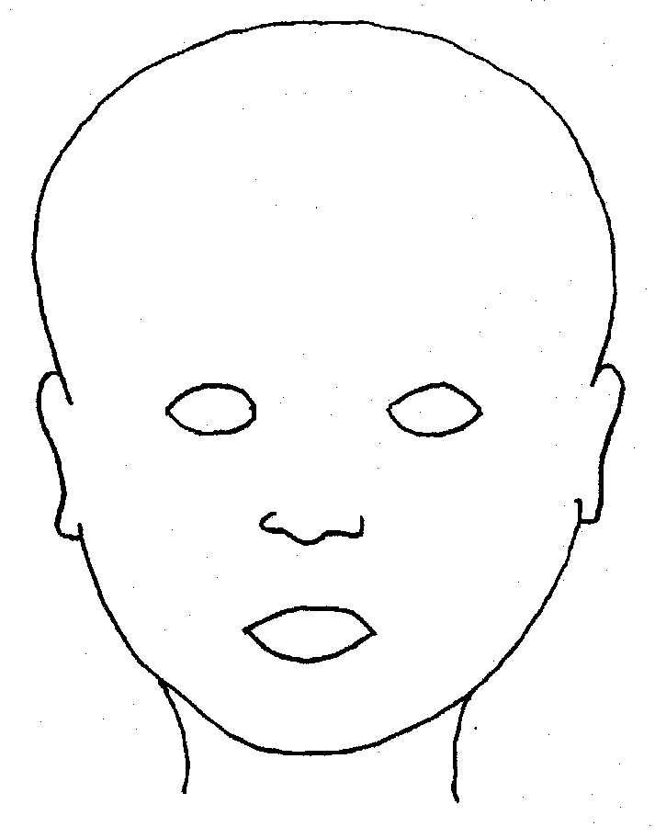 |  | 
FRONT |  | BACK
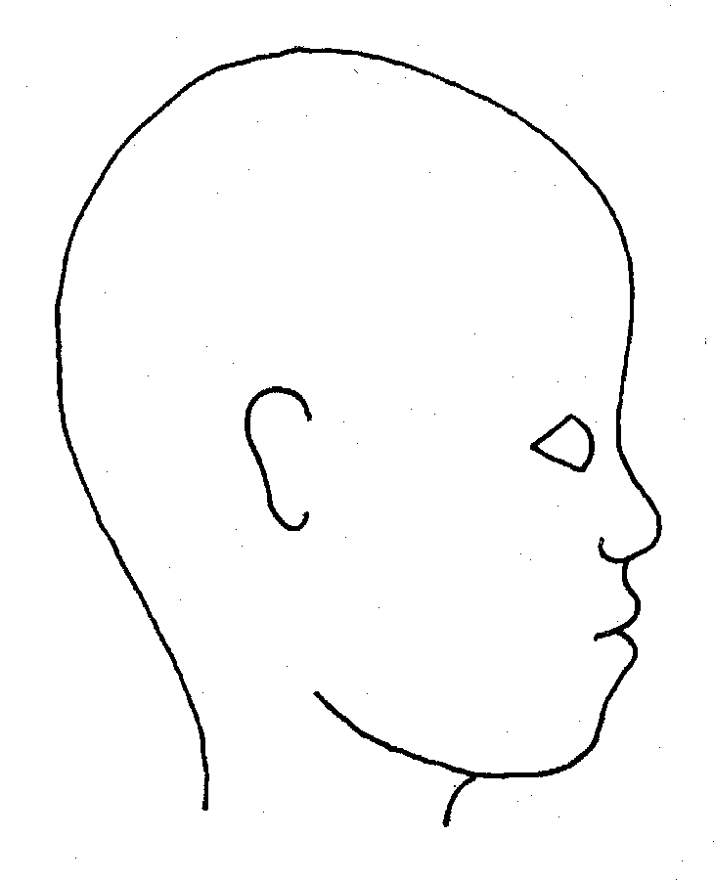 |  | 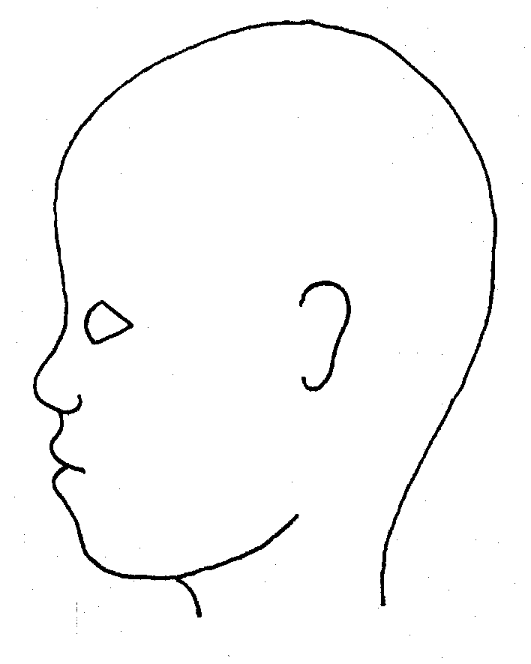
RIGHT |  | LEFT

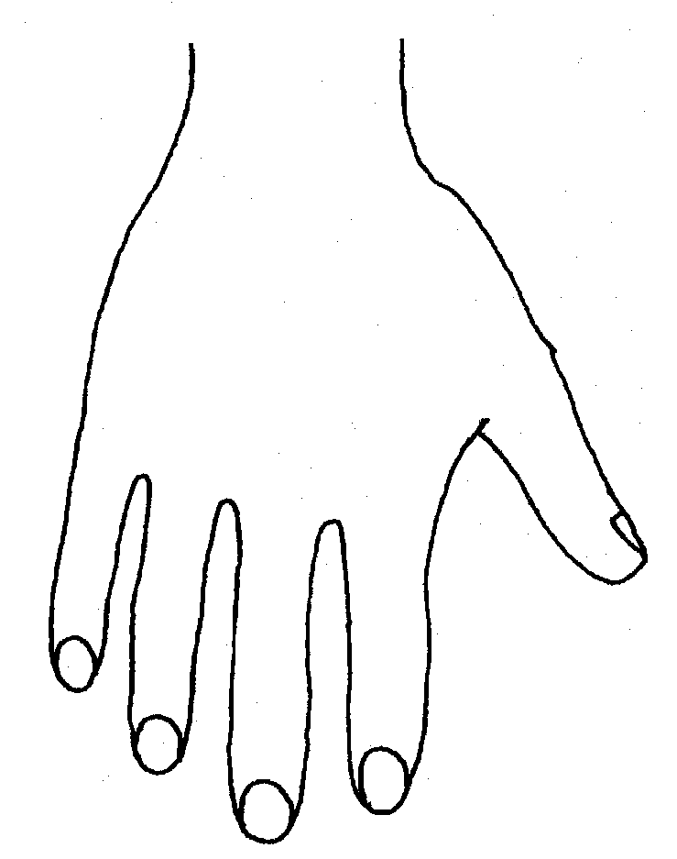 |  |  |  |  |  | 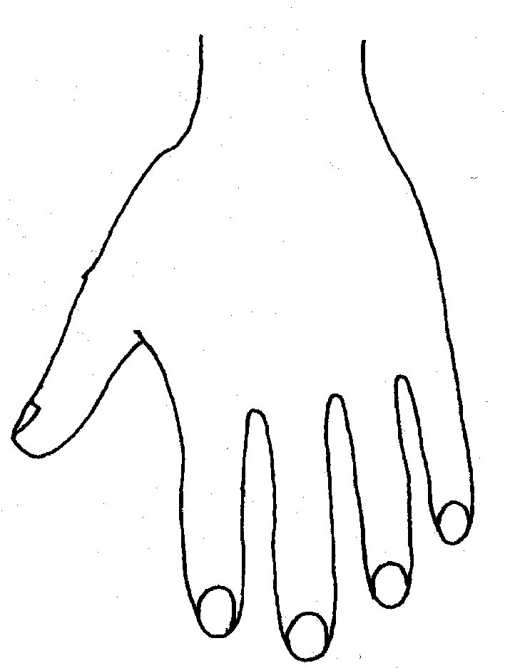
R |  |  |  |  |  | L
BACK
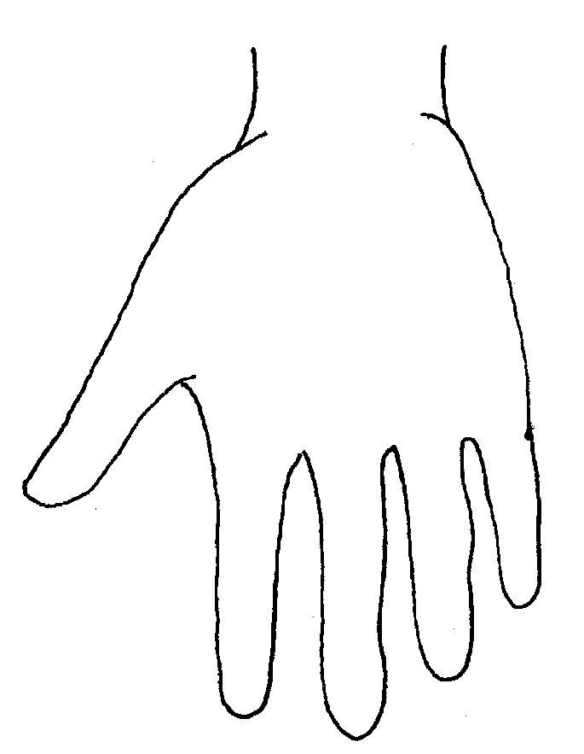 |  |  |  |  |  | 
 |  |  |  |  | 
R | TOP |  |  | L | R |  |  | BOTTOM |  |  |  | L
 |  |  |  |  | 
R |  |  |  |  | L
INNER
 |  |  |  |  | 
R |  |  |  |  | L
OUTER

Appendix 3: Categories of Abuse

Abuse: a form of maltreatment of a child. Somebody may abuse or neglect a child by inflicting harm, or by failing to act to prevent harm. They may be abused by an adult or adults or another child or children. It should be noted that abuse can be carried out both on and offline and be perpetrated by men, women and children. All members of staff should read and understand part one of ‘Keeping children safe in education’ 2016 and staff who have direct contact with pupils n should also read annex A.

Sexual abuse: involves forcing or enticing a child or young person to take part in sexual activities, not necessarily involving a high level of violence, whether or not the child is aware of what is happening. The activities may involve physical contact, including assault by penetration (for example rape or oral sex) or non-penetrative acts such as masturbation, kissing, rubbing and touching outside of clothing. They may also include non-contact activities, such as involving children in looking at, or in the production of, sexual images, watching sexual activities, encouraging children to behave in sexually inappropriate ways, or grooming a child in preparation for abuse (including via the internet). Sexual abuse is not solely perpetrated by adult males. Women can also commit acts of sexual abuse, as can other children.

Signs that MAY INDICATE Sexual Abuse
- Sudden changes in behaviour and school performance
- Displays of affection which are sexual and age inappropriate
- Self-harm, self-mutilation or attempts at suicide
- Alluding to secrets which they cannot reveal
- Tendency to cling or need constant reassurance
- Regression to younger behaviour for example thumb sucking, playing with discarded toys, acting like a baby
- Distrust of familiar adults e.g. anxiety of being left with relatives, a child minder or lodger
- Unexplained gifts or money
- Depression and withdrawal
- Fear of undressing for PE
- Sexually transmitted disease
- Fire setting

Physical abuse: a form of abuse which may involve hitting, shaking, throwing, poisoning, burning or scalding, drowning, suffocating or otherwise causing physical harm to a child. Physical harm may also be caused when a parent or carer fabricates the symptoms of, or deliberately induces, illness in a child.

Signs that MAY INDICATE physical abuse
- Bruises and abrasions around the face
- Damage or injury around the mouth
- Bi-lateral injuries such as two bruised eyes
- Bruising to soft area of the face such as the cheeks
- Fingertip bruising to the front or back of torso
- Bite marks
- Burns or scalds (unusual patterns and spread of injuries)
- Deep contact burns such as cigarette burns
- Injuries suggesting beatings (strap marks, welts)
- Covering arms and legs even when hot
- Aggressive behaviour or severe temper outbursts.
- Injuries need to be accounted for. Inadequate, inconsistent or excessively plausible explanations or a delay in seeking treatment should signal concern.

Emotional abuse: the persistent emotional maltreatment of a child such as to cause severe and adverse effects on the child’s emotional development. It may involve conveying to a child that they are worthless or unloved, inadequate, or valued only insofar as they meet the needs of another person. It may include not giving the child opportunities to express their views, deliberately silencing them or ‘making fun’ of what they say or how they communicate. It may feature age or developmentally inappropriate expectations being imposed on children. These may include interactions that are beyond a child’s developmental capability as well as overprotection and limitation of exploration and learning, or preventing the child participating in normal social interaction. It may involve seeing or hearing the ill-treatment of another. It may involve serious bullying (including cyberbullying), causing children frequently to feel frightened or in danger, or the exploitation or corruption of children. Some level of emotional abuse is involved in all types of maltreatment of a child, although it may occur alone.

Signs that MAY INDICATE emotional abuse
- Over reaction to mistakes
- Lack of self-confidence/esteem
- Sudden speech disorders
- Self-harming
- Eating Disorders
- Extremes of passivity and/or aggression
- Compulsive stealing
- Drug, alcohol, solvent abuse
- Fear of parents being contacted
- Unwillingness or inability to play
- Excessive need for approval, attention and affection

Neglect: the persistent failure to meet a child’s basic physical and/or psychological needs, likely to result in the serious impairment of the child’s health or development. Neglect may occur during pregnancy as a result of maternal substance abuse. Once a child is born, neglect may involve a parent or carer failing to: provide adequate food, clothing and shelter (including exclusion from home or abandonment); protect a child from physical and emotional harm or danger; ensure adequate supervision (including the use of inadequate care-givers); or ensure access to appropriate medical care or treatment. It may also include neglect of, or unresponsiveness to, a child’s basic emotional needs.

Signs that MAY INDICATE neglect.
- Constant hunger
- Poor personal hygiene
- Constant tiredness
- Inadequate clothing
- Frequent lateness or non-attendance at School
- Untreated medical problems
- Poor relationship with peers
- Compulsive stealing and scavenging
- Rocking, hair twisting and thumb sucking
- Running away
- Loss of weight or being constantly underweight
- Low self esteem

Appendix 4: Keeping yourself safe when responding to disclosures (the 6 R’s – what to do if…)

1. Receive
- Keep calm
- Listen to what is being said without displaying shock or disbelief
- Take what is being said to you seriously
- Note down what has been said

2. Respond
- Reassure the pupil that they have done the right thing in talking to you
- Be honest and do not make promises you cannot keep e.g. “It will be alright now”
- Do not promise confidentiality; you have a duty to refer
- Reassure and alleviate guilt, if the pupil refers to it e.g. “you’re not to blame”
- Reassure the child that information will only be shared with those who need to know

3. React
- React to the pupil only as far as is necessary for you to establish whether or not you need to refer the matter, but do not interrogate for full details
- Do not ask leading questions; “Did he/she….?” Such questions can invalidate evidence.
- Do ask open “TED” questions; Tell, explain, describe
- Do not criticise the perpetrator; the pupil may have affection for him/her
- Do not ask the pupil to repeat it all for another member of staff
- Explain what you have to do next and who you have to talk to

4. Record
- Make some brief notes at the time on any paper which comes to hand and write them up as soon as possible
- Do not destroy your original notes
- Record the date, time, place, any non-verbal behaviour and the words used by the child. Always ensure that as far as possible you have recorded the actual words used by the child.
- Record statements and observable things rather than your interpretations or assumptions

5. Remember
- Contact the designated safeguarding lead (DSL)
- The DSL may be required to make appropriate records available to other agencies
- LSCB: www.LSCB.org.uk

6. Relax
- Get some support for yourself, dealing with disclosures can be traumatic for professionals

Appendix 5

Supervision Process

Holly Park expects all EYFS staff to take part in regular supervision sessions.

The main purposes of the supervisory process are:

- To ensure regular opportunities to discuss Safeguarding issues or concerns
- To ensure there are clear channels of communication
- To ensure that the worker is fulfilling their responsibilities to the expected standards;
- To provide support to the worker;
- To identify the professional development and learning needs of the worker.

We have agreed on the following structure for the supervision

Sessions, which will typically:
- Be offered as and when needed (an open door policy)
- More formal opportunities take place half termly which will last about 20 mins, be uninterrupted, unless by prior agreement. Be held in a mutually agreed setting, which is quiet and ensures privacy. Be booked in advance . If a supervision date has to be altered by either party, a new date and time should be fixed straight away.
- A supervision record sheet should be filled in as a record that the meeting took place
- The record should be kept by the Supervisor
- The supervision sessions DO NOT replace the need for staff to fill in safeguarding alert forms as required or follow the normal school procedures on reporting
- The supervision form will be given to the Headteacher at the end of the academic year and will be place in the staff file.

Appendix 6

SUPERVISION RECORD

Name of Supervisor ……………………………………………………………………..

Name of Supervisee ……………………………………………………………………..

Date of meeting ……………………………………………….

Signed by Supervisor____________________________

Signed by Supervisee ___________________________

Date of meeting ……………………………………………….

Signed by Supervisor____________________________

Signed by Supervisee ___________________________

Date of meeting ……………………………………………….

Signed by Supervisor____________________________

Signed by Supervisee ___________________________

Date of meeting ……………………………………………….

Signed by Supervisor____________________________

Signed by Supervisee ___________________________

Date of meeting ……………………………………………….

Signed by Supervisor____________________________

Signed by Supervisee ___________________________

Date of meeting ……………………………………………….

Signed by Supervisor____________________________

Signed by Supervisee ___________________________

Appendix 7 Private Fostering

What is Private Fostering?
A private fostering arrangement is essentially one that is made privately (that is to say without the involvement of a local authority) for the care of a child under the age of 16 (under 18, if disabled) by someone other than a parent or close relative with the intention that it should last for 28 days or more.

Who is Private Foster Carer?
A child may be privately fostered if s/he does not live with:
• Parent or legal guardian
• Grandparent
• Brother or sister

Some Common Examples of Private Fostering:
- A teenager who isn’t getting on with their parents so goes to live with a friend’s family.
- Parents who pay someone to care for their children while they are away working or studying.
- Children who are sent from abroad to live with other families in the UK.
- Children who are placed with a family friend or relative as a result of parental separation, divorce, arguments at home or a parent being hospitalised.

If you think that a child may be privately fostered or is about to enter into a private fostering arrangement, then you must follow this process:

Make your Safeguarding Lead and Head Teacher aware of the situation

A referral then needs to be made to the MASH Team

MASH team will refer onto appropriate agency who will then gather information to
determine whether child is privately fostered

If the child is privately fostered then the case will be allocated to a Social Worker
who will assess, visit and support the child, parents and private foster carer.

