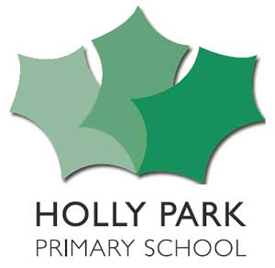
Pupil Premium Grant Expenditure: 2018/19
Number of pupils and pupil premium grant (PPG) received
Total number of pupils on roll (Reception to Y6) | 480
Total number of pupils eligible for PPG
Amount of PPG received per eligible pupil  (Free School Meals pupils and Looked After Children) | £1,320 Pupil premium  £1,900 Pupil premium Plus  £300 Early Years Pupil Premium
Total amount of PPG received | £ 163,680
Focus of PPG spending 2018/19
£22,100 clawback in June adjustment (25 Y6 children left July 2017 and only 8 new Rec children joining in September 2018 – so taking off 18 PP)

Leaving £141,580

£100,000 Teaching Assistant, Learning Mentor & Teacher salaries
£21,600 Saturday Tutoring (1 term) and in school targeted support
£8,900 Enabling Enterprise
£4,000 Books
£1,900 Tracking system
£4,500 HEWS
£680 Resources

Total £141,580

