**Ideas to support your child’s reading, spelling and writing at home.**

*Workshop by Matthew Fuller with the Barnet Educational Psychology Team*



**The Three Ps**

* + **PAUSE –** For 5 seconds
  + **PROMPT –** 
    - Do they recognise any of the letters in the word and can they say the sounds that go with them?
    - Can they break the word up into chunks, for example ‘can–dle’?
    - Can they try reading again from the start of the sentence, or continue reading the rest of the sentence?
    - Are there any clues from the pictures?
    - If your child still has troubles with the word after two ‘prompts’, say it for them and encourage them to move on with their reading, “The word is ‘monkey’, let’s keep going.”
  + **PRAISE**
    - * Support your child’s reading with positive reinforcement.
      * *“Your reading is getting so much better, Good work!*”



**Comprehension Questions**

Question 1 – Summarising

* *Get them to summarise what they read*
  + *So what happened in the story you read today?*
  + *Can you explain to me what happened in a sentence?*

Question 2 - Question generating*;*

* *Get them to ask you some questions about the book*
  + *“Now you have to ask me some questions?”*
    - * *“Can you ask me a question about the part we read.*
      * *And can your question begin with …”*
    - *Who*
    - *Where*
    - *Why*

Question 3 – Clarifying

* Get them to ask you if there’s anything they didn’t understand.
  + You could say “Is there anything you didn’t understand in the book?”

Question 4 – Predicting

* What might happen next in the story?
  + What could have happened before the story started?
  + What might happen after the story?





**Cued Spelling**

1. The intervention would start with your child choosing several words they would like to learn to spell.

2. The child and parent then engage in the active learning of these words, including the identification of mnemonic strategies to remember the spelling.

3. Parent then writes out the words and the child cues them with the mnemonic strategies they discussed.

4. Child then attempts the words and parent cues them with the strategies.

5. Child then copies the words whilst saying the cues

6. Child then writes the words as quickly as possible on their own.

7. The final step is for the child to read through the words they have written.

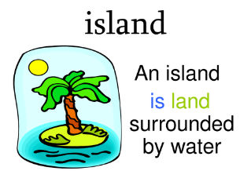

**Dialogical Questions**

**When Turning a page…**

**1 - Ask an open-ended question**

* Who is that?
* Where is the ___?
* What is that character doing?

**2 - Repeat or expand the child’s responses**

* Why did they do that?
* Yes, that’s right the caterpillar ate too many sweets!

**3 - Follow the child’s interest**

* Who’s your favourite character?
* What's your favourite bit?

**4 - Connect to real life**

* Have you ever felt like that?
* When was the last time you saw a duck/went to the park?



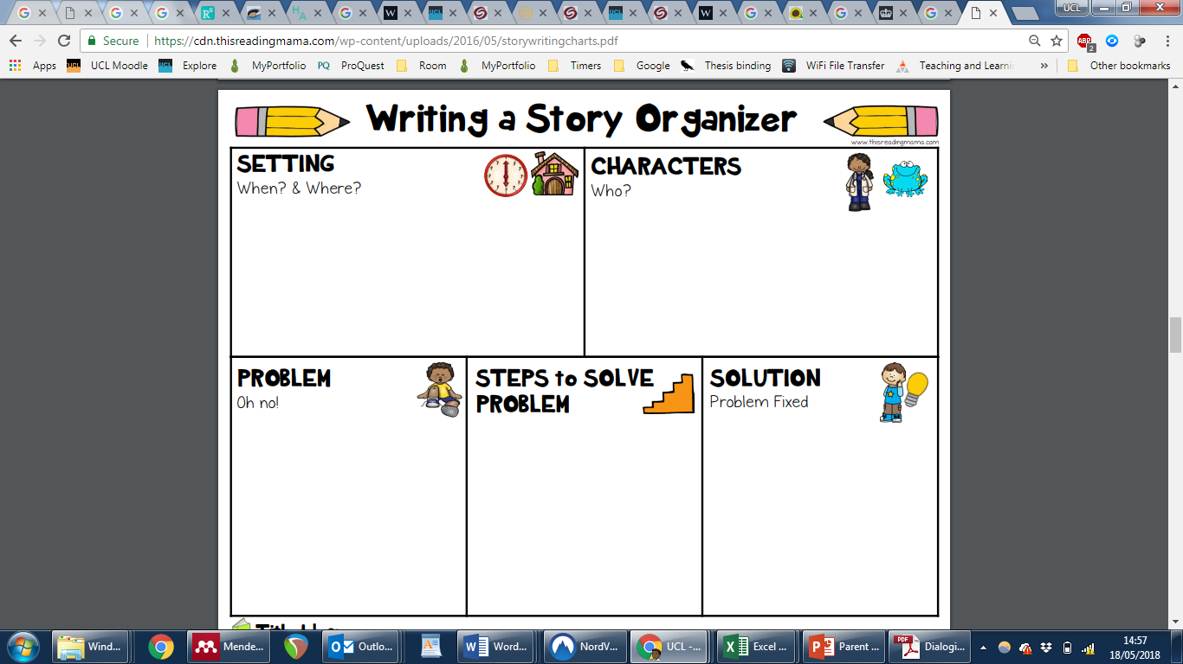

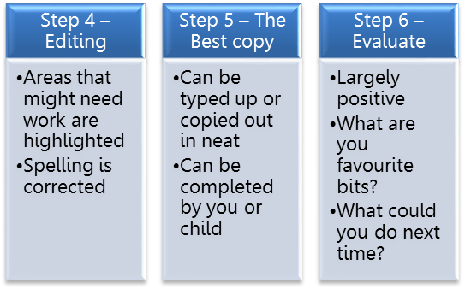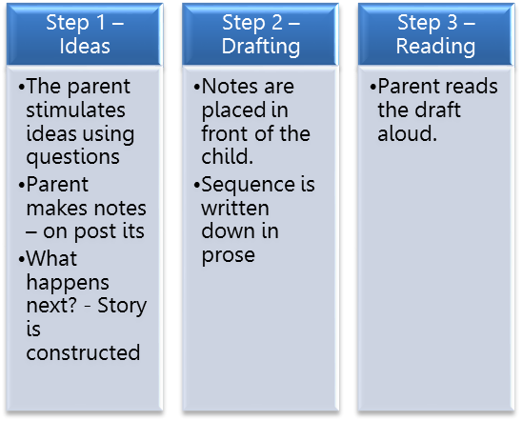

**Paired Writing**

|  |  |  |
| --- | --- | --- |
| **Start** | **Middle** | **End** |
|  |  |  |