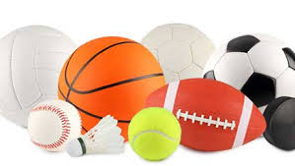
Physical Education: Games
Year 4
Physical Me:  To become more physically skilful and competent in games skills in all 3 families (invasion, net and Striking & fielding) | Creative Me:  To become better at making decisions independently and with others about tactics and attacking and defending | Healthy Me:  To take part in a more physically active and healthy lifestyle including competitive games through increased health, fitness, confidence, motivation, knowledge and understanding | Thinking Me:  To be able to peer and self assess to bring about improvement in myself and others
I can use a range of techniques dependent on the game. | I can keep and use rules given to me and suggest how rules could be changed to improve the game. | I use the knowledge I am learning in PE to make up suitable warm-up activities for the games I am playing. | I know and explain the tactics and skills that I am confident with and use well in games.
I can change direction and speed when keeping possession, show growing consistency and control and play with greater speed and flow. | I can adapt rules in agreement with others and, later, make rules for their own games, which they explain and teach to others. |  | I can describe the help I need to improve my play.
 | I can use a range of tactics to keep possession of the ball and get into positions to shoot or score. |  | I can describe the help I need to improve my play.

