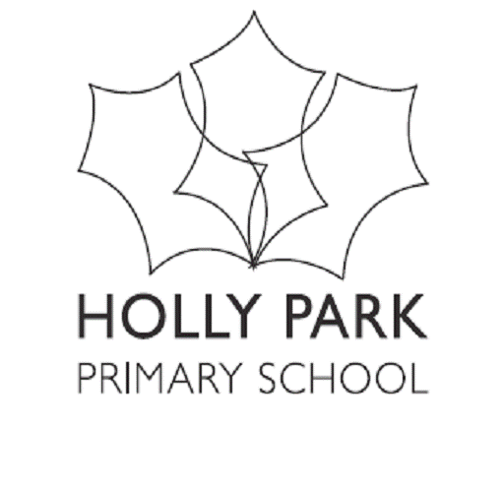

HOLLY PARK PRIMARY SCHOOL

Permission Form

Name of Child ____________________________

Local Walks
I give permission for my child to be taken on short walks around Friern Barnet during his/her time at
Holly Park School. I understand that separate letters will be sent out for educational visits that involve
a whole day, or those involving the use of public transport or coach hire.
*Please delete as appropriate *YES / NO

Reading Books
I would like my child to bring home his/her reading books and library books and agree to pay for any
books that are lost or damaged *YES / NO

Photographs
I give permission for my child to have their photograph taken whilst participating in school
activities and for these to be used in the school’s own materials (for example displays, website and prospectus) *YES / NO

I give permission for my child to video, and be videoed, as part of curriculum work for use internally
by the school *YES / NO

I give permission for my child’s photograph to be used by other agencies approved by the school (for
example the local authority and local press) *YES / NO

Plasters
I give permission for a first aider to use plasters on my child *YES / NO

Earrings
My child wears earrings and I agree that they will be removed for PE lessons *YES / NO / N/A

Head Lice
In the event of an outbreak of headlice in school, I give permission for my child’s head to be examined
and understand that if lice are found my child will be sent home, where it is my responsibility to treat
them before they return to school *YES / NO

Dinner Money
I agree that if my child has school dinners I shall pay in full, in advance *YES / NO

Computer
I give permission for my child to use the internet under supervision at school in line
with the school Internet policy *YES / NO
I give permission for my child to use electronic mail under supervision at school in line
with the school Internet policy *YES / NO

Signed ______________________________________ Date __________________

Name ______________________________________

Relationship to child _________________________

