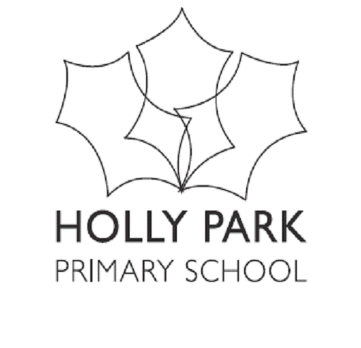 Holly Park School
Minutes of Achievement Committee Meeting held on Monday 27th February

Present: Ann Pelham, Liz Pearson, Clare Wischhusen, Fiona Vettiankal, Hedley Dindoyal
In attendance: Sally Thomas, Maria Michael
Apologies: Andrew Balham-Davies, Fiona Quinton, Michael Crookes, Gael Birtill, Angie Peake l
AGENDA ITEMS | KEY DISCUSSION POINTS | ACTION (who? /timescale?)
Update from previous meeting  - Attainment review feedback  - Pupil Progress meetings  - Policies - Assessment  - Internal data across the school - Aut  - The impact of interventions across the school - Aut  - Tracking the progress of Disadvantaged & SEN children - Aut  - Pupil Premium spending plans for 2017-18  - Target setting for key stage 2 results end of 2017 | - The Marking Policy, which had been approved by governors, will be revisited in the light of comments in reports from OFSTED. Staff have been considering examples of marking from partner schools  - Staff are attending course on phonics following a downward trend in results of the tests. Phonics is in the SIP and where appropriate is included in appraisal targets. The School Improvement Partner is pleased with the progress being made and will work with the Nursery in the summer term.  The Annual attainment review took place in December with the LA inspector. The summary shows  - EYFS strong and improving,  - Phonics – falling trend, below national average  - KS! literacy – below on progress and attainment and maths above  - KS2 – attainment in line, progress strong  Actions from the review – Phonics, high achievers in Y3 to make strong progress, spelling and tracking of all groups  A governor asked about flooding reading in Y3. This is not being done in Y3. The governor asked if it would be implemented in Y3 when Y2 finishes in June. Ann explained that it would move to Y1, but other measures are being taken in Y3.  A governor asked if poor readers are mainly boys – no  Holly Park has bought Arbor, system which produces statistical models. It predicts a 65% probability of achieving Good with OFSTED, 24% outstanding  These are now going to take place at the end of each term in line with book looks and uploading of tracker data. For efficiency staff now meet with either Ann or Maria rather than both together and focus on books rather than data. Interventions are decided at these meetings.  Governors are reminded to peruse this policy and send comments to Ann.  A governor asked whether monitoring teaching strategies and interventions should be included in this policy. This was discussed – there may be a more appropriate place for it.  Ann presented sheets giving details of progress and attainment in each year group, also showing data for groups (boys, girls, etc)  Information about individual children is obtained by observing progress in books and on the tracked system  A governor asked how the tracker data is obtained –it is based on tests and is age related. It was pointed out that book looks do not cover reading.  A governor asked what is the important feature of book looks –good progress, even if attainment is low.  A governor asked if there are booster groups for those high achievers approaching greater depth – not at present, the focus is on children at “just below” expectations  To raise attainment everyone needs to teach with the right expectations. The new curriculum makes clear what each year group should do, and thai needs to be evident in books and lessons.  Interventions and their results are now being closely monitored. Ann presented sheets showing the results of the various interventions, and these are on the whole very promising. TAs have been trained to deliver the interventions.  Ann presented a sheet showing the progress of PP children. Overall they make slightly less progress than non-PP children.  A governor asked why there seem to be fewer PP children in higher year groups. It may be because it is easier now to get accurate numbers of eligible children  The daa analysis sheet is showing the effects iof the new maths teaching.  It is important to look at the needs of the PP children and not just do the same things every year. The information is on the website. Decisions will be made when the final funding figures are in.  Sally will be used to take classes in Y2-6 while the teacher takes individual children to work with them on feedback as this has been shown to be a good strategy for improving progress.  It is probable that the targets will not be achieved. This year group, the original bulge class, has had enormous turmoil with fewer children than normal having been at Holly Park throughout. This year already there have been 120 children admitted – 11% of the cohort- and many also in previous years. It will be important to make clear the progress of those who have been here since KS1.

