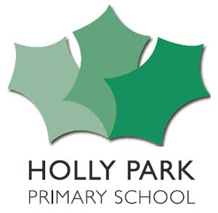 Well-Being Week & Sponsored Run

During the week beginning 27th March, we will be having a “Well-Being Week”. One of the many activities that the children will be doing will be a sponsored run in the playground along our new track to raise money for the British Heart Foundation and also for the school. The money raised will be split between the two. Each class will do their sponsored run with their class teacher.

Child’s Name ______________________________ Class __________

Name | Tick this column if you will sponsor an amount per lap run | Tick this column if you will sponsor a fixed amount for having a go | Total amount | Paid

No. of laps run: ____________
Total amount raised ____________________________

All money and sponsor forms should be handed in by: Wednesday 19th April to the class teacher.

