African Adventure

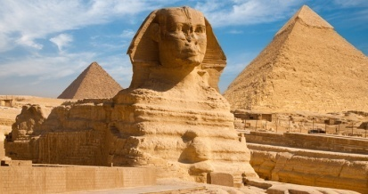
Dear Parents/Carers,
Welcome to the Autumn term in Year 4. In our Learning Project this term we will be finding out about Africa. Please see below for how this links to different areas of the curriculum.
Best wishes,
Ms Owen and Mrs Tsenti
English | Maths |  | Science
Researching African countries and presenting informationStories from other cultures  Grammar: Word classes- nouns, adjectives, verbs, adverbs  Spelling: Strategies for ‘having a go’, apostrophes for possessions, homophones  Writing: Story-mapping, write own creative stories set in Africa  Reading: ‘Flooding of reading’ daily | Place value and number  - knowing place value of 4 digit numbers  - ordering numbers  - rounding  - negative numbers  Addition & Subtraction  - formal written methods  - estimate and use inverse operations to check calculations  - Solve two step problems | Measurement :  Length and Perimeter  Measure and calculate the perimeter of a rectilinear figure (including squares) in centimetres and metres  Convert between different units of measures e.g kilometre to metre  Solve problems involving multiplying and adding, including the distributive law to multiply two digit numbers by one digit number  Multiplication & Division -  learning times tables up to 12x12 | Sound and Hearing  - vibrations  - volume  - how the ear works  Light and Seeing  - reflection  - shadows
Art & Design | Design & Technology | RE | PSHE
Print & Textiles – linked to Design & Technology: Looking at African patterns and colour and creating prints.  Using different types of stitch, joining materials. | Textiles – Using a variety of skills (printing and stitching) to design and create an African themed patchwork wall hanging. | Inspirational People | Physical: helping to keep ourselves and others safe  - road safety  - emergency situations
Computing | Geography | History | PE
Using the internet to research Africa  Dance Ejay (music composition software) | Global sense: Africa (a study of significant places, features and environments) | Ancient Egypt | Swimming  Invasion games – basketball, netball, football and hockey skills
Spanish | Music | Other Information: | Key dates
To be able to say the date in Spanish  To be able to say the weather in Spanish  To be able to greet and exchange some personal information in Spanish  To be able to introduce yourself in Spanish  To learn how many Spanish speaking countries are there in the world  To be able to say the Spanish alphabet  To be able to describe the weather in Spanish | To understand what pentatonic scales are  To use a pentatonic scale to create a composition (group composing).  To create a well-structured composition with contrasting sections.  To be able to compose a whole class song. To understand how end of line rhythms may be used in song writing process. | PE Day – Tuesday Swimming is on Wednesday  Homework goes home on Thursday and must be returned by the following Tuesday | 13th October – Curriculum Day- Africa  30th October – Year 4 Workshop on writing  7th December – Visit to the British Museum

