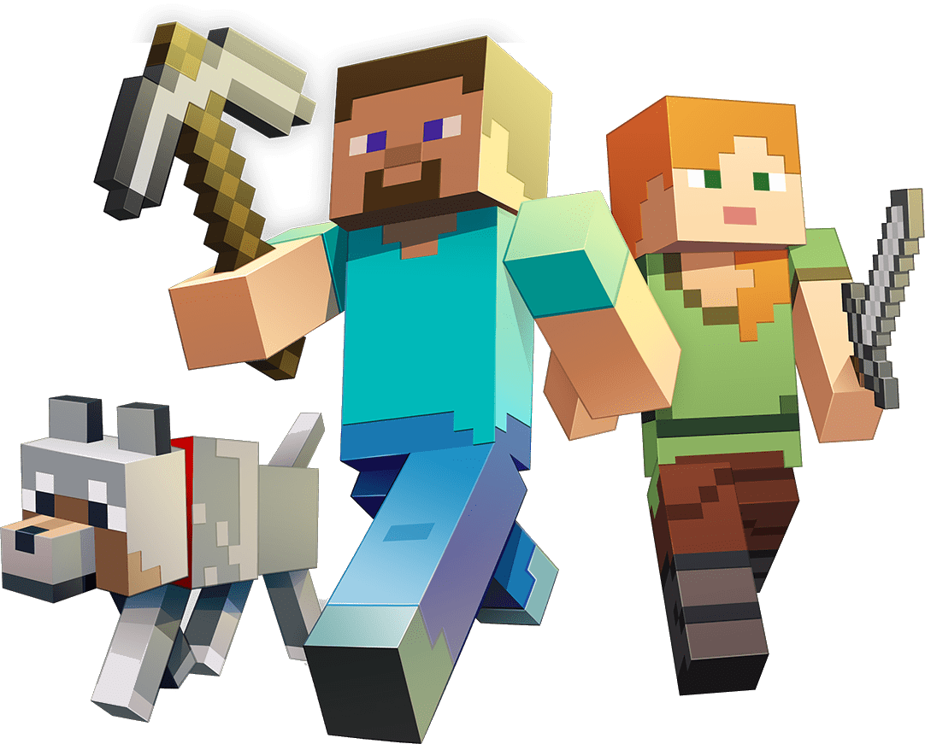
Superheroes & Master Builders

Dear Parents/Carers,
Welcome to the Autumn term in Year 2. Our Learning Project this half term is all about heroes and villains, including those in stories and films. Next half term we will be focusing on materials and buildings, through the popular game of Minecraft. Please see below for how this links to different areas of the curriculum.
Best wishes,
Lewis Turner and Emma Fitzpatrick
English | Maths |  | Science
Sequencing events in stories  Reading accurately using phonic knowledge  Write fiction about themselves and others  Reading and writing instructions | Place Value – tens and ones  Addition and Subtraction –  three 1-digit numbers  2-digit + 1-digit  2-digit + multiple of ten  2-digit + 2-digit | Shape- identifying, sorting and describing 2D and 3D shapes.  Position- using mathematical language to describe movement, position and direction.  To arrange and order objects into patterns and sequences. | Light  Sound  Materials
Art & Design | Design & Technology | RE | PSHE
Printing and Patterns  Sketching  Collage | Cooking – weighing, grating, chopping and measuring ingredients. | Special People including trip to the synagogue | Being Responsible, writing our class charter  Recognising and Managing feelings
Computing | Geography | History | PE
Coding – writing instructions for BeeBot  www.code.org | Looking at key features of a location – houses, cities, rivers, mountains, hills etc |  | Throwing and Catching  Flight (jumping)
Spanish | Music | Visits and events
To be able greet someone in Spanish, to have a basic conversation (name, how are you, how old are you) and to sing a greetings song  To be able to say ´yes and no´´  To be able to count from 1 to10 and sing a song about numbers  To be able to say please and thank you and other general vocabulary  To be able to say in Spanish “It´s hot, its cold” | To understand that music is made up of long and short sounds.  To create sequences of long/short sounds.  To be able to combine long/short sounds within a steady pulse.  To begin to distinguish between rhythm patterns and the musical pulse. To combine rhythm patterns and the pulse.  To use word phrases to compose rhythm patterns. | Visit to Synagogue  Visit to Café Blue  Visit to Barnet Museum
Other Information:
We will be asking for voluntary contributions towards our cooking ingredients later this half term. Please look out for further information about this.
Homework will be sent home each Friday and needs to be returned each Thursday, please.
We will need additional parents helpers on our trips, please support us in this if you are able. We will send more information nearer the time.
Key Dates:
3rd October 2017 – Year Two End of Year Expectations Meeting

