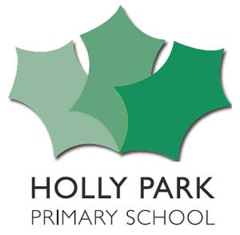
Pupil Premium Grant Expenditure: 2017/18
Number of pupils and pupil premium grant (PPG) received
Total number of pupils on roll (Reception to Y6)
Total number of pupils eligible for PPG
Amount of PPG received per eligible pupil  (Free School Meals pupils and Looked After Children) | £1,320 Pupil premium  £1,900 Pupil premium Plus  £300 Early Years Pupil Premium
Total amount of PPG received | £ 170,420
Focus of PPG spending 2017/18
£100,000 Teaching Assistant, Learning Mentor & Teacher salaries
£21,600 Saturday Tutoring
£8,900 Enabling Enterprise
£5,878 PP Resources (e.g spellodrome, reading eggs, mathletics, 5 to thrive etc)
£4,000 PP Discount on trips
£4,000 Books
£3,210 Beanstalk Readers
£1,400 Navigator trip,visits & Resources
£1,762 Recorder Tuition for Y3 PP
£1600 Tracking system
£500 School Uniform
£4,500 HEWS
£450 EYFS Talk Boost Intervention pack

(Possible Clawback is £12,620 for 1 service child @£300 and estimate of £12,320 based on 26 Y6 children leaving in July and only 12 new Rec children joining in September – so taking off 14 PP children at 2 terms each)

